COLLEGE OF MILITARY ENGINEERING, PUNE
FACULTY OF CIVIL ENGINEERING

PROJECT REPORT

CBRN HARDENED UNDERGROUND OPS ROOM

(DESIGN OF A BLAST-RESISTANT, CBRN AND EMP PROTECTED UNDERGROUND OPERATIONS ROOM WITH SENTRY POST AT PUNE)

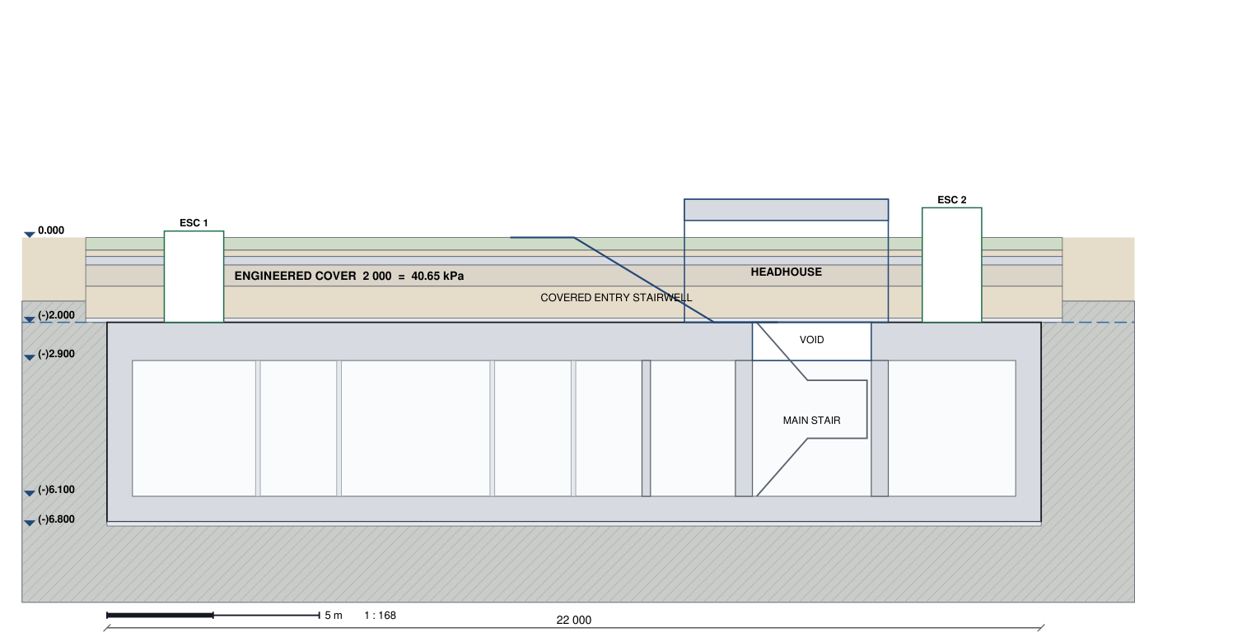

Submitted in partial fulfilment of the requirements for the award of the degree of
Bachelor of Technology (Civil)

Submitted by
SYNDICATE 01

Maj Yatin | Capt Sonu Sharma
Capt Sukender Singh | Capt Balbanka Tiwary
Capt DV Ghanashyama | Capt Siddharth Sinha

Under the guidance of

Maj Ashish Dubey, FGS | Lt Col APS Chauhan
Dr I R Chaudhuri | Sh Tilak Sharma, Jt Dir (C), FCM
Dr Uttam Awari

SEPTEMBER 2026

CERTIFICATE
COLLEGE OF MILITARY ENGINEERING, PUNE


This is to certify that the project entitled 'CBRN HARDENED UNDERGROUND OPS ROOM' submitted by six officers of Syndicate 01, in partial fulfilment of the requirements for the award of the degree of Bachelor of Technology (Civil) of College of Military Engineering, Pune, affiliated to the Jawaharlal Nehru University, New Delhi, is a record of their own work.
SYNDICATE 01  1. Maj Yatin  2. Capt Sonu Sharma  3. Capt Sukender Singh | 4. Capt Balbanka Tiwary  5. Capt DV Ghanashyama  6. Capt Siddharth Sinha

GUIDES
Maj Ashish Dubey, FGS |  | Dr I R Chaudhuri |  | Dr Uttam Awari
Lt Col APS Chauhan |  | Sh Tilak Sharma, Jt Dir (C), FCM
Shri AV Sangamnerkar, Assoc Prof
Chief Project Coordinator
Date : ________ Sep 2026
Place : CME Pune
APPROVAL SHEET

This Project Entitled
"CBRN HARDENED UNDERGROUND OPS ROOM"
by
SYNDICATE 01
1. Maj Yatin
2. Capt Sonu Sharma
3. Capt Sukender Singh
4. Capt Balbanka Tiwary
5. Capt DV Ghanashyama
6. Capt Siddharth Sinha
is Approved for the Degree of
Bachelor of Technology (Civil)
of
Jawaharlal Nehru University
at
Faculty of Civil Engineering
College of Military Engineering, Pune
Examiners | Name | Signatures
1. External Examiner
2. Guide

Date : ________ Sep 2026
Place : CME Pune
DECLARATION

We declare that this written submission represents our ideas in our own words and, where others' ideas or words have been included, we have adequately cited and referenced the original sources. We also declare that we have adhered to all principles of academic honesty and integrity and have not misrepresented, fabricated or falsified any idea, data, fact or source in our submission. We understand that any violation of the above will be cause for disciplinary action by the Institute and can also evoke penal action from the sources which have thus not been properly cited or from whom proper permission has not been taken when needed.

Maj Yatin
CME/EODE 128
Syndicate Leader
(on behalf of Syndicate 01)

Date : ________ Sep 2026
Place : CME Pune
ACKNOWLEDGEMENT
It is indeed difficult to express in words our gratitude to all those who stood by us through this project. Nevertheless, we attempt to do so here.
We express our deep sense of gratitude to our guides, Maj Ashish Dubey, FGS, Dr I R Chaudhuri, Dr Uttam Awari, Lt Col APS Chauhan and Sh Tilak Sharma, Jt Dir (C), FCM, for their expert guidance, advice and encouragement, and for their critical review at every stage of the project, from the selection of the site to the preparation of the final drawings and estimate.
We are thankful to the Head of the Structures Department for constantly driving us towards the completion of the project.
We extend our sincere thanks to the Commander, Faculty of Civil Engineering, CME, Pune, for extending all support during the course.
We are also thankful to the Dean and Deputy Commandant, CME, Pune, for the constant inspiration and encouragement.
We are grateful to the Commandant, CME, Pune, for providing the student officers constant support and the infrastructure that made for a conducive academic environment in which to complete this project.
We gratefully acknowledge the Soil Engineering and Material Testing Wing, CME, whose sub-soil investigation report for the adjoining CTW Phase III project provided the geotechnical data for the site, and the staff of CTW for their assistance during the site studies.
We are thankful to all the Instructors and Professors of the Faculty for sharing their knowledge with us, and to the library and the administrative staff for their cordial support and the facilities provided in preparing this report.

Maj Yatin
CME/EODE 128
Syndicate Leader
(On behalf of Syndicate 01)
CME, Pune-411031

ABSTRACT
The project covers the planning, analysis, design and works management of a CBRN hardened underground operations room at the College of Military Engineering campus, Pune. The facility protects nine occupants for 96 hours against the blast of a nuclear air burst with a peak incident overpressure of 344.7 kPa (50 psi), together with chemical, biological, radiological and nuclear contamination, initial nuclear radiation, fallout and electromagnetic pulse.
The protected volume is a buried reinforced concrete box 22.0 m long and 6.2 m wide, divided into eight bays and founded on Deccan basalt at a depth of 6.8 m, with 2.0 m of engineered cover including a reinforced concrete burster slab. Entry is through a covered stairwell, an entry headhouse and a main staircase to two blast doors rated at 7 bar, and two vertical escape shafts provide emergency exits. A two-storey framed sentry post on isolated footings completes the installation.
The blast load has been derived using the dynamic load factor approach of IS 4991 with a ductility ratio of 5, giving a design pressure of 383 kPa on the roof and walls. With a roof natural period of 13.4 ms against a positive phase duration of 0.13 to 1.33 s, the response is quasi-static. All elements have been designed to IS 456 : 2000 by the limit state method, using the plastic mechanism moment and dynamic material strengths for the blast case, and the sentry post frame has been detailed to IS 13920 : 2016 for seismic Zone III. The governing element, the 900 mm pressure slab, carries T25 bars at 150 mm each face each way.
The protective services comprise two 300 m³/h NBC filter trains with an overpressure cascade through a three-stage decontamination airlock, a shielded EMP Zone 2 enclosure designed for 80 dB from 10 kHz to 1 GHz, a tanked drainage system with a clean sump, a 15 kVA standby generator with battery-backed essential supply, and a fire and life safety plan with three escape routes. The works have been estimated at Rs 2,97,90,913 and programmed for completion in 224 working days.
CONTENTS

Certificate i
Approval sheet ii
Declaration iii
Acknowledgement iv
Abstract v
List of figures vii
List of tables ix
Abbreviations xii
Chapter 1 : Introduction 1
Chapter 2 : Site selection and geotechnical investigation 5
Chapter 3 : Planning and architectural layout 17
Chapter 4 : Design basis and materials 28
Chapter 5 : Loads and load combinations 37
Chapter 6 : Structural analysis 47
Chapter 7 : Design of the underground structure 55
Chapter 8 : Design of staircases, headhouse and closures 66
Chapter 9 : Design of the sentry post 74
Chapter 10 : CBRN protection and ventilation 82
Chapter 11 : EMP protection 89
Chapter 12 : Water supply, drainage and sewage 96
Chapter 13 : Electrical services 101
Chapter 14 : Fire and life safety 105
Chapter 15 : Site layout, finishes and concealment 109
Chapter 16 : Works management 114
Chapter 17 : Environmental management plan 123
Chapter 18 : Conclusion 125
Appendix A : Reinforcement schedule 127
Appendix B : Bill of quantities 131
Appendix C : List of drawings 136
Appendix D : References 138

LIST OF FIGURES

Fig 2.1 : Site location 5
Fig 2.2 : Existing services on the campus 7
Fig 2.3 : The site as found 8
Fig 2.4 : Contour map 9
Fig 2.5 : Watershed and surface drainage 10
Fig 2.6 : Site layout plan 10
Fig 2.7 : Bearing demand against capacity 15
Fig 2.8 : Monthly rainfall and temperature at the site 16
Fig 3.1 : Underground level plan at (-)6.100 19
Fig 3.2 : Longitudinal section on the box centreline 21
Fig 3.3 : Transverse section through the box 21
Fig 3.4 : Access route from grade to the clean zone 22
Fig 3.5 : Main staircase, developed section 23
Fig 5.1 : Design blast wave (pressure-time history) 37
Fig 5.2 : Response regime of the structure 38
Fig 5.3 : Dynamic load factor against ductility ratio 39
Fig 5.4 : Engineered cover over the pressure slab 41
Fig 5.5 : Lateral pressure on a perimeter wall, static and blast cases 42
Fig 6.1 : Underground structure model and load cases 1 to 5 (STAAD.Pro) 49
Fig 6.2 : Load cases 6 to 10, underground structure model (STAAD.Pro) 49
Fig 6.3 : Plate stress contours, underground structure model (STAAD.Pro) 50
Fig 6.4 : Mesh sensitivity study, coarse, medium and fine meshes (STAAD.Pro) 51
Fig 6.5 : Sentry post frame model (STAAD.Pro) 53
Fig 6.6 : Load cases, sentry post frame model (STAAD.Pro) 53
Fig 7.1 : Perimeter wall W1 to W4, section and reinforcement 56
Fig 7.2 : Walls W6 and W7 with the blast door opening 58
Fig 7.3 : Mat foundation, governing soft-band case 59
Fig 7.4 : Flotation check at each construction stage 61
Fig 7.5 : Pressure slab, section and reinforcement 63
Fig 7.6 : Roof plan, openings and trimmers 64
Fig 8.1 : Opening corner detail at the top of the entry flight 69
Fig 8.2 : Escape shaft head, hatch and ladder 73
Fig 9.1 : Sentry post, two-storey RC frame on isolated footings 74
Fig 10.1 : NBC filter train, seven stages 83
Fig 10.2 : Ventilation air path and room distribution 85
Fig 10.3 : Overpressure cascade through the airlock 86
Fig 11.1 : EMP zones 90
Fig 11.2 : Shielding effectiveness of the reinforcement cage 91
Fig 11.3 : Honeycomb waveguide ventilation panel 94
Fig 12.1 : Septic tank and soak pit 99
Fig 13.1 : Electrical single line diagram 103
Fig 14.1 : Fire and egress, escape routes and decision rule 107
Fig 15.1 : External works, septic tank, soak pits and soakaways 110

LIST OF TABLES

Table 1.1 : Design requirements 2
Table 2.1 : SWOT analysis of the selected site 6
Table 2.2 : Strata recorded in the trial pits 12
Table 2.3 : Laboratory test results on soil samples 12
Table 2.4 : Rock core test results 13
Table 2.5 : Design ground parameters 14
Table 2.6 : Bearing pressure checks 14
Table 2.7 : Meteorological data (monthly averages) 16
Table 3.1 : Level schedule 18
Table 3.2 : Main dimensions of the underground box 19
Table 3.3 : Bay schedule 20
Table 3.4 : Internal walls 20
Table 3.5 : Main staircase geometry 23
Table 3.6 : Escape shafts 24
Table 3.7 : Door and opening schedule 26
Table 4.1 : Codes and standards 28
Table 4.2 : Materials 31
Table 4.3 : Clear cover to reinforcement 31
Table 4.4 : Development and lap lengths (mm) 32
Table 4.5 : Waterproofing system 33
Table 4.6 : Stipulations for proportioning 34
Table 4.7 : Mix proportions per cubic metre 36
Table 5.1 : Gravity, earth and water loads on the underground structure 40
Table 5.2 : Engineered cover build-up 41
Table 5.3 : Entry stairwell loads 43
Table 5.4 : Sentry post loads 44
Table 5.5 : Load combinations, underground structure 46
Table 5.6 : Load combinations, sentry post 46
Table 6.1 : Underground structure model 48
Table 6.2 : Primary load cases, underground structure model 48
Table 6.3 : Mesh sensitivity study, underground structure model 50
Table 6.4 : Sentry post model 52
Table 6.5 : Statics check, sentry post model 52
Table 6.6 : Beam gravity moments at the first floor (kNm) 54
Table 7.1 : Mat thickness study (case 2) 59
Table 7.2 : Factor of safety against flotation 60
Table 7.3 : Pressure slab thickness study 62
Table 7.4 : Summary of design, underground structure and headhouse 65
Table 9.1 : Detailing of slab S1 75
Table 9.2 : Beam B1, support moments (kNm) 76
Table 9.3 : Beam B2, support moments (kNm) 77
Table 9.4 : Strong column - weak beam check at the first floor 78
Table 9.5 : Reinforcement of the sentry post 81
Table 10.1 : Ventilation design basis 82
Table 10.2 : Threats and means of removal 83
Table 10.3 : Blast valves 84
Table 10.4 : Room air distribution 85
Table 10.5 : Overpressure cascade 86
Table 10.6 : Operating modes 87
Table 11.1 : Components of high-altitude EMP 89
Table 11.2 : EMP zones 90
Table 11.3 : Shielding effectiveness of the 150 mm cage 91
Table 11.4 : Zone 2 enclosure 92
Table 11.5 : Points of entry of the Zone 2 enclosure 93
Table 11.6 : Impedance of bonding straps 94
Table 12.1 : Daily water balance 97
Table 12.2 : Internal drainage 98
Table 12.3 : Trap seal depth against overpressure 98
Table 12.4 : Disposal of water in each operating mode 100
Table 13.1 : Electrical load schedule 101
Table 14.1 : Fire load 106
Table 14.2 : Escape routes 106
Table 14.3 : Route decision rule 107
Table 15.1 : External works 109
Table 15.2 : Finish codes 111
Table 15.3 : Room finish schedule 112
Table 16.1 : Quantity of concrete 116
Table 16.2 : Quantity of reinforcement (Fe500D) 116
Table 16.3 : Abstract of the bill of quantities 117
Table 16.4 : Cost estimate 117
Table 16.5 : Master construction schedule (summary) 118
Table 16.6 : Hold points 121
Table 16.7 : Safety measures 122
Table 17.1 : Environmental aspects and controls 124
Table A.1 : Reinforcement, underground structure 127
Table A.2 : Additional reinforcement, underground structure 128
Table A.3 : Reinforcement, stairs and headhouse 128
Table A.4 : Reinforcement, sentry post 130
Table B.1 : Bill of quantities 131
Table C.1 : Drawing index 136

ABBREVIATIONS
Abbreviation | Expansion
AHU | Air handling unit (filter train)
BD | Blast door
BV | Blast valve
CBRN | Chemical, biological, radiological and nuclear
CME | College of Military Engineering
DLF | Dynamic load factor
EF EW | Each face, each way
EMP | Electromagnetic pulse
ESC | Escape shaft
FSI | Free swell index
GWT | Groundwater table
HEPA | High efficiency particulate air (filter)
HW | Headhouse wall
IEEE | Institute of Electrical and Electronics Engineers
IS | Indian Standard
MDD / OMC | Maximum dry density / optimum moisture content
NBC | Nuclear, biological and chemical (filtration); National Building Code (codes)
PCC | Plain cement concrete
PCI | Pulse current injection (protection device)
RC / RCC | Reinforced concrete / reinforced cement concrete
SBC | Safe bearing capacity
SDOF | Single degree of freedom
SE | Shielding effectiveness
SEMT | Soil Engineering and Material Testing (Wing)
T12, T16 ... | High yield deformed bar of 12 mm, 16 mm ... diameter
ULS / SLS | Ultimate limit state / serviceability limit state
WBC | Waveguide below cutoff

CHAPTER 1
INTRODUCTION
(BACKGROUND, AIM AND SCOPE OF THE PROJECT)
General
1.1 Background. An operations room is the nerve centre from which a commander and a small staff plan and control operations. In a conflict in which nuclear, biological or chemical weapons may be employed, such a room must continue to function during and after an attack, and its occupants must survive for a stated period without outside support. This requires a structure that resists the blast of a nuclear air burst, keeps contaminated air out, shields its occupants from nuclear radiation and fallout, and protects its electronic equipment from electromagnetic pulse.
1.2 Project. The project deals with the complete design of such a facility, titled the CBRN Hardened Underground Ops Room, to be constructed within the College of Military Engineering (CME) campus at Pune, Maharashtra. The project has been carried out as the final year project of the Bachelor of Technology (Civil) course and has been developed to the stage of drawings, bill of quantities, cost estimate and construction programme.
1.3 Aim. The aim of the project is to plan and design a buried reinforced concrete operations room that protects nine occupants for 96 hours against the blast of a nuclear air burst, chemical, biological, radiological and nuclear (CBRN) contamination, initial nuclear radiation, fallout and electromagnetic pulse (EMP), together with an associated sentry post, and to prepare the drawings, bill of quantities, cost estimate and construction programme for its execution.
1.4 Scope. The scope of the project is as under:-
1.4.1 Selection of the site and interpretation of the sub-soil investigation.
1.4.2 Planning of the underground structure, the entry headhouse, the covered entry stairwell and the sentry post.
1.4.3 Derivation of the design loads, including blast, earth and water pressure, seismic and wind loads.
1.4.4 Analysis and structural design of all reinforced concrete elements to the relevant Indian Standards, and preparation of the reinforcement details.
1.4.5 Design of the protective services, namely CBRN filtration and ventilation, EMP protection, water supply and drainage, electrical power, and fire and life safety.
1.4.6 Works management, comprising the bill of quantities, cost estimate, construction programme, quality control and safety.
Design requirements
1.5 User requirements. The design requirements adopted for the project are given in Table 1.1.
Table 1.1 : Design requirements
Parameter | Requirement
Occupancy | 9 persons
Endurance | 96 hours without external support
Design threat | Nuclear air burst; peak incident overpressure 344.7 kPa (50 psi); positive phase duration 0.13 to 1.33 s
Protection | Blast, CBRN contamination, initial nuclear radiation, fallout and EMP
Ventilation | Filtered air 300 m³/h with a standby train of equal capacity; internal overpressure +50 to +100 Pa
Standby power | 15 kVA diesel generator with battery back-up for essential loads
EMP performance | 80 dB from 10 kHz to 1 GHz for mission equipment (MIL-STD-188-125-1)
Seismic zone | Zone III, IS 1893 (Part 1) : 2016
Location | CME campus, Pune, Maharashtra

1.6 Components of the project. The installation consists of three separate structures:-
1.6.1 Underground structure. A buried reinforced concrete box 22.0 m long and 6.2 m wide externally, divided into eight bays, with its roof 2.0 m below finished ground level. This is the protected volume and houses the operations room, berthing, CBRN plant, decontamination airlock, stair shaft and generator.
1.6.2 Entry headhouse and covered entry stairwell. A reinforced concrete headhouse standing on the roof of the box and bermed on all sides, reached from ground level through a covered stairwell of twelve risers.
1.6.3 Sentry post. A two-storey reinforced concrete framed observation post on isolated footings on rock, located 10 m clear of the underground structure.
Methodology
1.7 Stages of work. The project has been executed in the following stages:-
1.7.1 Study of the threat and of the codes and literature on protective design, including IS 4991, IS 456, IS 13920, MIL-STD-188-125-1, UFC 3-340-02 and Glasstone and Dolan.
1.7.2 Selection of the site and study of the sub-soil investigation report and the meteorological data.
1.7.3 Architectural planning and preparation of the general arrangement drawings.
1.7.4 Derivation of the design loads and preparation of the analysis models in STAAD.Pro.
1.7.5 Design of every structural element by the limit state method, with the blast case treated as an equivalent static load using the dynamic load factor.
1.7.6 Design of the protective services.
1.7.7 Preparation of the reinforcement drawings, presentation sheets, bill of quantities, cost estimate and construction programme.
1.8 Software used. AutoCAD has been used for all general arrangement, structural, services and site drawings, STAAD.Pro for the structural analysis models, Autodesk Revit for the architectural presentation sheets, MS Excel for the bill of quantities and cost estimate, and MS Project for the construction programme.
1.9 Organisation of the report. The report is arranged in eighteen chapters. Chapters 2 and 3 cover the site and the planning of the installation. Chapters 4 to 9 cover the design basis, loads, analysis and the structural design of the underground structure, the stairs and headhouse, and the sentry post. Chapters 10 to 15 cover the protective and building services, fire safety, external works, finishes and concealment. Chapter 16 covers works management, Chapter 17 the environmental management plan and Chapter 18 the conclusions. The reinforcement schedule, the bill of quantities, the list of drawings and the references are placed in the appendices.
CHAPTER 2
SITE SELECTION AND GEOTECHNICAL INVESTIGATION
(SITE, SOIL, ROCK, GROUNDWATER AND CLIMATE)
Site selection
2.1 Location. The site is located within the CTW area of the College of Military Engineering campus, Pune. It is an undeveloped rectangular plot east of the two CTW blocks, bounded on the east by the perimeter track and the nullah line, with the CBRN Live Training Area to the south. The location of the site is shown in Fig 2.1. The following inferences are drawn from it:-
2.1.1 The plot is open ground clear of the existing buildings and roads, so the excavation and the construction yard can be laid out without disturbing any existing facility.
2.1.2 The plot is separated from the CTW blocks by open ground, which reduces the effect of the noise and dust of rock breaking on the occupied buildings.
2.1.3 A track runs along the eastern side of the plot and gives access for plant and tippers.
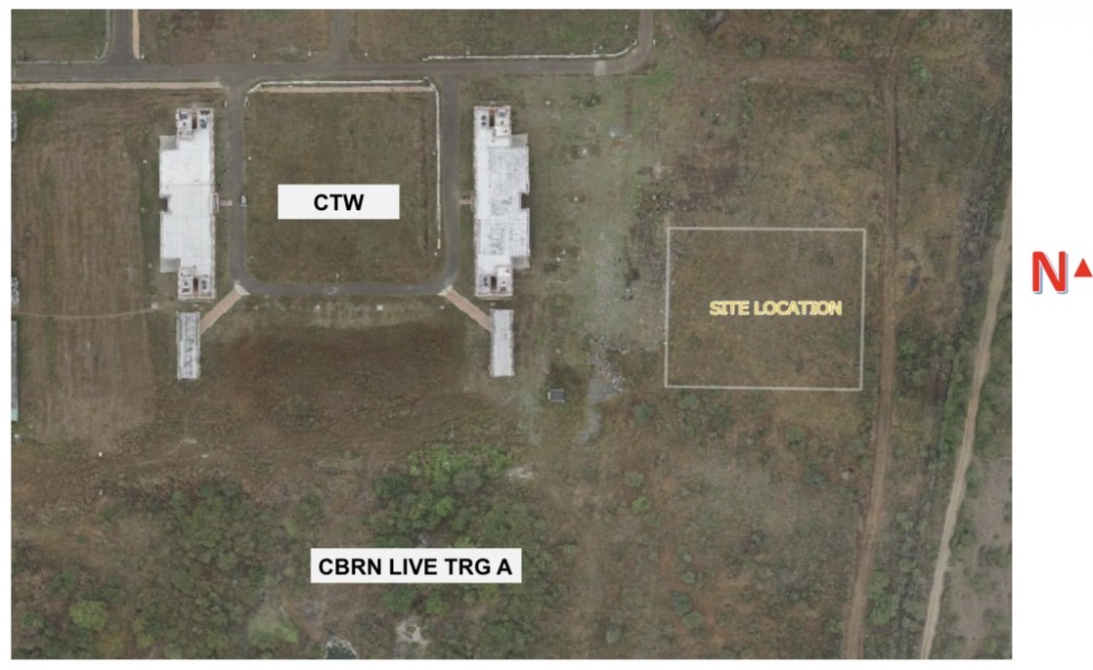
Fig 2.1 : Site location
2.2 Selection criteria. The site was selected after a study of the location, contours, watershed, existing pipelines, elevation profile, wind, rainfall, temperature, seismic zone and soil conditions of the candidate areas. The SWOT analysis on which the selection was made is given in Table 2.1.
Table 2.1 : SWOT analysis of the selected site
Factor | Assessment
Strengths | Proximity to FCBRNP; availability of electric lines; good road connectivity; good water supply; no pipelines crossing the plot
Weakness | Located near the perimeter fence
Opportunities | Training value of a protected facility within the campus
Threats | Interference with the CTW training schedule during construction

2.3 Significance of the site features. Four of the strengths are of direct value to the design. The existing services on the campus are shown in Fig 2.2.
2.3.1 No pipelines. The plot is free of buried services. Every service that crosses the protective envelope is a blast, gas and EMP discontinuity, and a clear plot allows the box to be excavated and tanked without diversions.
2.3.2 Electric supply. Mains supply is available on the campus from substation SS-15, and an existing electric line is available for the peacetime supply to the installation, with the generator and battery providing the protected supply.
2.3.3 Water supply. The campus water supply is fed from an RCC overhead reservoir of 15 000 gallons capacity on 15 m staging, and supplies the installation in peacetime (Chapter 12).
2.3.4 Road connectivity. About 1 000 m³ of rock is to be broken and removed by tipper, and the existing roads provide the haul route.
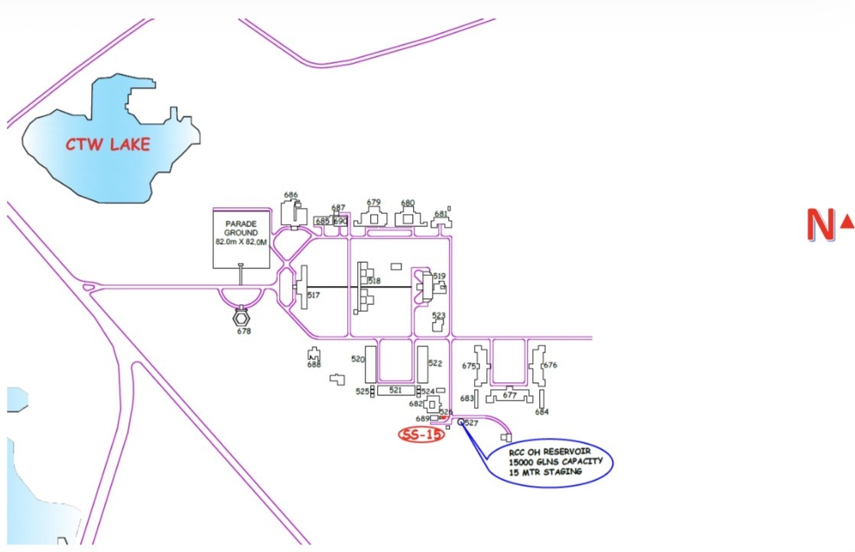
Fig 2.2 : Existing services on the campus
Site reconnaissance
2.4 Site as found. The condition of the plot at the time of the site reconnaissance is shown in Fig 2.3. The following inferences are drawn:-
2.4.1 The plot is covered with scrub and grass, with loose basalt at the surface. There is no structure or large tree on it, and site clearance is limited to clearing and grubbing the scrub and stripping the topsoil (Appendix B).
2.4.2 The loose basalt at the surface agrees with the shallow rock recorded in the trial pits (Table 2.2).
2.4.3 Water stands on the track and in shallow depressions after rain, which shows that the surface drains slowly. The finished grade over the box is accordingly crowned and falls at 1 in 50, and a channel across the entrance of the covered stairwell intercepts surface water (Chapter 3).
2.4.4 An overhead electric line runs along the access track.
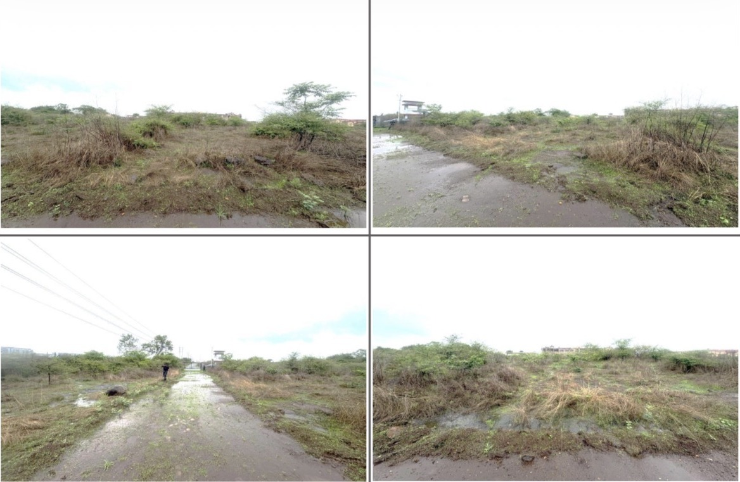
Fig 2.3 : The site as found
2.5 Contours. The contour map of the site and its surroundings, with contours at 1 m interval, is shown in Fig 2.4. The following inferences are drawn:-
2.5.1 The contours run roughly north-south across the plot, and the ground falls gently from the CTW blocks in the west towards the track and the nullah line in the east.
2.5.2 There is no closed contour on the plot, so there is no hollow in which surface water can collect over the structure.
2.5.3 The levels of the project are referred to a site datum, with the finished ground level over the box taken as 0.000. All levels in this report are given to this datum.
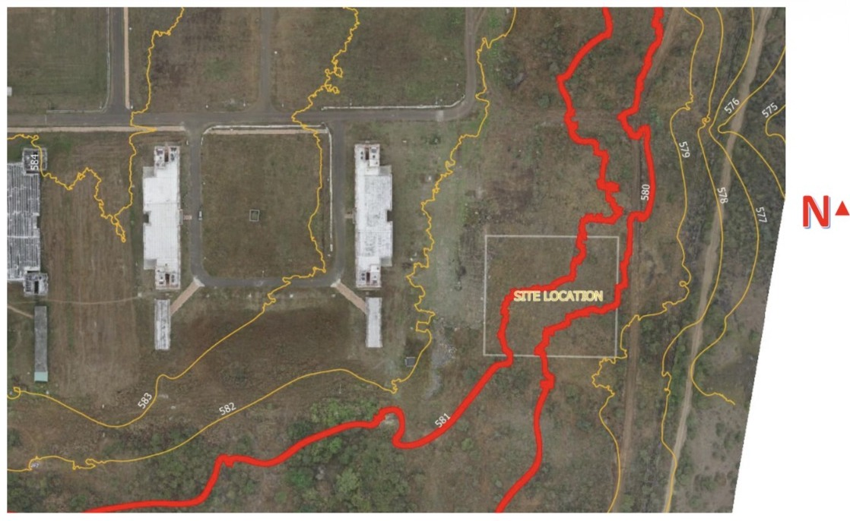
Fig 2.4 : Contour map
2.6 Watershed and surface drainage. The flow accumulation over the site and its surroundings, derived from the terrain, is shown in Fig 2.5. The following inferences are drawn:-
2.6.1 The flow lines over the plot are fine and scattered and all run towards the east. No concentrated drainage line crosses the plot.
2.6.2 The larger flow paths form to the south and south-east of the plot, on the lower ground towards the nullah, which is the natural outfall for surface water from the site.
2.6.3 The structure is therefore not placed in the path of any concentrated surface flow. The surface water to be dealt with is local sheet flow, which runs off the crowned cover and away to the east with the natural fall of the ground.
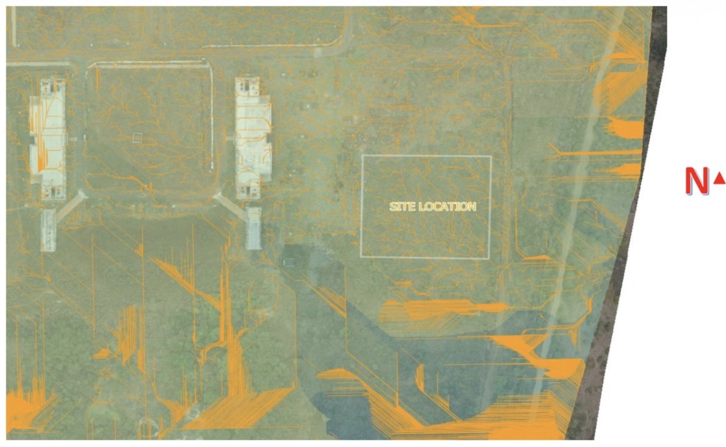
Fig 2.5 : Watershed and surface drainage
Site layout
2.7 Orientation and layout. The underground box is aligned east-west. The covered entry stairwell runs along its north side and descends eastward from ground level to the headhouse (Chapter 3). The project coordinate system has its origin at the south-west external corner of the box at ground level, with X to the east and Y to the north. The finished grade over the box is crowned and falls at 1 in 50 on either side. The site layout is shown in Fig 2.6.
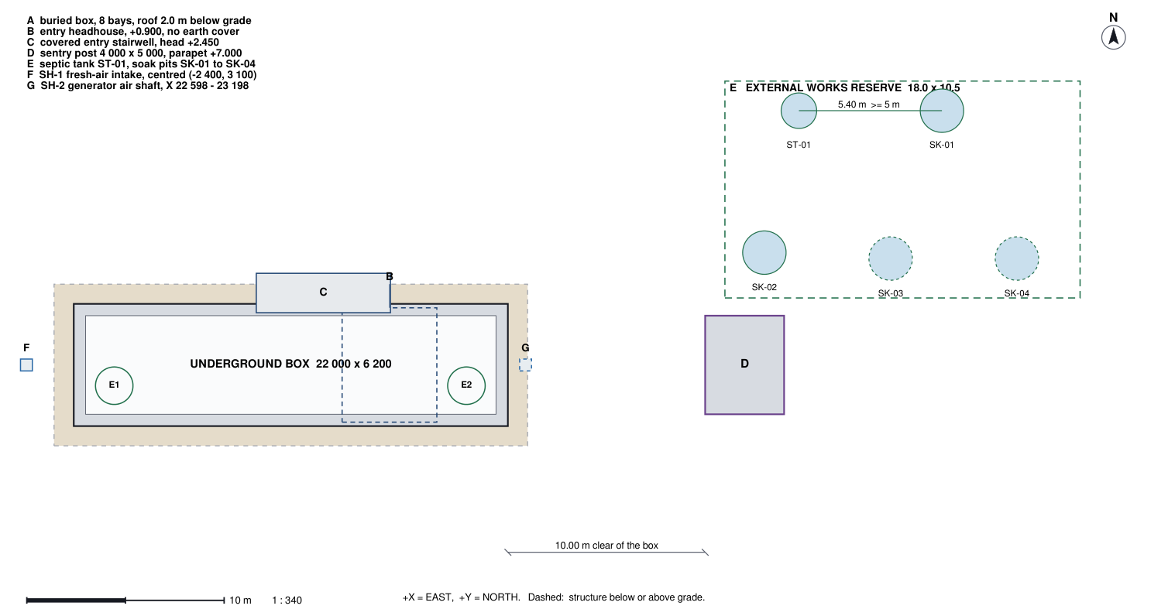
Fig 2.6 : Site layout plan
Sub-soil investigation
2.8 Source of data. The geotechnical data for the site is taken from the sub-soil investigation carried out by the Soil Engineering and Material Testing (SEMT) Wing, CME, Report No SEMT/67/15, Report on Sub-Soil Investigation for CTW Ph-III ACCN Project at CME Pune. Eleven trial pits were excavated by JCB at three locations adjoining the site (G Building, H Building and Mess Building), and soil samples and rock cores were tested in the laboratory. In addition, four confirmatory boreholes with rock coring at the location of the underground structure form the first item of the works (Appendix B) to confirm the founding strata before excavation.
2.9 Geology. The report states that "the area under investigation is underlain by the Deccan Trap formation. These are volcanic lava flows, which were poured out between the late cretaceous and early Eocene times. These basaltic flows are horizontally bedded and more or less uniform in character over a wide area." The founding stratum of the underground structure is therefore sound basalt.
2.10 Strata. The strata recorded in the trial pits are given in Table 2.2. Hard basalt was met at 0.9 m to 1.5 m below ground level at all three locations, overlain by broken rock, murrum and, at two locations, high plasticity clay.
Table 2.2 : Strata recorded in the trial pits
Location | Pits | Depth (m) | Stratum | IS 1498 | SBC (kg/cm²) | SBC (kPa)
G Building | TP-1 to 4 | GL - 1.0 | High plasticity clay | CH | 0.27 | 26.5
 |  | 1.0 - 1.2 | Murrum | GM | 4.27 | 418.7
 |  | 1.2 - 1.5 | Broken rock | - | 10.00 | 980.7
 |  | Below 1.5 | Basalt | - | 20.00 | 1 961.3
H Building | TP-5 to 8 | GL - 0.18 | High plasticity clay | CH | 0.25 | 24.5
 |  | 0.18 - 0.7 | Murrum | GM | 4.66 | 457.0
 |  | 0.7 - 0.9 | Broken rock | - | 10.00 | 980.7
 |  | Below 0.9 | Basalt | - | 21.00 | 2 059.4
Mess Building | TP-9 to 11 | GL - 0.2 | Murrum | SC | 2.07 | 203.0
 |  | 0.2 - 0.5 | Murrum | GP | 5.18 | 508.0
 |  | 0.5 - 1.0 | Broken rock | - | 10.00 | 980.7
 |  | Below 1.0 | Basalt | - | 21.00 | 2 059.4

2.11 Laboratory tests on soil. The soil samples were tested to IS 2720 (Parts IV, VIII, X, XIII and XL). The results are given in Table 2.3. The safe bearing capacities in the report are for a footing 1.2 m wide at 1.5 m depth in the submerged condition, with a factor of safety of 2.5.
Table 2.3 : Laboratory test results on soil samples
Sample | Pit | Depth (m) | IS 1498 | LL % | PL % | PI % | FSI % | OMC % | MDD (g/cc) | c (kg/cm²) | φ (deg) | SBC (kPa)
44/15 | TP-1 | GL-1.0 | CH | 61 | 29 | 32 | 60 | 10 | 1.76 | 0.13 | - | 26.5
45/15 | TP-1 | 1.0-1.2 | GM | - | - | - | - | 9 | 1.93 | 0.00 | 33 | 418.7
61/15 | TP-8 | GL-0.18 | CH | 63 | 30 | 33 | 65 | 12 | 1.78 | 0.12 | - | 24.5
62/15 | TP-8 | 0.18-0.7 | GM | - | - | - | - | 8 | 1.90 | 0.00 | 34 | 457.0
64/15 | TP-9 | GL-0.2 | SC | 30 | 15 | 15 | - | 10 | 1.88 | 0.01 | 27 | 203.0
65/15 | TP-9 | 0.2-0.5 | GP | - | - | - | - | 8 | 1.91 | 0.00 | 35 | 508.0

2.12 Rock core tests. Rock cores were tested for unconfined compressive strength to IS 1121 (Part I), and the safe bearing capacity was obtained as UCS / 25 in accordance with IS 12070. The results are given in Table 2.4. The founding horizon of the underground structure lies below the design groundwater table, so the soaked values govern the design.
Table 2.4 : Rock core test results
Condition | Location | Max load (kg) | Area (cm²) | UCS (kg/cm²) | SBC (kg/cm²) | SBC (kPa)
Unsoaked | G Building, TP-1 | 42 356 | 52.06 | 814 | 33 | 3 236.2
Unsoaked | H Building, TP-8 | 21 924 | 29.15 | 752 | 30 | 2 942.0
Unsoaked | Mess, TP-9 | 57 573 | 63.96 | 900 | 36 | 3 530.4
Soaked | G Building, TP-1 | 24 563 | 48.30 | 509 | 20 | 1 961.3
Soaked | H Building, TP-8 | 14 133 | 27.56 | 513 | 21 | 2 059.4
Soaked | Mess, TP-9 | 27 033 | 51.12 | 529 | 21 | 2 059.4

Surface soil and groundwater
2.13 Black cotton soil. The surface soil at two of the three locations is a high plasticity clay (CH) with a free swell index of 60 to 65 per cent, which places it in the black cotton soil category. No structural element is founded in it. The underground structure bears on basalt at (-)6.800 and the sentry post footings on in-situ basalt at (-)2.000. Under the stepped raft of the covered entry stairwell, whose top is at about (-)0.300, the clay is stripped to 1.0 m below existing ground over the raft area plus 1.0 m beyond every edge and replaced with granular fill of free swell index not more than 20 per cent, compacted in 200 mm layers to at least 95 per cent of MDD.
2.14 Groundwater. The investigation report records that "water table was not encountered in any trial pit. However, water table may raise during/after rainy season." The design groundwater table has therefore been taken at (-)2.000, i.e. 2.0 m below finished ground level, representing the monsoon condition. This is conservative for both the hydrostatic uplift on the mat and the lateral pressure on the walls. At this level the lateral load on the walls below the water table is about two-thirds water pressure and one-third effective earth pressure.
Design parameters
2.15 Adopted ground parameters. The ground parameters adopted for design are given in Table 2.5.
Table 2.5 : Design ground parameters
Parameter | Value | Basis
Founding stratum | Deccan basalt | SEMT/67/15
Rockhead | (-)1.500 to (-)2.000 | Adopted
Safe bearing capacity, hard rock | 3 240 kPa | IS 1904 : 1986, Table 1
Soaked basalt SBC (measured range) | 1 961 to 2 059 kPa | Rock core tests
Bulk unit weight, γ | 20 kN/m³ | Adopted
Saturated unit weight, γ_{sat} | 21 kN/m³ | Adopted
Submerged unit weight, γ′ = 21 - 9.81 | 11.19 kN/m³ | Derived
Coefficient of earth pressure at rest, K₀ = 1 - sin φ | 0.50 (φ = 30°) | Jaky
Design groundwater table | (-)2.000 | Monsoon condition
Modulus of subgrade reaction, k_{s} | 100 000 kN/m³ (upper bound 500 000) | Basalt
Soil transmission factor for blast, K_{a} | 1.0 | IS 4991 Cl. 7.2, saturated ground

2.16 Check on K<sub>0</sub>. The measured angles of internal friction of the granular murrum samples (27° to 35°) give K₀ between 0.43 and 0.55, so the adopted value of 0.50 is representative. The bulk unit weight of 20 kN/m³ is 2 to 5 per cent above the compacted densities measured at MDD, and is conservative for lateral load.
2.17 Bearing capacity. The bearing pressures under the governing cases are compared with the soaked rock capacity in Table 2.6 and Fig 2.7. Even under the full blast load the mat uses about one-fifth of the lowest measured soaked capacity; bearing therefore does not govern any element.
Table 2.6 : Bearing pressure checks
Element and case | Pressure (kPa) | % of 3 240 kPa | % of 1 961 kPa (soaked)
Mat, service | 58.4 | 1.8 | 3.0
Mat, blast | 404.9 | 12.5 | 20.6
Sentry post footing F1, service | 157.6 | 4.9 | 8.0

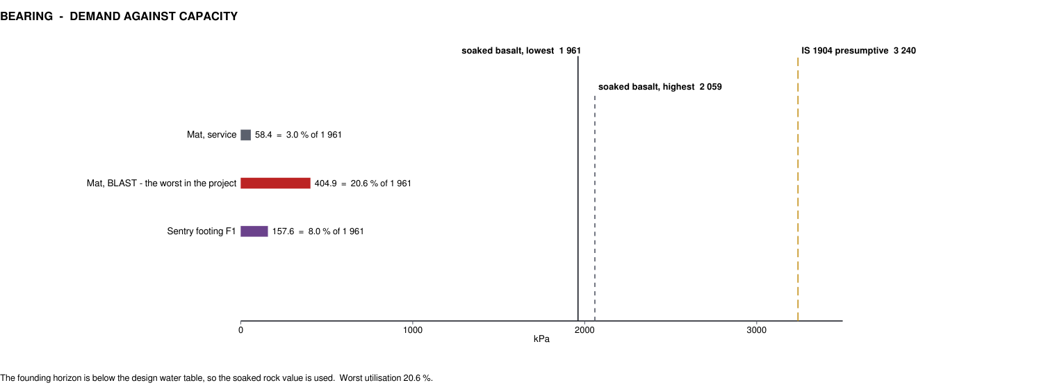
Fig 2.7 : Bearing demand against capacity
2.18 Settlement. The excavation removes more load than the completed structure imposes, as shown below. The foundation is fully compensated and settlement on sound basalt is negligible (IS 12070 Cl. 6).
Overburden removed, 1.13 m of soil at 19.5 kN/m³ | 22.10 kPa
Overburden removed, 5.67 m of basalt at 25.0 kN/m³ | 141.67 kPa
Total pressure removed at formation | 163.77 kPa
Pressure applied by the completed structure in service | 58.40 kPa
Net change of pressure at formation | (-) 105.37 kPa

Excavation
2.19 Excavation profile. The excavation is 6.8 m deep to formation, with 1.0 m working space around the box at formation level. The soil and murrum cap above rockhead is battered at not steeper than 1 : 1 on all four sides, graded back to rockhead, and the face below rockhead is cut vertical in basalt.
2.20 Method. Rock is broken by hydraulic breaker; blasting is not permitted, so that the founding rock and the adjoining campus facilities are not disturbed. The excavation is dewatered continuously from the start of excavation until the backfill and cover are complete.
2.21 Treatment of weak seams. Basalt flows commonly contain red-bole or vesicular layers at flow contacts. Any such seam exposed at formation level is over-excavated and replaced with M15 lean concrete. The mat is designed for the loss of support over a 3.0 m wide band at the worst position (Chapter 7), so that a local seam does not govern the structure.
Meteorological data
2.22 Climate. The monthly averages of wind speed, rainfall and temperature for the site, based on ten years of data, are given in Table 2.7 and Fig 2.8. About 700 mm of the annual rainfall falls between June and October, which has been considered in programming the excavation and the substructure.
Table 2.7 : Meteorological data (monthly averages)
Item | Jan | Feb | Mar | Apr | May | Jun | Jul | Aug | Sep | Oct | Nov | Dec | Year
Wind (km/h) | 1.4 | 2.1 | 2.5 | 3.6 | 6.2 | 6.6 | 5.7 | 5.2 | 3.3 | 1.6 | 1.4 | 1.2 | 3.4
Rain (mm) | 0.1 | 3.0 | 5.5 | 3.9 | 19.0 | 137.8 | 166.2 | 120.8 | 134.9 | 139.8 | 22.7 | 5.9 | 759.6
Max (°C) | 29.8 | 32.4 | 35.5 | 38.3 | 37.8 | 32.1 | 28.5 | 28.2 | 29.7 | 31.6 | 30.9 | 29.6 | 38.3
Avg (°C) | 20.7 | 23.2 | 26.0 | 29.3 | 30.6 | 27.6 | 25.4 | 24.8 | 25.4 | 25.6 | 23.1 | 21.7 | 25.3
Min (°C) | 11.6 | 13.7 | 16.7 | 20.2 | 23.1 | 23.1 | 22.3 | 21.6 | 21.1 | 19.7 | 15.2 | 13.5 | 11.6

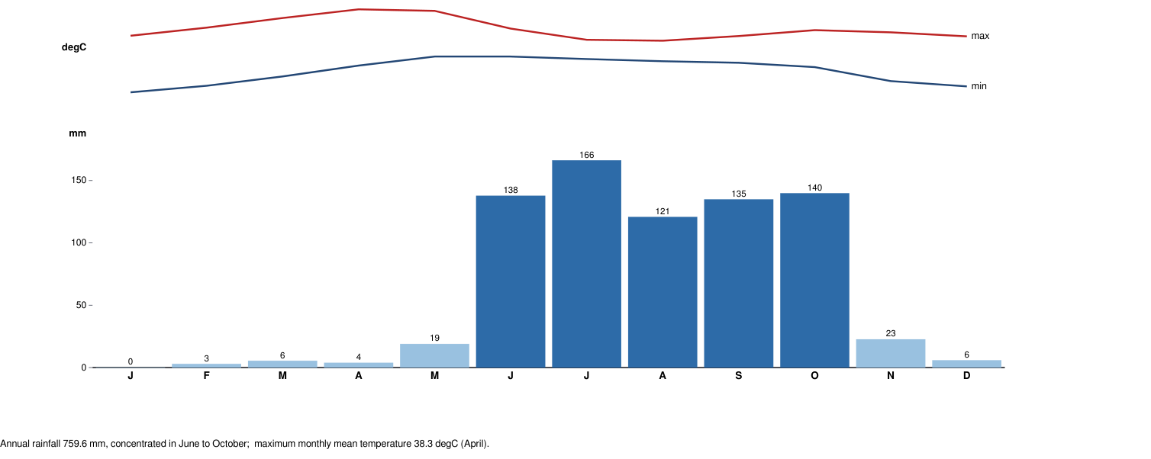
Fig 2.8 : Monthly rainfall and temperature at the site
2.23 Design wind and seismic data. The design wind speed for Pune is 39 m/s (IS 875 Part 3, Annex A) and the site lies in seismic Zone III (IS 1893 Part 1, Z = 0.16). Both are used only for the sentry post, since the buried structure is governed by blast.
CHAPTER 3
PLANNING AND ARCHITECTURAL LAYOUT
(UNDERGROUND STRUCTURE, HEADHOUSE, ENTRY AND SENTRY POST)
Planning concept
3.1 Protective boundary. The planning of the installation is governed by the protective boundary, which is the continuous surface that excludes blast, contaminated air and radiation. The boundary is formed by Blast Doors 1 and 2 at level (-)6.100, walls W6 and W7 in which they are set, the perimeter walls, the mat foundation and the pressure (roof) slab. The stair shaft, the headhouse and the covered entry stairwell lie outside the boundary. The stair shaft is open to the atmosphere through the stair void and fills with blast pressure; walls W6 and W7 and both blast doors are therefore designed for the full blast pressure.
3.2 Gas-tight envelope. Within the protective boundary, bays 1 to 6 form the gas-tight envelope, which is held at a positive pressure by the filtration plant. Its floor area is 67.80 m² and its volume 216.96 m³. Bay 7 (stair shaft) and bay 8 (generator) are outside the gas-tight envelope; bay 8 is a grey zone, separately ventilated for the generator.
3.3 Planning principles. The following principles have been followed in the layout:-
3.3.1 Width fixed, length free. The roof spans one way across the 5.0 m internal width (Chapter 7), so its moment depends only on the width. Additional accommodation is therefore obtained by lengthening the box, never by widening it.
3.3.2 Minimum penetrations. Every opening in the boundary is a blast, gas and EMP discontinuity. All services enter through one service entry plate, the air enters and leaves through blast valves only, and nothing penetrates the buried roof.
3.3.3 No movement joints. No movement joint is provided anywhere within the protective envelope. Construction joints are made with continuous reinforcement, two waterstops and a welded EMP bonding strap.
3.3.4 Clean to dirty. The bays are arranged so that air, people and water move from the clean end (west) towards the dirty end (east), through the decontamination airlock to the stair shaft.
Underground structure
3.4 Coordinate system and levels. All dimensions are in millimetres and all levels in metres relative to finished site grade 0.000, negative downwards. The origin is at the south-west external corner of the box. The level schedule is given in Table 3.1.
Table 3.1 : Level schedule
Level | Value | Description
Finished site grade | 0.000 | Crowned, falling 1 in 50 away from the box
Top of pressure slab | (-)2.000 | Headhouse floor level
Roof soffit | (-)2.900 | 900 mm pressure slab
Internal floor, top of mat | (-)6.100 | 3 200 mm clear height
Underside of mat | (-)6.700 | 600 mm mat
Formation, underside of PCC | (-)6.800 | 100 mm M15 blinding
Design groundwater table | (-)2.000 | Monsoon condition
Stair landing L1 | (-)4.733 | 8 risers above the floor
Stair landing L2 | (-)3.367 | 16 risers above the floor
Headhouse roof soffit / top | +0.400 / +0.900 | 2 400 mm clear inside
Entry stairwell roof at head | +2.450 | Soffit +2.200
Sentry post floors | +0.450 / +3.650 / +6.700 | Ground, first floor, roof
Sentry post parapet top | +7.000 | -
Sump pit invert / base | (-)7.600 / (-)8.000 | Clean sump SU-01, bay 5

3.5 Main dimensions. The main dimensions of the underground box are given in Table 3.2 and the plan, longitudinal section and cross section in Figs 3.1 to 3.3.
Table 3.2 : Main dimensions of the underground box
Item | Value
External length x width | 22 000 x 6 200 mm
Internal length x width | 20 800 x 5 000 mm
Perimeter walls W1 to W4 | 600 mm
Pressure (roof) slab | 900 mm
Mat foundation | 600 mm on 100 mm M15 blinding
Internal clear height | 3 200 mm
Engineered cover over the roof | 2 000 mm in six layers

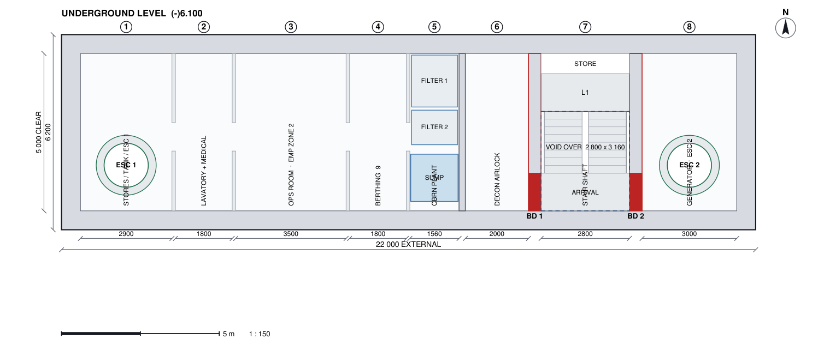
Fig 3.1 : Underground level plan at (-)6.100
3.6 Bay schedule. The box is divided into eight bays, as given in Table 3.3.
Table 3.3 : Bay schedule
Bay | X range (mm) | Clear width | Use
1 | 600 - 3500 | 2900 | Emergency stores, 1 000 L potable water tank, escape shaft ESC 1
2 | 3610 - 5410 | 1800 | Lavatory (1800 x 2000) and medical room (1800 x 3000)
3 | 5520 - 9020 | 3500 | Operations room and hazard plotting; EMP Zone 2 enclosure
4 | 9130 - 10930 | 1800 | Berthing, three 3-tier bunks, 9 berths
5 | 11040 - 12600 | 1560 | CBRN plant: two 300 m³/h NBC filter trains, CO₂ scrubber and O₂ store, dehumidifier, clean sump
6 | 12800 - 14800 | 2000 | Decontamination airlock, three stages (2000 x 2000, 2000 x 1500, 2000 x 1500)
7 | 15200 - 18000 | 2800 | Stair shaft (main staircase)
8 | 18400 - 21400 | 3000 | 15 kVA generator (grey zone), escape shaft ESC 2

3.7 Internal walls. The internal walls are given in Table 3.4.
Table 3.4 : Internal walls
Mark | X range (mm) | Thickness | Function
W8 (4 No.) | 3500-3610, 5410-5520, 9020-9130, 10930-11040 | 110 | Non-structural partitions, each with a 900 mm opening at Y 2500 - 3400
W5 | 12600 - 12800 | 200 | Fire and gas-tight wall between the plant room and the airlock, with gas-tight door D-05
W6 | 14800 - 15200 | 400 | Protective boundary, bay 6 / 7; Blast Door 1 at Y 600 - 1800
W7 | 18000 - 18400 | 400 | Protective boundary, bay 7 / 8; Blast Door 2 at Y 600 - 1800

3.8 Walls W6 and W7. W6 and W7 separate the stair shaft, which fills with blast pressure, from bays 6 and 8. They are part of the protective boundary and are 400 mm thick, compared with 110 mm and 200 mm for the other internal walls. The additional 400 mm this needs has been taken in the length of the box, since the stair shaft width (two 1 200 mm flights and a 200 mm well) and the bay 8 width (set by the escape shaft clearance) cannot be reduced.
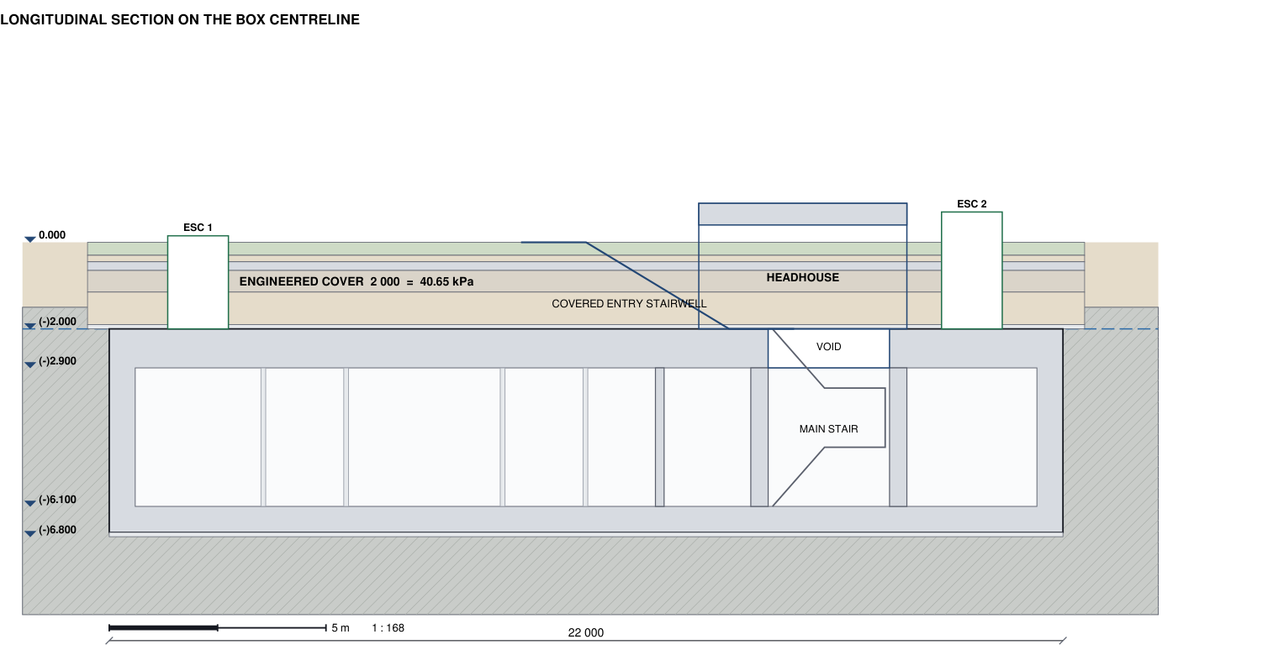
Fig 3.2 : Longitudinal section on the box centreline
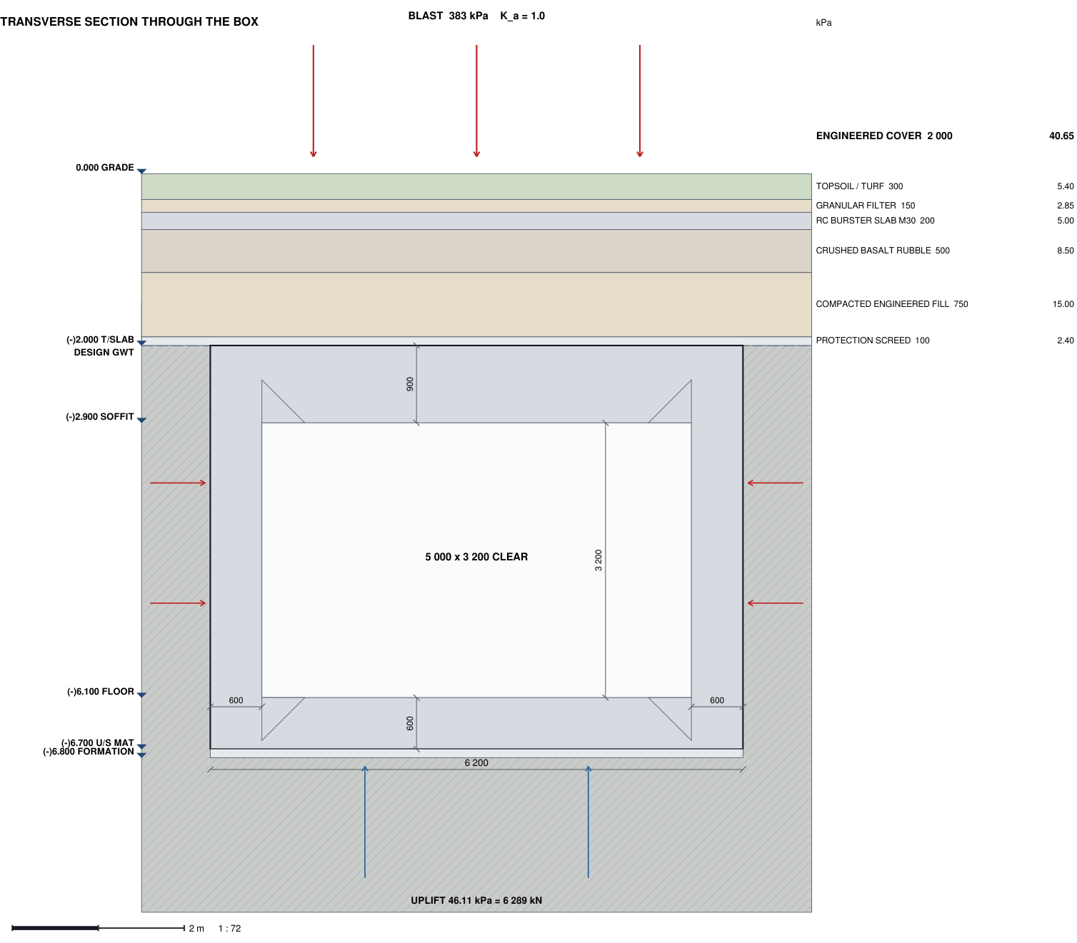
Fig 3.3 : Transverse section through the box
Access and egress
3.9 Routes. The access and escape routes are as under:-
3.9.1 Primary. From ground level through the entry door and the covered entry stairwell (12 risers of 166.67 mm, going 300 mm) to the platform at (-)2.000, through the inner security door into the headhouse, down the main staircase (24 risers in three flights of eight) to the arrival landing at (-)6.100, and through Blast Door 1 (1 200 x 2 100, 7 bar) into the decontamination airlock in bay 6.
3.9.2 Secondary. Through Blast Door 2 (1 200 x 2 100) from the stair shaft into bay 8.
3.9.3 Emergency. Two 1 400 mm diameter vertical escape shafts, ESC 1 in bay 1 and ESC 2 in bay 8, each in a 250 mm reinforced concrete collar and fitted with a ladder and a hatch at the head.
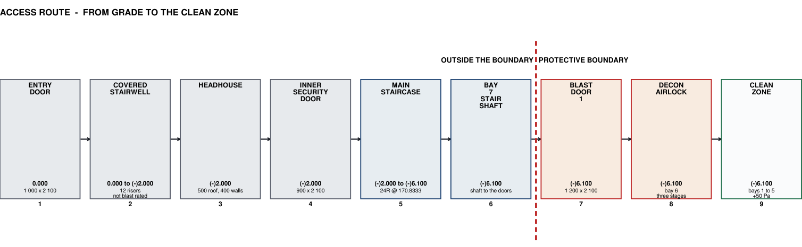
Fig 3.4 : Access route from grade to the clean zone
3.10 Main staircase. The main staircase in bay 7 is a dog-leg stair of three flights. Its geometry and the checks against NBC 2016 Part 4 are given in Table 3.5, and the developed section in Fig 3.5.
Table 3.5 : Main staircase geometry
Item | Provided | Limit | Check
Riser | 170.833 mm | 190 mm max | OK
Tread (going) | 280 mm | 250 mm min | OK
Flight width | 1 200 mm | 1 000 mm min | OK, stretcher width
Risers per flight | 8 | 12 max | OK
Headroom | 2 533 mm | 2 200 mm min | OK
Total rise | 24 x 170.833 = 4 100 mm | (-)6.100 to (-)2.000 | Closes exactly
2R + T | 621.7 mm | 550 to 700 mm | OK

3.11 Stair shaft layout. The stair shaft is 2 800 x 5 000 mm clear (X 15200 - 18000, Y 600 - 5600). Flights 1 and 3 are stacked in the 1 200 mm lane at X 15300 - 16500, flight 2 is in the lane at X 16700 - 17900, with a 200 mm well between them. Landing L1 at (-)4.733 is at the north end and landing L2 at (-)3.367 at the south end, over the arrival landing, which is the mat surface. A store is formed under landing L1. The pressure slab over the shaft has a 2 800 x 3 160 mm void, leaving a 1 840 mm cantilever pad at the north end.
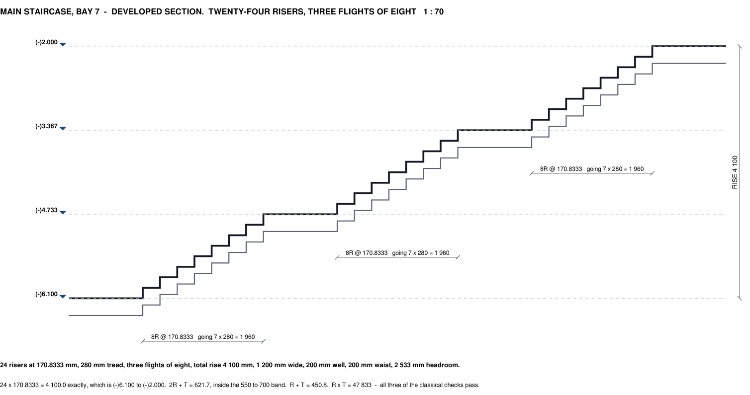
Fig 3.5 : Main staircase, developed section
3.12 Escape shafts. The escape shafts are detailed in Table 3.6. Each opening edge is kept at least 750 mm from the face of the nearest structural wall, made up of the 250 mm collar, a trimmer band of about 400 mm and a tolerance of 100 mm. A bay must therefore be at least 1 400 + 2 x 750 = 2 900 mm wide to hold an escape shaft, which fixes the widths of bays 1 and 8.
Table 3.6 : Escape shafts
Item | ESC 1 | ESC 2
Location | Bay 1, centre (2050, 2050) | Bay 8, centre (19900, 2050)
Clear opening | 1 400 mm diameter | 1 400 mm diameter
Collar | 250 mm RC, OD 1 900 | 250 mm RC, OD 1 900
Clearance to wall face | 750 mm all round | 800 mm
Head level | +0.150 | +0.700
Climb from (-)6.100 | 6.250 m | 6.800 m
Escape route | R2 | R3

Headhouse and covered entry stairwell
3.13 Entry headhouse. The headhouse is a reinforced concrete room standing on the pressure slab over the stair shaft, as under:-
3.13.1 Dimensions. External 4 800 x 5 800 mm (X 13600 - 18400, Y 200 - 6000); internal 4 000 x 5 000 mm; clear height 2 400 mm.
3.13.2 Construction. Walls HW1 (south), HW2 (north), HW3 (west) and HW4 (east) are 400 mm thick; the roof is 500 mm thick with its soffit at +0.400 and top at +0.900, without earth cover. The floor is the top of the pressure slab at (-)2.000. The berm is graded against all four walls to +0.900 at 1.5 : 1.
3.13.3 Opening. The inner security door, 900 x 2 100 mm, is in HW2 at X 14450 - 15350. It is a security door and is not blast rated.
3.13.4 Support. HW1 and HW2 stand directly over the box perimeter walls and HW4 over wall W7. HW3 stands on the pressure slab over bay 6 and is designed as a line load on the slab (Chapter 8).
3.14 Covered entry stairwell. The covered entry stairwell leads from ground level to the headhouse platform, as under:-
3.14.1 Dimensions. External 6 800 x 2 000 mm (X 9250 - 16050, Y 5750 - 7750); internal 6 300 x 1 500 mm.
3.14.2 Construction. 250 mm RC side walls, headwall and east wall; top landing at 0.000 (X 9500 - 11000); flight of 12 risers of 166.67 mm with 11 goings of 300 mm (X 11000 - 14300), waist 250 mm; platform 1 500 x 1 500 mm at (-)2.000 (X 14300 - 15800); raking roof 250 mm with soffit 2 200 mm above the flight, remaining 250 mm over the platform.
3.14.3 Entry. The entry door, 1 000 x 2 100 mm, is at grade in the headwall and opens outward. A 300 mm channel with grating across the full 1 500 mm width at the threshold intercepts surface water.
3.14.4 Foundation. The stairwell stands on a stepped RC raft 300 mm thick on compacted granular fill, with a movement joint where it meets the headhouse. A 1.0 m³ external sump at the platform drains to its own soakaway. The berm is graded against the walls at 1.5 : 1 to +0.900.
3.15 Function. The covered stairwell and the headhouse provide a weather-proof and secure approach to the stair shaft. Both are outside the protective boundary. The headhouse roof and walls are designed for the full blast pressure; the covered stairwell is designed for static loads only and is not blast rated.
Sentry post
3.16 Description. The sentry post is a two-storey reinforced concrete framed building, as under:-
3.16.1 Plan. External 4 000 x 5 000 mm, internal 3 600 x 4 600 mm. Column grid A - B at 3 650 mm centres (X) and 1 - 2 at 4 650 mm centres (Y).
3.16.2 Frame. Four columns C1, 350 x 350 mm; beams B1 (250 x 450) spanning A - B on grids 1 and 2, and B2 (250 x 450) spanning 1 - 2 on grids A and B; two-way slab S1, 150 mm thick, at both floors; plinth beam PB 250 x 400 at +0.450.
3.16.3 Foundations. Four isolated footings F1, 1 500 x 1 500 x 600 mm, on in-situ basalt at (-)2.000.
3.16.4 Storeys. Ground storey +0.450 to +3.650 (3 200 mm); first storey +3.650 to +6.700 (3 050 mm); parapet top +7.000.
3.16.5 Walls. The ground storey infill is 190 mm one-brick modular brickwork to IS 1077 in CM 1 : 6, built within the 200 mm structural zone between the columns. The first storey carries armoured vision panels 1 200 mm wide. Access to the first floor is by an external spiral stair of 1 000 mm radius around a 250 mm diameter central pole. The door D1 is 900 mm wide.
3.17 Siting. The sentry post is sited east of the underground structure at X 32000 - 36000, Y 600 - 5600, 10 m clear of the box, so that its footings are on undisturbed rock and not on the backfill of the shelter excavation.
Openings in the protective boundary
3.18 Door and opening schedule. Every door and opening in and around the protective boundary is listed in Table 3.7.
Table 3.7 : Door and opening schedule
Mark | Location | Size | Level | Rating
BD 1 | Wall W6, stair shaft to bay 6 | 1 200 x 2 100 | (-)6.100 | 7 bar, gas-tight, rebound rated
BD 2 | Wall W7, stair shaft to bay 8 | 1 200 x 2 100 | (-)6.100 | 7 bar, gas-tight, rebound rated
D-05 | Wall W5, clean-side exit from the airlock | Single leaf | (-)6.100 | Gas-tight and fire-rated
D1 (HH) | Headhouse wall HW2 | 900 x 2 100 | (-)2.000 | Security door
Entry | Stairwell headwall, opens outward | 1 000 x 2 100 | 0.000 | Weather and security door
W8 gaps | Four partitions | 900 x 2 100 | (-)6.100 | Open, no door
ESC 1 / 2 | Pressure slab, bays 1 and 8 | 1 400 dia | +0.150 / +0.700 | Blast hatch, 383 kPa
Stair void | Pressure slab, bay 7 | 2 800 x 3 160 | (-)2.000 | Guarded, 1 100 mm railing
BV-1 to BV-5 | W1 bay 1 (2), W6 (1), east wall bay 8 (2) | DN100 (3), DN350 (2) | Various | Blast valves
SEP | Service entry plate, north wall | 800 wide | - | Welded steel plate

Radiation shielding
3.19 Engineered cover. The roof of the box is covered by 2.0 m of engineered cover in six layers (Chapter 5). Since a buried roof receives the full blast overpressure (K_{a} = 1.0), the cover is not provided for blast; it is provided for protection against nuclear radiation, as under:-
3.19.1 Fallout. The first metre of cover gives a protection factor of about 2 200 against fallout, against a requirement of the order of 1 000.
3.19.2 Initial radiation. The second metre provides the mass needed to attenuate the initial neutron and gamma radiation. Attenuation is exponential in the areal density of the shield, and the moisture in the fill and the bound water in the concrete are effective in slowing neutrons.
3.19.3 Burster slab. A 200 mm M30 reinforced concrete burster slab (T12 at 150 mm both ways) within the cover breaks up a penetrating item so that its energy is dispersed in the 500 mm layer of crushed basalt rubble below it instead of being delivered to the roof as a concentrated load.
CHAPTER 4
DESIGN BASIS AND MATERIALS
(CODES, DESIGN PHILOSOPHY, MATERIALS AND CONCRETE MIX DESIGN)
Codes and standards
4.1 Codes followed. The design has been carried out in accordance with the codes and references listed in Table 4.1.
Table 4.1 : Codes and standards
Code / reference | Used for
IS 456 : 2000 | Design of all reinforced concrete elements, limit state method
IS 4991 : 1968 | Blast loading on buried elements, soil transmission factor, dynamic load factor and dynamic material strengths
IS 875 (Parts 1, 2, 3, 5) | Dead, imposed and wind loads; load combinations
IS 1893 (Part 1) : 2016 | Seismic loads
IS 13920 : 2016 | Ductile detailing of the sentry post frame
IS 3370 (Parts 1 and 2) : 2021 | Crack width and surface-zone steel for water-retaining faces
IS 1786 : 2008 | Fe500D reinforcement
IS 10262 : 2019 / IS 383 : 2016 / IS 269 : 2015 | Concrete mix proportioning, aggregates and cement
IS 1904, IS 12070, IS 2950 (Part 1) | Foundations on rock and raft foundations
IS 1498, IS 2720, IS 1121 | Soil classification, soil testing and rock testing
IS 2470 (Parts 1 and 2) : 1985 | Septic tank and soak pit
IS 1077, IS 2645 | Burnt clay bricks; integral waterproofing admixture
IS 732, IS 3043, IS 694, IS 1554 | Electrical installation, earthing and cables
SP 16 : 1980, SP 34 : 1987, BS 8666 | Design aids, detailing and bar shape codes
NBC 2016 Part 4 | Stairs, guarding and means of escape
UFC 3-340-02 | Direct shear and trimming of openings in blast-resistant slabs
MIL-STD-188-125-1 / IEEE Std 299 | EMP protection requirement and shielding effectiveness testing
FEMA 453 / EN 1822 | Shelter ventilation rate; HEPA filter classification
Glasstone and Dolan, The Effects of Nuclear Weapons; Biggs, Introduction to Structural Dynamics | Blast and radiation data; single degree of freedom response

4.2 Order of precedence. Where two project documents differed, the following order of precedence was applied: the latest general arrangement drawings over earlier reports; arithmetic over a transcribed figure; the analysis input file over a picture of it; and a value confirmed by several independent sources over a single differing figure.
Design philosophy
4.3 Limit state design. All elements have been designed by the limit state method of IS 456 : 2000. The blast case is treated as an equivalent static load obtained from the dynamic load factor (Chapter 5), which is valid because the response of the structure to the long-duration nuclear blast pulse is quasi-static.
4.4 Blast case. For the blast combination the following provisions of IS 4991 have been applied, with all section capacities computed to IS 456:-
4.4.1 Load factor. The blast load is applied with a load factor of 1.0, since it is an extreme event checked against ultimate capacity with dynamic material strengths.
4.4.2 Dynamic strength. The characteristic strengths of concrete and steel are increased by 25 per cent for flexure (IS 4991 Cl. 10.3.1): f_{ck,dyn} = 43.75 N/mm² for M35 and f_{y,dyn} = 625 N/mm² for Fe500D.
4.4.3 Shear. No dynamic increase is taken on shear (IS 4991 Cl. 10.3.1.1). Every τ_{c} is taken at the static M35 value.
4.4.4 Bond. The 25 per cent increase in bond permitted for the blast case is not taken; all development and lap lengths are the static values.
4.4.5 Ductility. A ductility ratio μ = 5 (moderate, repairable damage) is adopted. The sections are kept under-reinforced (x_{u}/d well below 0.46) and every blast-governed element carries designed shear links, so that the ductile flexural mode governs.
4.5 Other cases. The static, uplift, serviceability and construction cases are designed with the partial safety factors of IS 456 Table 18, and the sentry post to IS 456 and IS 13920 with the seismic combinations of IS 1893.
Materials
4.6 Concrete and steel. The materials adopted are given in Table 4.2.
Table 4.2 : Materials
Item | Shelter, stairs, headhouse | Sentry post | Reference
Concrete grade | M35 | M30 | IS 456 Table 5
Maximum free w/c ratio | 0.45 | 0.45 | IS 456 Table 5
Minimum cement content | 340 kg/m³ | 320 kg/m³ | IS 456 Table 5
Admixture | Integral crystalline waterproofing + superplasticiser | Superplasticiser | IS 2645
Blinding | M15, 100 mm | M15 | -
Burster slab (in the cover) | M30, 200 mm | - | -
Reinforcement | Fe500D | Fe500 | IS 1786
E_{c} = 5000 √f_{ck} | 29 580 N/mm² | 27 386 N/mm² | IS 456 Cl. 6.2.3.1
Poisson's ratio | 0.20 | 0.20 | -
Unit weight of RC | 25 kN/m³ | 25 kN/m³ | IS 875 (Part 1)
γ_{m}, concrete / steel | 1.5 / 1.15 | 1.5 / 1.15 | IS 456 Cl. 36.4.2

4.7 Choice of grade. M35 is the minimum grade for the very severe exposure condition (IS 456 Table 3 and 5), which applies because the structure stands permanently below the design groundwater table. Fe500D is used for the shelter because the D grade guarantees the minimum elongation on which the ductility ratio of 5 depends.
4.8 Cover. The clear cover adopted is given in Table 4.3. The 5 mm reduction permitted by IS 456 Table 16 for M35 and above has not been taken.
Table 4.3 : Clear cover to reinforcement
Face | Cover
Cast against blinding or trimmed rock | 75 mm
Formed face against earth | 50 mm
Internal faces | 40 mm
Stair shaft faces | 30 mm
Sentry post beams and slabs | 30 mm
Sentry post columns | 40 mm
Footings cast against earth | 50 mm
Maximum bar spacing, both curtains | 150 mm (EMP requirement)

4.9 Bar spacing. The spacing of the main bars in both curtains of every element of the box is limited to 150 mm each way. This is closer than IS 456 Cl. 26.3.3 requires and has been adopted so that the reinforcement cage gives useful low-frequency EMP shielding (Chapter 11).
4.10 Development and lap lengths. Development lengths have been worked out to IS 456 Cl. 26.2.1 as under.
L_{d} = φ σ_{s} / (4 τ_{bd}), with σ_{s} = 0.87 f_{y} = 435 N/mm²
τ_{bd} for deformed bars in tension: M35 = 1.7 x 1.6 = 2.72 N/mm²; M30 = 1.5 x 1.6 = 2.40 N/mm²
L_{d} in tension, M35 = 435 / (4 x 2.72) = 40 φ | 40 φ
L_{d} in tension, M30 = 435 / (4 x 2.40) = 46 φ | 46 φ

Table 4.4 : Development and lap lengths (mm)
Bar | L_{d} M35 (40 φ) | Lap M35 (50 φ) | L_{d} M30 (46 φ) | L_{d} comp. M30
T8 | 320 | 400 | 368 | 296
T10 | 400 | 500 | 460 | 370
T12 | 480 | 600 | 552 | 444
T16 | 640 | 800 | 736 | 592
T20 | 800 | 1000 | 920 | 740
T25 | 1000 | 1250 | 1150 | 925

4.11 Lap policy. IS 456 Cl. 26.2.5.1 gives a lap length of L_{d} or 30 φ, whichever is greater, i.e. 40 φ. All laps are staggered so that not more than 50 per cent of the bars are lapped at any section, and the lap is specified as 50 φ.
Waterproofing
4.12 Tanked structure. The underground structure is a tanked box and is never drained to relieve groundwater pressure. The waterproofing system is given in Table 4.5.
Table 4.5 : Waterproofing system
Element | Specification
Membrane | Continuous tanking membrane on the blinding, turned up the external face of the walls and lapped to the roof membrane
Admixture | Integral crystalline waterproofing admixture in all M35 concrete
Roof protection | 100 mm protection screed over the roof membrane
Construction joints | At about 6 m centres; reinforcement fully continuous; two waterstops; welded copper or galvanised EMP bonding strap
Movement joints | None within the protective envelope
Floor falls | Formed in the floor screed, never cut into the mat
Pipe crossings | Puddle flange welded to the sleeve; membrane dressed and clamped to it

Concrete mix design
4.13 Method. The concrete mixes have been proportioned by the method of IS 10262 : 2019 (Annex A) for M35 (shelter, stairs and headhouse) and M30 (sentry post and burster slab). The pressure slab is cast in a single continuous pour of 112 m³ into a congested cage (T25 at 150 mm in both curtains with four-legged links), and the M35 mix is therefore designed for pumping at 100 mm slump.
4.14 Stipulations. The stipulations for proportioning are given in Table 4.6.
Table 4.6 : Stipulations for proportioning
Item | M35 | M30
Type of cement | OPC 43 grade, IS 269 | OPC 43 grade, IS 269
Maximum nominal size of aggregate | 20 mm | 20 mm
Minimum / maximum cement content | 340 / 450 kg/m³ | 320 / 450 kg/m³
Maximum free w/c ratio | 0.45 | 0.45
Workability | 100 mm slump | 75 mm slump
Exposure condition | Very severe | Severe
Method of placing | Pumped | Conventional
Type of aggregate | Crushed angular basalt | Crushed angular basalt
Fine aggregate | Zone II, IS 383 | Zone II, IS 383
Chemical admixture | Superplasticiser + crystalline waterproofing | Superplasticiser

4.15 Test data for materials. Specific gravity of cement 3.15, coarse aggregate (basalt) 2.84, fine aggregate 2.65 and admixture 1.145. Standard deviation s = 5.0 N/mm² (IS 10262 Table 2). Entrapped air 1.0 per cent for 20 mm aggregate (Table 3).
4.16 Target mean strength. The target mean strength is the greater of f_{ck} + 1.65 s and f_{ck} + X (IS 10262 Cl. 5.2).
M35: 35 + 1.65 x 5.0 = 43.25; 35 + 6.5 = 41.50 | f′_{ck} = 43.25 N/mm²
M30: 30 + 1.65 x 5.0 = 38.25; 30 + 6.5 = 36.50 | f′_{ck} = 38.25 N/mm²

4.17 Water/cement ratio. The free w/c ratio has been taken as 0.40 for M35 and 0.44 for M30, within the limit of 0.45. The lower value for M35 is adopted because the structure is permanently below the water table and its external face can never be inspected; a dense, low-permeability matrix is also required for the crystalline waterproofing admixture to be effective.
4.18 Water content. IS 10262 Table 4 gives 186 kg/m³ for 20 mm aggregate at 50 mm slump, increased by 3 per cent for every 25 mm of additional slump.
M35: 186 x 1.06 (100 mm slump) = 197.16; less 20 % for superplasticiser = 157.7 | 158 kg/m³
M30: 186 x 1.03 (75 mm slump) = 191.58; less 18 % for superplasticiser = 157.1 | 157 kg/m³

4.19 Cement content. The cement content follows from the water content and the w/c ratio.
M35: 158 / 0.40 = 395.0, adopted 400 kg/m³; free w/c = 158 / 400 = 0.395 | 400 kg/m³
M30: 157 / 0.44 = 356.8, adopted 360 kg/m³; free w/c = 157 / 360 = 0.436 | 360 kg/m³
Check: 400 and 360 lie between the minimum (340 / 320) and the maximum (450) | OK

4.20 Proportion of coarse aggregate. IS 10262 Table 5 gives 0.62 for 20 mm aggregate with zone II sand at w/c 0.50, corrected by 0.01 for every 0.05 change in w/c. For the pumped M35 the value is reduced by 10 per cent (Cl. 5.5.1).
M35: 0.62 + 0.01 x (0.50 - 0.395) / 0.05 = 0.641; x 0.90 = 0.577 | CA 0.577, FA 0.423
M30: 0.62 + 0.01 x (0.50 - 0.436) / 0.05 = 0.633 | CA 0.633, FA 0.367

4.21 Mix calculations. The quantities per cubic metre are obtained by the absolute volume method.
M35
Volume of cement = 400 / (3.15 x 1000) | 0.12698 m³
Volume of water = 158 / 1000 | 0.15800 m³
Volume of admixture (1.0 % of cement) = 4.00 / (1.145 x 1000) | 0.00349 m³
Volume of entrapped air | 0.01000 m³
Volume of all-in aggregate = 1 - 0.29847 | 0.70153 m³
Mass of coarse aggregate = 0.70153 x 0.577 x 2.84 x 1000 | 1 149.6 kg
Mass of fine aggregate = 0.70153 x 0.423 x 2.65 x 1000 | 786.4 kg
M30
Volume of cement = 360 / 3150 = 0.11429; water 0.15700; admixture (0.8 %) 0.00252; air 0.01000 | 0.28380 m³
Volume of all-in aggregate = 1 - 0.28380 | 0.71620 m³
Mass of coarse aggregate = 0.71620 x 0.633 x 2.84 x 1000 | 1 287.5 kg
Mass of fine aggregate = 0.71620 x 0.367 x 2.65 x 1000 | 696.5 kg

4.22 Mix proportions. The mix proportions are given in Table 4.7. The M35 and M30 cement contents of 400 and 360 kg/m³ are those used in the quantity take-off of the bill of quantities.
Table 4.7 : Mix proportions per cubic metre
Material | M35 | M30
Cement, OPC 43 | 400 kg | 360 kg
Water | 158 litres | 157 litres
Fine aggregate, zone II | 786.4 kg | 696.5 kg
Coarse aggregate, 20 mm graded (60 : 40 of 20 mm and 10 mm) | 1 149.6 kg | 1 287.5 kg
Superplasticiser | 4.00 kg | 2.88 kg
Free w/c ratio | 0.395 | 0.436
Mix by mass (C : FA : CA) | 1 : 1.966 : 2.874 | 1 : 1.935 : 3.576
Fresh density | 2 498 kg/m³ | 2 504 kg/m³
Batch per 50 kg bag: FA / CA / water | 98.3 kg / 143.7 kg / 19.75 l | 96.7 kg / 178.8 kg / 21.81 l

4.23 Trial mixes. The proportions are confirmed by trial mixes before the first structural pour. The trials establish workability after the transport time, 7 and 28 day strength against the target mean strength, the compatibility of the superplasticiser with the crystalline admixture, and the behaviour of the mix at the placing temperature. Water and aggregate batch weights are corrected on site for the free moisture and absorption of the aggregate.
CHAPTER 5
LOADS AND LOAD COMBINATIONS
(BLAST, GRAVITY, EARTH AND WATER, SEISMIC AND WIND LOADS)
Blast loading
5.1 Blast wave. A nuclear air burst releases its energy far faster than the surrounding air can move away, and the disturbance steepens into a shock front across which pressure, density and particle velocity rise almost instantaneously. Two pressures act behind the front:-
5.1.1 Static overpressure, p<sub>so</sub>. The rise above ambient pressure, acting equally in all directions. It loads the roof and walls of a buried structure.
5.1.2 Dynamic pressure, q. The kinetic pressure of the moving air, q = 0.5 ρ u², which acts only in the direction of flow and produces drag on an object standing in the flow.
5.2 Design blast parameters. The design blast parameters are as under. The reflected pressure applies only to a free-standing face normal to the wave and is used in Chapter 9 for the sentry post.
Peak incident static overpressure, p_{so} (50 psi) | 344.7 kPa
Positive phase duration, t_{d} | 0.13 to 1.33 s
Peak reflected pressure, p_{r} | 1 366 kPa
Peak dynamic pressure, q | 282 kPa
Reflection coefficient, p_{r} / p_{so} = 1366 / 344.7 | 3.96

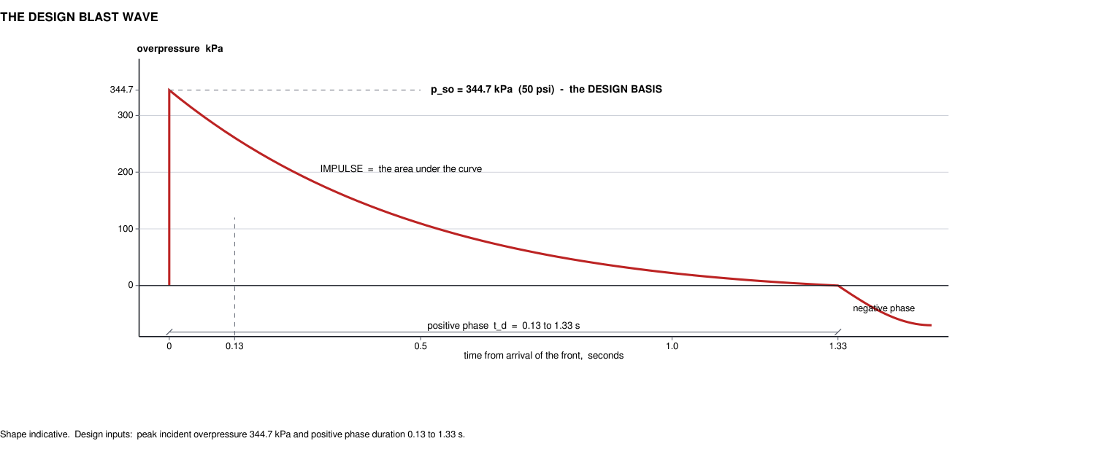
Fig 5.1 : Design blast wave (pressure-time history)
5.3 Load on a buried structure. Soil transmits the air-blast pressure to a buried structure as a stress wave. IS 4991 Cl. 7.2 and Table 3 apply a soil transmission factor K_{a} to the free-field overpressure. The founding horizon is below the design water table, and for saturated soil K_{a} = 1.0. The roof and walls of the box are therefore designed for the full overpressure. No reduction has been taken for arching of the soil over the roof, which is conservative.
5.4 Dynamic response. A blast-loaded slab responds essentially in its first mode, and is idealised as a single degree of freedom system. Its response depends on the ratio of the load duration to its natural period, t_{d} / T: below about 0.1 the response is impulsive, between 0.1 and 10 it is dynamic, and above 10 it is quasi-static, i.e. the peak response approaches that under a suddenly applied constant load. The natural period of the governing element, the 900 mm pressure slab spanning 5.0 m, is worked out below.
Participating mass, m = 0.900 x 2500 + 0.25 x 2.0 x 2000 | 3 250 kg/m²
Cracked stiffness, 0.5 E I_{g} = 0.5 x 2.958 x 10¹⁰ x 0.900³ / 12 | 8.985 x 10⁸ Nm²/m
f₁ = (22.373 / 2π) √(EI / m L_{n}⁴), fixed-fixed beam | 74.9 Hz
T = 1 / f₁ | 13.4 ms
t_{d} / T = 130 / 13.4 to 1330 / 13.4 | 10 to 100

The ratio t_{d} / T lies between 10 and 100 and the response is quasi-static (Fig 5.2). An equivalent static load obtained with a dynamic load factor therefore gives the correct design demand.
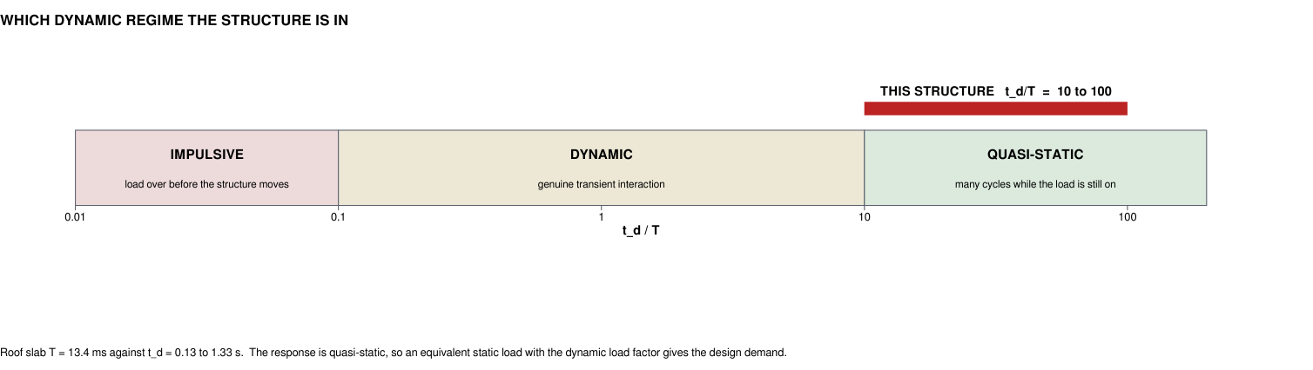
Fig 5.2 : Response regime of the structure
5.5 Dynamic load factor. For an elasto-plastic system under a suddenly applied load, the dynamic load factor is related to the ductility ratio μ (maximum displacement / yield displacement) by IS 4991 Cl. 10.3.3.
DLF = μ / (μ - 0.5); check: μ = 1 gives DLF = 2.00, the elastic value
Adopted μ = 5 (moderate, repairable damage), DLF = 5 / 4.5 | 1.111
Design blast pressure = 344.7 x 1.111 | 383 kPa

The design pressure of 383 kPa is applied to the roof and to all external walls. The ductility on which it depends is ensured by the detailing: the neutral axis depth of the pressure slab is x_{u}/d = 0.139 against the limit of 0.46 for Fe500, and all blast-governed elements carry designed shear links (Chapter 7).
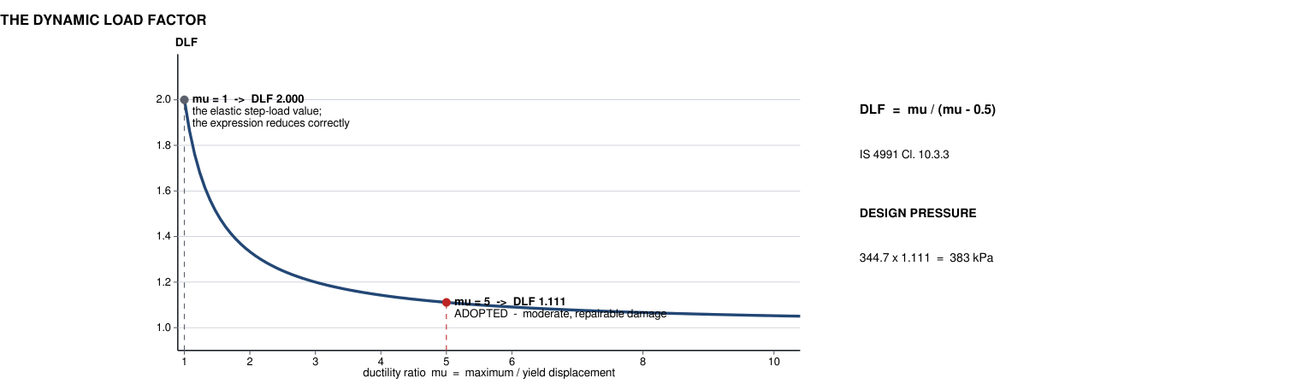
Fig 5.3 : Dynamic load factor against ductility ratio
5.6 Plastic mechanism moment. The flexural demand on the blast-governed one-way elements is taken as the collapse mechanism moment of a fixed-fixed strip, M_{p} = w L_{n}² / 16, which is reached when hinges have formed at both supports and at mid-span. This is permissible because the sections are ductile enough to redistribute moment, which is the same condition on which μ = 5 depends.
Dead, imposed, earth and water loads
5.7 Gravity loads. The gravity loads on the underground structure are given in Table 5.1.
Table 5.1 : Gravity, earth and water loads on the underground structure
Load | Value | Applied to
Self weight of RC | 25 kN/m³ | All elements
Roof self weight, 0.900 x 25 | 22.50 kPa | Roof
Mat self weight, 0.600 x 25 | 15.00 kPa | Mat
Engineered cover, 2 000 mm | 40.65 kPa | Roof
Superimposed dead load | 2.0 kPa roof / 1.0 kPa mat | Roof / mat
Imposed load, internal floor | 5.0 kPa (plant and storage) | Mat
Earth and water, gradient K₀γ′ + γ_{w} | 15.41 kPa/m | External walls
- at roof soffit (-)2.900 / at floor (-)6.100 | 33.9 / 83.2 kPa | External walls
Hydrostatic uplift, 4.700 x 9.81 | 46.11 kPa (6 289 kN) | Mat
Construction surcharge | 20 kPa vertical / 10 kPa lateral | Construction case
Staircase load on the shaft walls | 2.947 kPa | W6 / W7

5.8 Engineered cover. The 2 000 mm cover over the roof is built up in six layers, as given in Table 5.2 and Fig 5.4. The design value of 40.65 kPa includes an allowance of 1.50 kPa for the tolerance on six compacted layers over the 136 m² roof.
Table 5.2 : Engineered cover build-up
Layer (from the top) | Thickness (mm) | Unit wt (kN/m³) | Load (kPa) | Function
Topsoil and turf | 300 | 18 | 5.40 | Concealment, erosion control
Granular filter | 150 | 19 | 2.85 | Drainage, prevents clogging
RC burster slab, M30, T12 @ 150 both ways | 200 | 25 | 5.00 | Breaks up a penetrating item
Crushed basalt rubble, 25 - 75 mm | 500 | 17 | 8.50 | Disperses burster energy
Compacted engineered fill, 95 % MDD | 750 | 20 | 15.00 | Radiation shielding mass
Protection screed over the membrane | 100 | 24 | 2.40 | Protects the waterproofing
Sum of layers | 2 000 | - | 39.15 | -
Allowance for layer tolerance | - | - | 1.50 | -
Design value | 2 000 | - | 40.65 | -

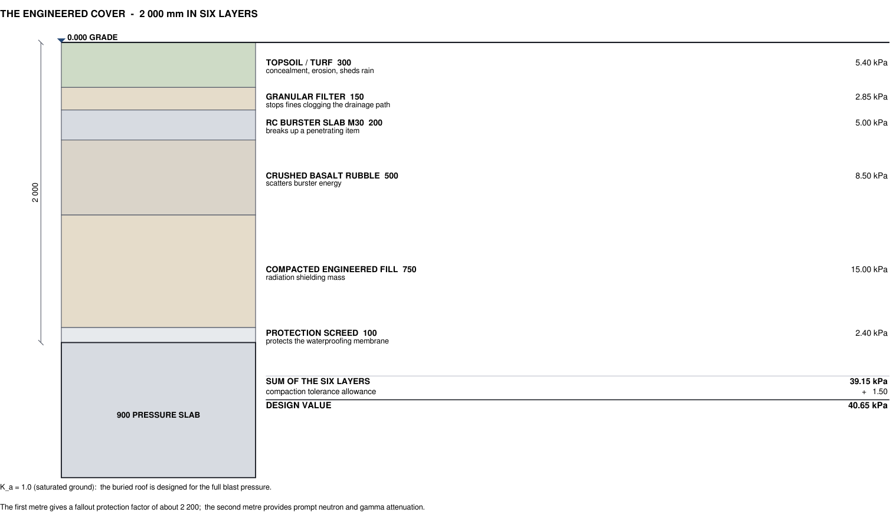
Fig 5.4 : Engineered cover over the pressure slab
5.9 Burster slab to falls. The burster slab is laid to a 1 in 50 crossfall from the box centreline (Y = 3100) towards both edges, parallel to the finished grade. Water that passes the topsoil is intercepted by the granular filter and led to the berm toe without any pipe in the cover. The fall is taken up in the compacted fill, which is 750 mm at the crown and 688 mm at the edges, so the load does not increase anywhere.
5.10 Earth and water pressure. Below the water table the soil skeleton and the pore water act separately. The at-rest coefficient is used because a stiff buried box does not move enough to develop active pressure.
Submerged unit weight, γ′ = γ_{sat} - γ_{w} = 21 - 9.81 | 11.19 kN/m³
K₀ = 1 - sin 30° | 0.50
Lateral gradient = K₀ γ′ + γ_{w} = 0.50 x 11.19 + 9.81 | 15.41 kPa/m
of which soil 5.60 kPa/m and water 9.81 kPa/m
Pressure at roof soffit (-)2.900 / at floor (-)6.100 | 33.9 / 83.2 kPa

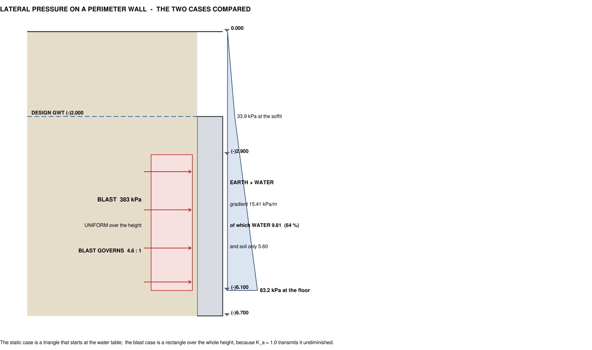
Fig 5.5 : Lateral pressure on a perimeter wall, static and blast cases
5.11 Hydrostatic uplift. The uplift acts on the actual underside of the mat.
u = γ_{w} h_{w} = 9.81 x 4.700 | 46.11 kPa
Plan area = 22.000 x 6.200 | 136.40 m²
Total uplift U = 46.11 x 136.40 | 6 289 kN

5.12 Total roof load. The load on the pressure slab in the blast combination (combination 103) is worked out below. No imposed load is taken on the roof at the time of blast (IS 4991 Cl. 11.2).
Blast, 344.7 x 1.111 | 383.00 kPa
Engineered cover | 40.65 kPa
Superimposed dead load | 2.00 kPa
Self weight | 22.50 kPa
Total, w (combination 103) | 448.15 kPa
Static ULS (combination 101), 1.5 x (40.65 + 2.0 + 22.5 + 20) | 127.7 kPa
Ratio blast / static = 448.15 / 127.7 | 3.51

The blast combination governs every element of the underground structure.
5.13 Headhouse loads. The headhouse roof, which is flush with the berm crest and has no earth cover, carries 383 + 12.5 (self weight) + 1.0 (SIDL) = 396.5 kPa. The headhouse walls stand behind about 2.5 m of berm; since earth transmits pressure and the transmission factor of a dry compacted berm cannot be relied upon, the walls are designed for the full 383 kPa instead of the drag load of C_{d} q = 0.4 x 282 = 113 kPa. The headhouse also fills with blast pressure through the entry, so the walls are designed for 383 kPa acting on either face.
5.14 Entry stairwell loads. The covered entry stairwell is designed for static loads only, as given in Table 5.3. The imposed load of 20 kPa on the raking roof allows for a vehicle straying on to the berm.
Table 5.3 : Entry stairwell loads
Element | Load build-up | w_{u}
Flight, waist 250 | Waist 7.150 + steps 2.083 + finishes 1.000 + imposed 5.000 = 15.233 kPa | 22.85 kPa
Side walls, 250 | K₀ 0.50 x 20 x 2.9 + 0.5 x 10 surcharge = 34 kPa at base | -
Raking roof, 250 | Self 6.25 + waterproofing 2.0 + earth lap 5.4 + imposed 20 = 33.65 kPa | 50.5 kPa
Top landing, 250 | 18.4 + flight reaction 36.5 | 54.9 kPa

5.15 Sentry post loads. The loads on the sentry post are given in Table 5.4. The slab loads are transferred to the beams by 45° yield lines (IS 456 Cl. 24.5): triangular on the short beams B1 and trapezoidal on the long beams B2, with an equivalent factor of 1 - 1 / (3 r²) = 0.7946 for r = 4650 / 3650 = 1.274.
Table 5.4 : Sentry post loads
Item | Value | Basis
Slab dead load, first floor | 4.750 kPa | 0.150 x 25 + 1.0 finish
Slab dead load, roof | 5.250 kPa | 3.75 + 1.5 screed and waterproofing
Imposed load, first floor | 3.000 kPa | IS 875 (Part 2), observation post
Imposed load, roof | 1.500 kPa | IS 875 (Part 2), accessible roof
Peak intensity on beams, DL floor / roof | 8.669 / 9.581 kN/m | w x 1.825 m
Peak intensity on beams, LL floor / roof | 5.475 / 2.737 kN/m | w x 1.825 m
Wall load on first-floor beams | 13.000 kN/m | 0.200 x 2.600 x 25
Roof projection and parapet | 4.162 kN/m | Parapet 300 x 150 = 1.125 kN/m + projection
Factored slab load, first floor | 11.625 kPa | 1.5 (4.75 + 3.00), governs
Factored slab load, roof | 10.125 kPa | 1.5 (5.25 + 1.50)

The wall load of 13.000 kN/m on the first-floor beams corresponds to a 200 mm RC panel. The brick masonry actually adopted weighs about 9.88 kN/m, so the value used is on the safe side.
Seismic and wind loads
5.16 Underground structure. The seismic load on the buried box has been worked out to IS 1893 (Part 1) : 2016.
Z = 0.16 (Zone III), I = 1.5, R = 4.0, S_{a}/g = 2.5
A_{h} = (Z/2)(I/R)(S_{a}/g) = 0.08 x 0.375 x 2.5 | 0.075
Seismic weight W | 14 002 kN
V_{b} = 0.075 x 14 002 | 1 050 kN
Shear per long wall = 525 kN; τ = 525 x 10³ / (600 x 0.8 x 22 000) | 0.05 N/mm²

The seismic shear stress in the walls is negligible, and the boundary element provisions of IS 13920 Cl. 10.4 are not attracted. A buried box moves with the surrounding ground and seismic loading does not govern any element of it.
5.17 Sentry post. The seismic load on the sentry post has been worked out to IS 1893 (Part 1) : 2016. The response reduction factor is taken as 3.0, since the masonry infill is built tight to the frame and is not separated from it.
Z = 0.16, I = 1.5, R = 3.0, S_{a}/g = 2.5 (rock, T on the plateau)
A_{h} = 0.08 x 0.50 x 2.5 | 0.100
T_{a}, bare frame = 0.075 h^{0.75} = 0.075 x 6.250^{0.75} | 0.297 s
T_{a}, with infill = 0.09 h / √d, X / Z direction | 0.281 / 0.252 s
Seismic weight from the STAAD model, roof 331.46 + floor 400.34 | 731.80 kN
Design base shear V_{b} = 0.100 x 731.80 | 73.18 kN
Check from the support reactions: 18.295 kN per column x 4 | 73.18 kN

All three period estimates lie on the plateau of the spectrum (0.10 to 0.40 s). A hand calculation of the seismic weight gives 592.7 kN; the model value of 731.80 kN is higher because it includes half the first-storey infill at the floor level and the full beam depth in the self weight, and the design uses the higher value.
5.18 Wind on the sentry post. The wind load has been worked out to IS 875 (Part 3) : 2015.
V_{b} = 39 m/s; k₁ = 1.08 (100 year life); k₂ = 1.00; k₃ = k₄ = 1.00
V_{z} = 39 x 1.08 | 42.12 m/s
p_{z} = 0.6 V_{z}² | 1.065 kPa
p_{d} = p_{z} x K_{d} 0.90 x K_{a} 0.897 x K_{c} 1.0 | 0.859 kPa
F = C_{f} 1.3 x A_{e} (4.0 x 6.7 = 26.8 m²) x p_{d} | 29.9 kN
Seismic 73.18 kN governs over wind 29.9 kN | 2.4 : 1

Load combinations
5.19 Underground structure. The load combinations for the underground structure are given in Table 5.5. Wind and earthquake are not combined with blast (IS 4991 Cl. 11.1).
Table 5.5 : Load combinations, underground structure
No | Title | Combination
101 | ULS static | 1.5 (DL + SIDL + LL + SOIL + UPLIFT)
102 | ULS uplift | 0.9 DL + 1.5 UPLIFT
103 | Blast | 1.0 (DL + SIDL + SOIL + UPLIFT + BLAST), governs
104 | SLS crack width | 1.0 (DL + SIDL + LL + SOIL + UPLIFT), IS 3370 (Part 2)
105 | Construction | 1.5 (DL + SOIL + UPLIFT + SURCHARGE)

5.20 Sentry post. The sixteen load combinations of the sentry post model are given in Table 5.6.
Table 5.6 : Load combinations, sentry post
No | Combination
101 | 1.5 DL + 1.5 LL
102 - 105 | 1.2 DL + 1.2 LL + 1.2 EQ (+X, -X, +Z, -Z)
106 - 109 | 1.5 DL + 1.5 EQ (+X, -X, +Z, -Z)
110 - 113 | 0.9 DL + 1.5 EQ (+X, -X, +Z, -Z)
201 | 1.0 DL + 1.0 LL (service)
202, 203 | 1.0 DL + 1.0 EQ+X; 1.0 DL + 1.0 EQ+Z (storey drift, IS 1893 Cl. 7.11)

CHAPTER 6
STRUCTURAL ANALYSIS
(ANALYSIS MODELS AND METHODS)
Approach
6.1 Methods used. The structural analysis has been carried out as under:-
6.1.1 Underground structure. The box has been modelled in STAAD.Pro as a plate model on an elastic foundation to represent the load distribution and the support conditions. The elements have been designed by hand calculation, using the plastic mechanism moment under the equivalent static blast load for the governing combination 103 and the elastic coefficients of IS 456 for the other cases.
6.1.2 Stairs, headhouse and stairwell. Designed as one-way slabs and walls by hand calculation, with the headhouse roof checked by three methods (Chapter 8). The covered entry stairwell has also been modelled in STAAD.Pro for the static load cases.
6.1.3 Sentry post. Analysed as a three-dimensional space frame in STAAD.Pro for the gravity and seismic load cases. The member forces used in design have been obtained from the model and from the portal method, the larger value being adopted.
Underground structure model
6.2 Model description. The model of the box is a plate and beam model on the mid-surface of every element, meshed on a regular grid over the 22.0 x 6.2 m footprint. Its particulars are given in Table 6.1. The model uses metres and kilonewtons with the global Y axis vertical; its origin is at the underside of the mat, so that project level = model Y - 6.700.
Table 6.1 : Underground structure model
Item | Particulars
Elements | 1 138 plate elements in four thickness groups: mat 600, roof 900, perimeter walls 600, internal walls 200 to 400
Supports | Elastic mat foundation, vertical springs at every mat node generated from k_{s} = 100 000 kN/m³ (a second model at 500 000 kN/m³ represents the stiffer bound)
Corner springs | 6 891 / 8 269 / 7 219 / 8 663 kN/m, from the corner tributary areas
Openings | Stair void 2 800 x 3 160 and two 1 400 mm escape shaft openings in the roof
Analysis | Linear static with statics check

6.3 Load cases. The primary load cases of the model are given in Table 6.2. Load case 11 represents the blast pressure in the stair shaft acting outward on walls W6 and W7.
Table 6.2 : Primary load cases, underground structure model
No | Title | Value
1 | DL1 Self weight | Automatic
2 | DL2 Earth cover on roof | 40.65 kPa
3 | DL3 Superimposed dead load, services and finishes | 2.0 kPa
4 | LL1 Live load on internal floor | 5.0 kPa
5 | DL4 Staircase load on the two shaft walls | 2.947 kPa
6 | EP1 Earth and water pressure on external walls | 33.9 to 83.2 kPa
7 | HY1 Hydrostatic uplift on mat | 46.11 kPa
8 | BL1 Blast on roof | 383 kPa
9 | BL2 Blast on external walls | 383 kPa
10 | LL2 Construction surcharge | 20.0 kPa
11 | BL3 Blast in the stair shaft on W6 and W7 | 383 kPa

6.4 Model and load cases. The model and the load cases 1 to 10, as applied in STAAD.Pro, are shown in Fig 6.1 and Fig 6.2, and the plate stress contours obtained from the model in Fig 6.3.
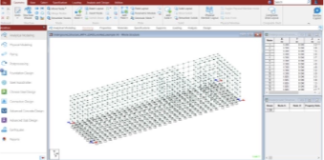  (a) Plate model | 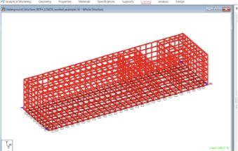  (b) Load case 1, self weight | 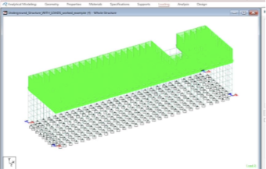  (c) Load case 2, earth cover on the roof
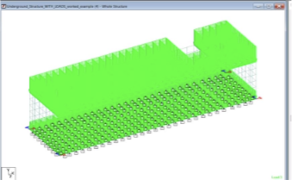  (d) Load case 3, superimposed dead load | 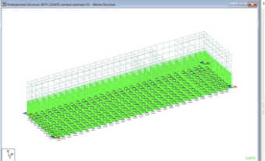  (e) Load case 4, live load on the floor | 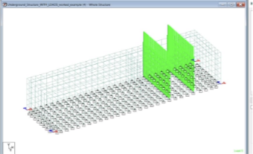  (f) Load case 5, staircase load on the shaft walls
Fig 6.1 : Underground structure model and load cases 1 to 5 (STAAD.Pro)
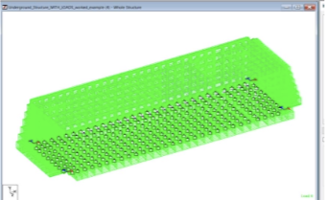  (a) Load case 6, earth and water pressure on the external walls | 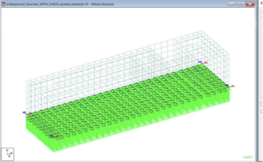  (b) Load case 7, hydrostatic uplift on the mat | 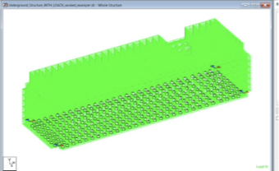  (c) Load case 10, construction surcharge
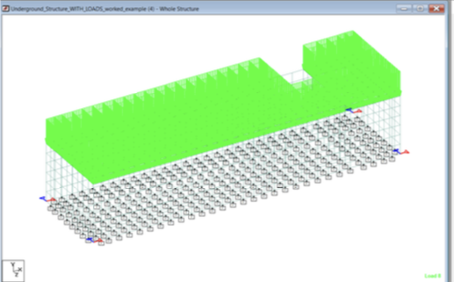  (d) Load case 8, blast on the roof | 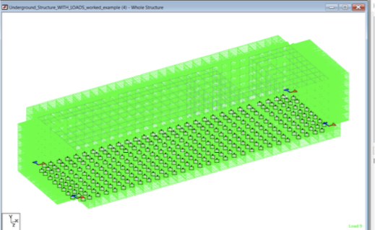  (e) Load case 9, blast on the external walls
Fig 6.2 : Load cases 6 to 10, underground structure model (STAAD.Pro)
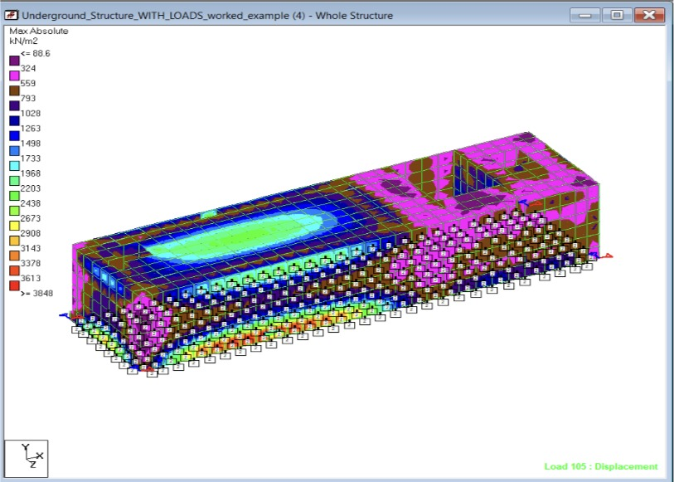
Fig 6.3 : Plate stress contours, underground structure model (STAAD.Pro)
6.5 Mesh sensitivity. The model has been analysed with three mesh densities under the same load case, earth and water pressure on the external walls, with the geometry, supports and loads unchanged. The meshes and the peak plate stresses are given in Table 6.3 and Fig 6.4.
Table 6.3 : Mesh sensitivity study, underground structure model
Mesh | Plate elements | Joints | Element size, X x Z (m) | Peak plate stress (kN/m²)
Coarse | 336 | 324 | 1.259 x 1.120 | 3 240
Medium (adopted) | 1 138 | 1 113 | 0.713 x 0.622 | 3 839
Fine | 4 552 | 4 500 | 0.357 x 0.311 | 4 482

The pattern of stress is the same in all three meshes. The peak value rises as the mesh is refined, which is the behaviour of a local peak, while the general stress field does not change. The elements have been designed from the plastic mechanism moments set out below and not from the peak plate stresses, and the medium mesh has been adopted for the model.
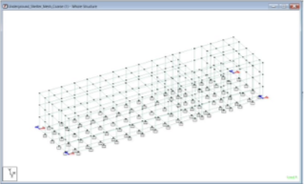  (a) Coarse mesh, 336 plates | 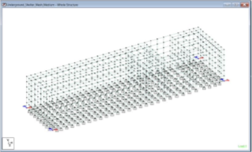  (b) Medium mesh, 1 138 plates | 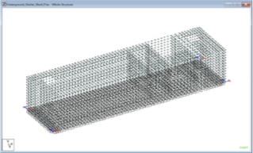  (c) Fine mesh, 4 552 plates
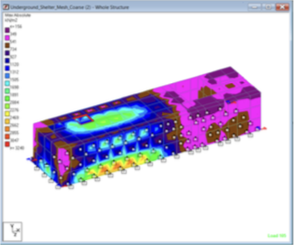  (d) Coarse mesh, plate stress | 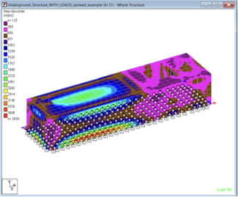  (e) Medium mesh, plate stress | 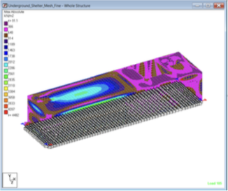  (f) Fine mesh, plate stress
Fig 6.4 : Mesh sensitivity study, coarse, medium and fine meshes (STAAD.Pro)
6.6 Flotation. The springs of an elastic foundation model act in tension as well as compression, so the model cannot show whether the box floats. Flotation has therefore been checked by hand on the actual weights and the actual plan area (Chapter 7).
Plastic mechanism method
6.7 Principle. For a one-way strip fixed at both ends, the elastic moments are w L²/12 at the supports and w L²/24 at mid-span. When the support sections yield they rotate at constant moment and the load is redistributed until a hinge also forms at mid-span. Equating the external work to the internal work of the three-hinge mechanism gives a capacity requirement of M_{p} = w L_{n}² / 16 at every hinge. This moment has been used for the blast design of the perimeter walls, walls W6 and W7, the pressure slab, the headhouse roof and walls, with the sections kept under-reinforced so that the hinges can rotate.
6.8 Flexural capacity. The flexural capacity of every section has been computed from IS 456 Annex G-1.1(b), with the limiting moment from Annex G-1.1(c) and the neutral axis depth from Cl. 38.1.
M_{u} = 0.87 f_{y} A_{st} d [1 - (A_{st} f_{y}) / (b d f_{ck})]
x_{u} = 0.87 f_{y} A_{st} / (0.36 f_{ck} b); x_{u,max} / d = 0.46 for Fe500
M_{u,lim} = 0.133 f_{ck} b d²

6.9 Shear. Shear has been checked to IS 456 Cl. 40, with τ_{c} from Table 19 at the static strength of concrete and τ_{c,max} from Table 20. Where τ_{v} exceeds τ_{c}, links have been designed for V_{us} = (τ_{v} - τ_{c}) b d with A_{sv} / s_{v} = V_{us} / (0.87 f_{y} d), subject to the maximum spacing of Cl. 26.5.1.5.
Sentry post model
6.10 Model description. The sentry post has been analysed as a space frame in STAAD.Pro. Its particulars are given in Table 6.4.
Table 6.4 : Sentry post model
Item | Particulars
Joints | 12: bases at +0.450, first floor +3.650, roof +6.700
Members | 16: members 1 to 8 columns 350 x 350; members 9 to 16 beams 250 x 450
Supports | All four column bases fixed; the footings are on in-situ rock
Connections | All beam-column joints fully continuous (no member releases)
Infill | Applied as member load on the beams
Slab | Load applied to the beams as triangular and trapezoidal loads
Analysis | Linear static with statics check

6.11 Statics check. The model reactions balance the applied loads exactly in every case, as given in Table 6.5.
Table 6.5 : Statics check, sentry post model
Load case | ΣF_{x} (kN) | ΣF_{y} (kN) | ΣF_{z} (kN) | ΣM_{x} (kNm) | ΣM_{y} (kNm)
1 Dead load | 0.000 | -624.548 | 0.000 | 1 561.369 | 0.000
2 Live load | 0.000 | -76.376 | 0.000 | 190.941 | 0.000
3 EQ +X | 73.180 | 0.000 | 0.000 | 0.000 | 182.950
5 EQ +Z | 0.000 | 0.000 | 73.180 | 436.631 | -146.360

6.12 Model views. The frame model, its load cases and the bending moment and shear force diagrams are shown in Fig 6.5 and Fig 6.6.
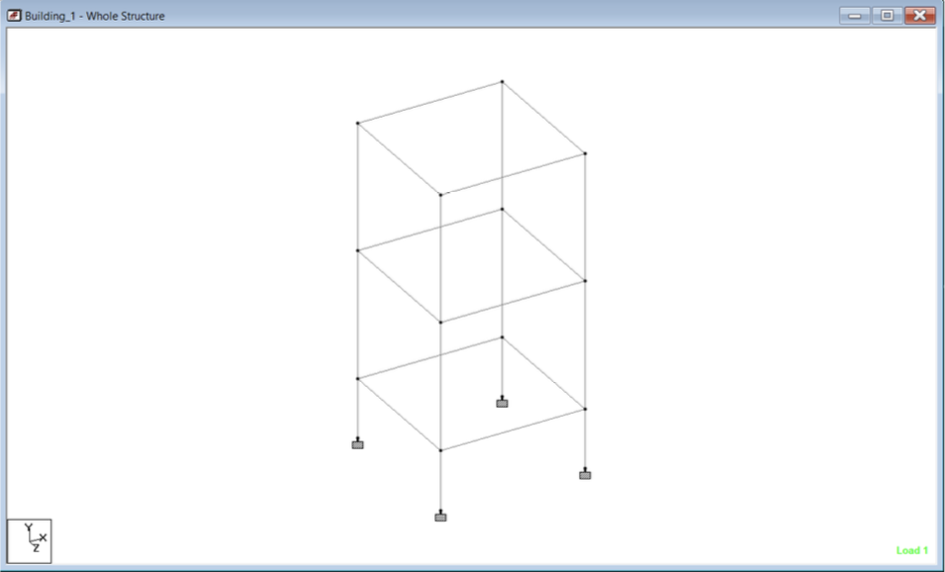  (a) Frame model | 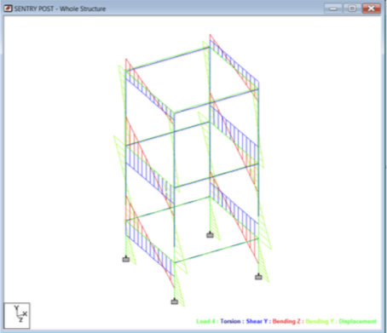  (b) Bending moment and shear force diagrams
Fig 6.5 : Sentry post frame model (STAAD.Pro)
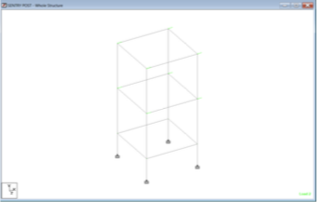  (a) Seismic load, +X | 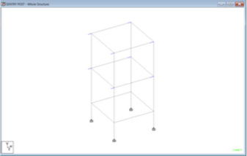  (b) Seismic load, -X | 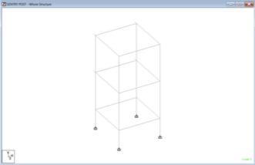  (c) Seismic load, +Z
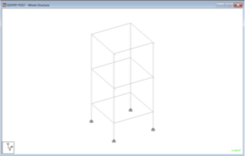  (d) Seismic load, -Z | 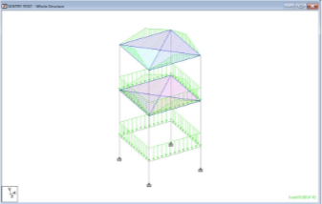  (e) Dead load | 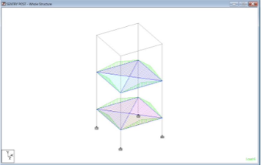  (f) Live load
Fig 6.6 : Load cases, sentry post frame model (STAAD.Pro)
6.13 Results used in design. The following results of the model have been used directly in design:-
6.13.1 Base shear. F_{x} = 18.295 kN per column, total 73.18 kN, which is exactly the equal-share distribution assumed in the portal method.
6.13.2 Seismic axial forces. F_{y} = ±36.127 kN (EQ in X) and ±27.891 kN (EQ in Z) in the columns due to overturning. The larger value, 36.127 kN, has been used in the column and footing design.
6.14 Portal method. The seismic member forces have been worked out by the portal method at the model base shear of 73.18 kN, with the storey forces distributed in proportion to W h².
Q_{roof} = 73.18 x (315.9 x 6.25²) / Σ W h² | 59.51 kN
Q_{floor} = 73.18 x (276.8 x 3.20²) / Σ W h² | 13.67 kN
Column shear, ground storey = 73.18 / 4 | 18.30 kN
Column shear, first storey = 59.51 / 4 | 14.88 kN
Column moment, ground storey = 18.30 x 3.200 / 2 | 29.27 kNm
Column moment, first storey = 14.88 x 3.050 / 2 | 22.69 kNm
Beam moment at the first-floor joint = 29.27 + 22.69 | 51.96 kNm
Beam moment at the roof joint | 22.69 kNm

This distribution places slightly more shear in the ground storey than the model's own distribution (roof 55.57 kN, floor 17.61 kN), and gives the larger ground-storey column moment.
6.15 Gravity moments in the frame. The beam-column joints rotate under gravity load, and the support moments of the beams have been obtained by slope deflection, as given in Table 6.6.
I_{beam} = 250 x 450³ / 12 | 1.8984 x 10⁹ mm⁴
I_{col} = 350⁴ / 12 | 1.2505 x 10⁹ mm⁴
Column stiffness at the first-floor joint, 4EI/3200 + 4EI/3050 | 3.203 x 10⁶ E
M_{support} = FEM x (column stiffness) / (2EI_{b}/L_{b} + column stiffness)

Table 6.6 : Beam gravity moments at the first floor (kNm)
Beam and load | FEM | 2EI/L (x E) | Factor | M_{support} | M_{mid}
B1, 1.5 (DL + LL) | 39.49 | 1.040 x 10⁶ | 0.755 | 29.81 | 30.90
B1, DL only | 22.53 | - | 0.755 | 17.01 | -
B2, 1.5 (DL + LL) | 70.60 | 0.8165 x 10⁶ | 0.797 | 56.26 | 49.64
B2, DL only | 39.21 | - | 0.797 | 31.25 | -

CHAPTER 7
DESIGN OF THE UNDERGROUND STRUCTURE
(PERIMETER WALLS, PROTECTIVE WALLS, MAT FOUNDATION AND PRESSURE SLAB)
General
7.1 Notation. In the reinforcement descriptions, T16 @ 150 EF EW denotes 16 mm Fe500D deformed bars at 150 mm centres, each face, each way, and 4L denotes four-legged links. Design values for the blast case use f_{ck,dyn} = 43.75 N/mm² and f_{y,dyn} = 625 N/mm² in flexure, and the static τ_{c} of M35 in shear.
Perimeter walls W1 to W4 (600 mm)
7.2 Design. The perimeter walls span vertically between the mat and the pressure slab over a clear height of 3.2 m and are designed for the blast pressure of 383 kPa, which exceeds the static earth and water pressure at the base (83.2 kPa) by 4.6 times.
d = 600 - 75 - 8 | 517 mm
M_{p} = w L_{n}² / 16 = 383 x 3.200² / 16 | 245.1 kNm/m
M_{u,lim} = 0.133 x 43.75 x 1000 x 517² | 1 556 kNm/m
A_{st} required (f_{y,dyn} 625, f_{ck,dyn} 43.75) | 894 mm²/m
Minimum steel: vertical 0.0012 x 600 = 720; horizontal 0.0020 x 600 = 1 200 mm²/m (IS 456 Cl. 32.5)
Surface zone steel, IS 3370 (Part 2): 0.35 % x 250 | 875 mm²/m per face
Provided T16 @ 150 EF EW = 1 340 mm²/m per face; M_{u} = 362.8 kNm/m | Utilisation 68 %
x_{u} = 46.3 mm, x_{u}/d = 0.089 < 0.46 | Ductile
Shear
V at d from the support = 383 (1.600 - 0.517) | 414.8 kN/m
τ_{v} = 414.8 x 10³ / (1000 x 517) | 0.802 N/mm²
τ_{c} (p_{t} = 0.259 %, M35) | 0.375 N/mm²
V_{us} = (0.802 - 0.375) x 517 = 220.8 kN/m; A_{sv}/s_{v} | 0.982 mm²/mm
Provided T12 closed links @ 200 (A_{sv}/s_{v} = 1.131) | OK
Axial load and cracking
N = 448.15 x 2.50 + 3.2 x 0.6 x 25 = 1 168 kN/m; f = 1.95 N/mm² = 11 % of 0.4 f_{ck,dyn} | Not critical
Crack width limit 0.2 mm (IS 3370); surface steel 875 < 1 340 mm²/m | OK

7.3 Thickness. The wall is 68 per cent utilised in flexure. The 600 mm thickness is also required for the 75 mm cover against rock, for two curtains of steel with closed links, waterstops and cast-in frames within one section, for crack control under a permanent head of water, for the EMP double curtain at 150 mm, and for the axial load of 1 168 kN/m from the roof.
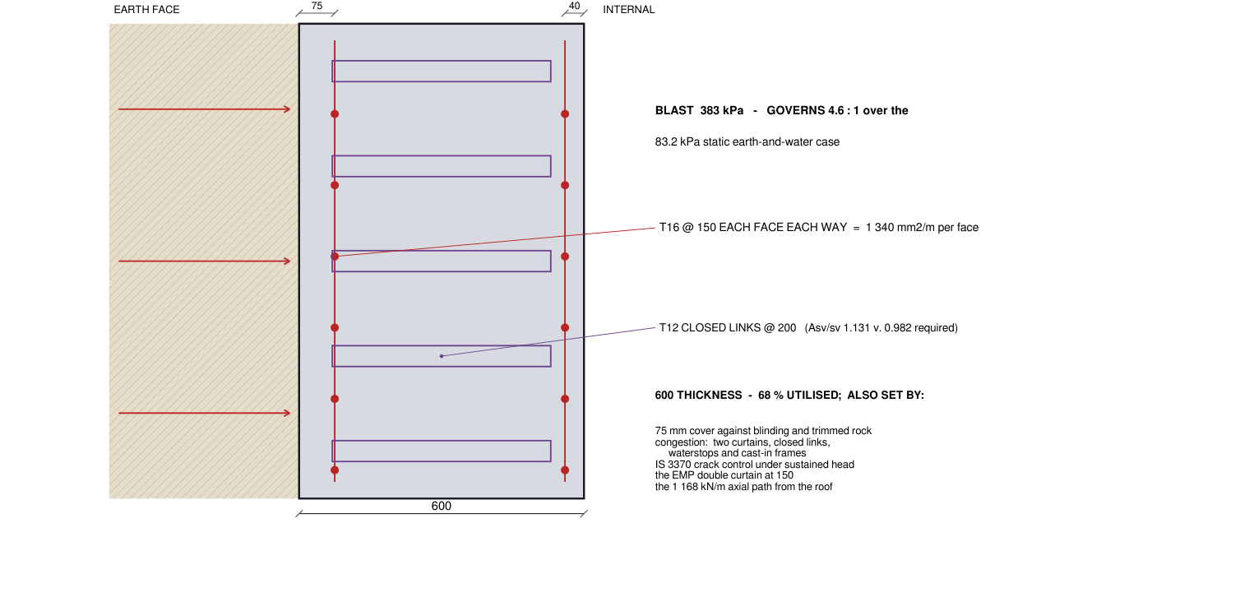
Fig 7.1 : Perimeter wall W1 to W4, section and reinforcement
Protective walls W6 and W7 (400 mm)
7.4 Loading. The stair shaft is open to the atmosphere through the 2 800 x 3 160 mm roof void, the headhouse and the entry stairwell. The time taken for the shaft to fill with blast pressure is compared below with the duration of the blast pulse.
Fill time = V / (A c) = 105 / (3.3 x 340) | 0.094 s
Positive phase duration, t_{d} | 0.13 to 1.33 s

The shaft fills to the full overpressure in less than the shortest positive phase duration. Walls W6 and W7 therefore separate a pressurised shaft from bays 6 and 8 at ambient pressure, and are designed for 383 kPa acting from the shaft (load case BL3).
7.5 Thickness. A 200 mm wall is not adequate for this load, since its limiting moment is below the demand whatever steel is provided:-
200 mm wall: d = 200 - 40 - 6 = 154 mm; M_{u,lim} = 0.133 x 43.75 x 1000 x 154² | 138.0 kNm/m
Demand M_{p} = 383 x 3.200² / 16 | 245.1 kNm/m
Two-way action, panel 3 200 x 3 800 fixed on three edges (yield line) | about 172 kNm/m

The walls have therefore been made 400 mm thick.
7.6 Design. The design of the 400 mm wall is as under.
d = 400 - 50 - 8 | 342 mm
M_{p} = 383 x 3.200² / 16 | 245.1 kNm/m
M_{u,lim} = 0.133 x 43.75 x 1000 x 342² | 680.6 kNm/m
A_{st} required | 1 400 mm²/m
Provided T20 @ 150 EF EW = 2 094 mm²/m; M_{u} = 355.3 kNm/m | Utilisation 69 %
x_{u}/d = 0.211 < 0.46 | Ductile
V at d = 383 (1.600 - 0.342) = 481.8 kN/m; τ_{v} = 1.409 N/mm²
τ_{c} (p_{t} = 0.612 %) = 0.540; τ_{c,max} = 3.70 N/mm² | OK
V_{us} = 297.2 kN/m; A_{sv}/s_{v} = 1.998, spacing limit min (0.75d = 257, 300) | 257 mm
Provided T12 4-legged links @ 200 | OK

7.7 Blast door openings. Each wall carries a blast door opening of 1 200 x 2 100 mm at Y 600 - 1800.
Interrupted steel = 2 094 x 1.2 = 2 513 mm² per face, i.e. 1 256 mm² per jamb per face
Provided 4 No. T20 each jamb each face (1 257 mm²), anchored L_{d} = 800 beyond | OK
Header 400 x 1 100 over 1 200 clear: w = 383 x 2.1 / 2 | 402 kN/m
M = w L² / 12 = 48.2 kNm; V = 241 kN; τ = 0.578 N/mm² | OK
Provided 4-T20 top + 4-T20 bottom, T12 4-legged links @ 150 | OK

7.8 Door frames. Each blast door frame is a cast-in steel frame anchored into and welded to the reinforcement cage, which provides both the blast fixing and the EMP continuity across the opening. The frames are welded into the W6 and W7 cages before the walls are cast.
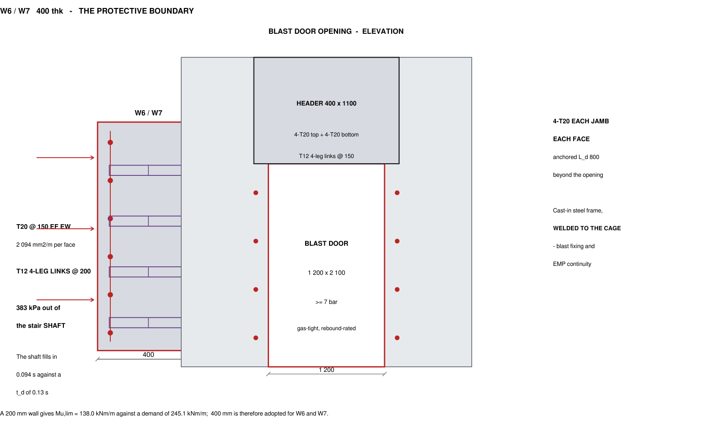
Fig 7.2 : Walls W6 and W7 with the blast door opening
Mat foundation (600 mm)
7.9 Bearing. The bearing pressure is 58.4 kPa in service and 404.9 kPa under blast, i.e. 1.8 and 12.5 per cent of the safe bearing capacity of 3 240 kPa, and 20.6 per cent of the lowest soaked rock value. Bearing does not govern.
7.10 Flexure. Two cases have been considered:-
7.10.1 Case 1, net uplift. Under combination 102 the net upward load over the 5.0 m span is 46.11 - 15.00 = 31.1 kPa, giving M_{p} = 31.1 x 5.0² / 16 = 48.6 kNm/m, which is nominal.
7.10.2 Case 2, soft band. A 3.0 m wide band of red-bole or vesicular rock is assumed to be lost at the worst position under the blast bearing pressure. This case governs.
q = 404.9 kPa over a 3.0 m unsupported width; M = q L² / 12 = 404.9 x 9 / 12 | 303.7 kNm/m
d = 600 - 75 - 8 | 517 mm
A_{st} required | 1 115 mm²/m
Provided T16 @ 150 EF EW = 1 340 mm²/m; M_{u} = 362.8 kNm/m | Utilisation 84 %

7.11 Thickness. The thickness has been chosen from the study in Table 7.1. A 500 mm mat would require more steel than the 150 mm spacing provides, and 600 mm is adopted.
Table 7.1 : Mat thickness study (case 2)
Thickness (mm) | A_{st} required (mm²/m) | % of T16 @ 150 | Remarks
500 | 1 407 | 105 | Inadequate
600 | 1 115 | 84 | Adopted
700 | 926 | 70 | Uneconomical
800 | - | about 57 | Uneconomical

7.12 Shear. One-way shear is checked at d from the edge of the soft band.
V = 404.9 (1.500 - 0.517) | 398.0 kN/m
τ_{v} = 0.770 N/mm²; τ_{c} = 0.375 N/mm² (static M35, p_{t} 0.259 %) | Links required
V_{us} = 204.2 kN/m; A_{sv}/s_{v} required | 0.908 mm²/mm
Provided T12 closed links on a 250 x 250 grid, A_{sv}/s_{v} = 4 x 113.1 / 250 = 1.810 | 2.0 x required

The link grid also acts as the spacer system between the two curtains of the mat.
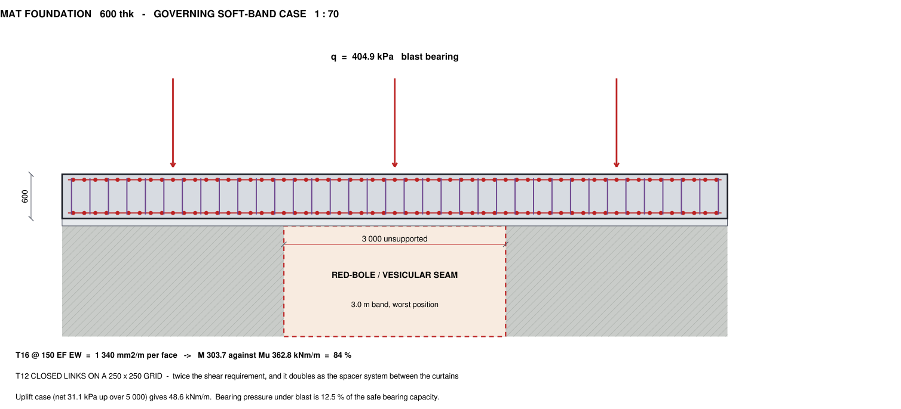
Fig 7.3 : Mat foundation, governing soft-band case
7.13 Other checks. The remaining checks on the mat are as under:-
7.13.1 Punching. No column or pedestal bears on the mat; the headhouse walls bear on the roof. Punching shear (IS 456 Cl. 31.6) does not arise.
7.13.2 Sliding and overturning. The box is socketed about 4.8 m into basalt and the annulus is backfilled with M15 lean concrete, and the lateral loads on opposite faces are symmetrical. Neither sliding nor overturning is a possible mode of failure.
7.13.3 Settlement. The foundation is compensated (net pressure change at formation -105 kPa) and rests on sound basalt. Settlement is negligible.
7.14 Flotation. The box is lightest during construction, before the roof and the cover are in place. The factor of safety against flotation at each stage, at the design groundwater table, is given in Table 7.2 and Fig 7.4. The factors are independent of the box length, since weight and uplift both vary in proportion to it.
Table 7.2 : Factor of safety against flotation
Construction stage | FoS at GWT (-)2.000 | Measure
1. Mat cast | 0.33 | Dewatering, relief plugs
2. Mat and walls, no roof | 0.78 | Dewatering, relief plugs
3. Box complete, not backfilled | 1.22 | Dewatering until backfilled
4. Backfilled and covered (in service) | 2.02 | -

In service, ULS combination 102: 0.9 x 12 684 / (1.5 x 6 289) | 1.21 > 1.2, OK

The following measures are specified for construction:-
7.14.1 Dewatering. Continuous dewatering from the start of excavation until the backfill and the cover are complete.
7.14.2 Relief plugs. Six temporary pressure-relief (knock-out) plugs in the mat, grouted only after backfilling.
7.14.3 Programme. The substructure is programmed to be completed and backfilled in the dry season, before the monsoon.
7.14.4 Backfilling. Backfill placed symmetrically on all sides in layers.
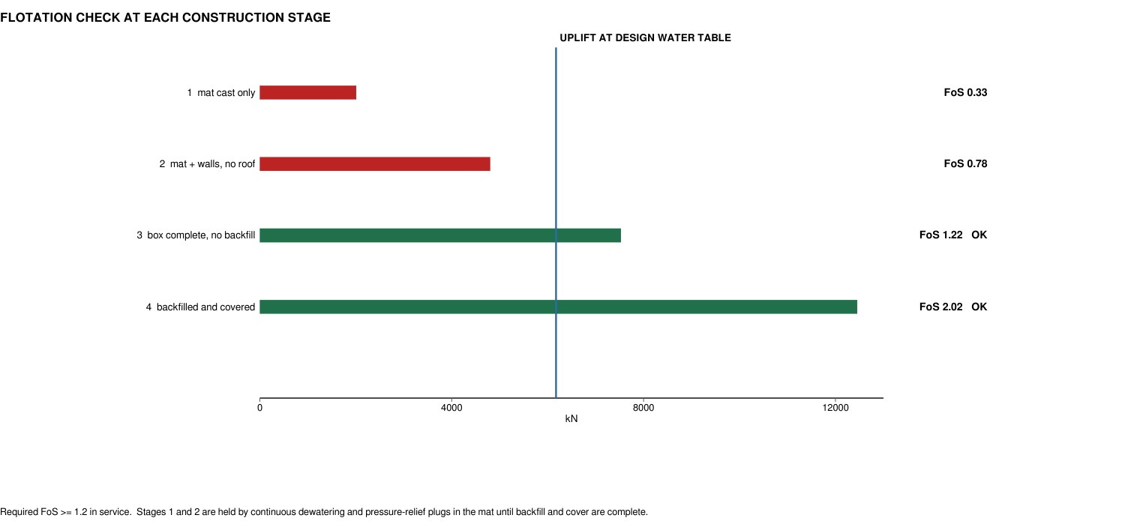
Fig 7.4 : Flotation check at each construction stage
Pressure slab (900 mm)
7.15 One-way action. The roof panel is 20.8 m long and 5.0 m wide, an aspect ratio of 4.2. IS 456 Table 26 is tabulated only up to 2.0, so two-way action is not claimed and the slab is designed to span one way across the 5.0 m width. The moment therefore depends only on the width; lengthening the box adds no roof moment, whereas widening it from 5.0 to 6.0 m would increase the moment by 44 per cent.
7.16 Flexure. The slab is designed for the total load of 448.15 kPa (combination 103).
d = 900 - 75 - 12.5 | 812.5 mm
M_{p} = w L_{n}² / 16 = 448.15 x 5.0² / 16 | 700.2 kNm/m
M_{u,lim} = 0.133 x 43.75 x 1000 x 812.5² | 3 841 kNm/m
A_{st} required | 1 632 mm²/m
Minimum steel 0.12 % x 900 = 1 080 mm²/m; maximum bar diameter D/8 = 112 mm | OK
Provided T25 @ 150 EF EW = 3 272 mm²/m; M_{u} = 1 362.4 kNm/m | Utilisation 51 %
x_{u} = 113.0 mm, x_{u}/d = 0.139 < 0.46 | Ductile

7.17 Shear. The shear at the support and the direct shear are checked as under.
V at the support face = 448.15 x 2.50 | 1 120 kN/m
V at d from the face = 448.15 (2.50 - 0.8125) | 756.3 kN/m
τ_{v} = 0.931 N/mm²; τ_{c} = 0.450 N/mm² (p_{t} 0.403 %); τ_{c,max} = 3.70 N/mm² | Links required
V_{us} = 390.8 kN/m; A_{sv}/s_{v} = 1.106 mm²/mm; spacing limit 300 mm governs
Provided T12 4-legged @ 250 in the end 1 500 mm each side; T12 2-legged @ 300 elsewhere | OK
Direct shear (UFC 3-340-02 Sec. 4-30)
V_{d,max} = 0.16 f_{ck,dyn} b d | 5 688 kN/m
Applied 1 120 kN/m | 19.7 %, OK

Direct shear is a blast-specific mode in which a very short, high shear pulse shears a slab at its support before the flexural response develops. It has been checked to UFC 3-340-02, since IS 456 does not cover it.
7.18 Choice of thickness. The thickness study for the pressure slab is given in Table 7.3. An 800 mm slab is the lightest adequate section; 900 mm has been adopted to provide reserve at the two 1 400 mm escape shaft collars where the slab is interrupted, to keep the support rotation small without lacing reinforcement, and to provide reserve against a higher threat level.
Table 7.3 : Pressure slab thickness study
t (mm) | d (mm) | M_{p} (kNm/m) | A_{st} req (mm²/m) | τ_{v} (N/mm²) | Remarks
600 | 512.5 | 689 | 2 673 | 1.71 | Links at 164, congested
800 | 712.5 | 696 | 1 868 | 1.12 | Lightest adequate
900 | 812.5 | 700 | 1 633 | 0.93 | Adopted
1000 | 912.5 | 704 | 1 453 | 0.78 | Heavier than needed

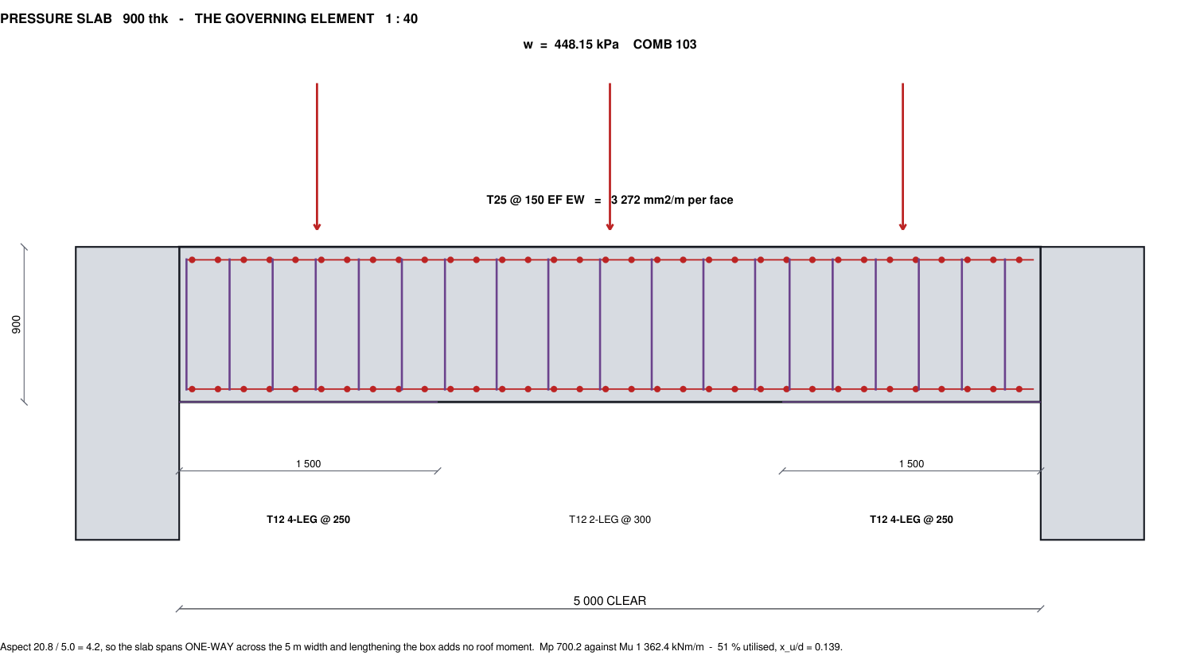
Fig 7.5 : Pressure slab, section and reinforcement
Openings in the pressure slab
7.19 Escape shaft openings. Each 1 400 mm diameter opening interrupts the slab steel in both directions and is trimmed as under.
Interrupted steel = 3 272 x 1.400 | 4 581 mm² per face per direction
Trimmers required each side = 4 581 / 2 | 2 291 mm²
Provided 5 No. T25 each side, each face, each direction (2 454 mm²), anchored L_{d} = 1 000 beyond | OK
Collar 250 RC with T16 @ 150 hoops in three layers and T16 @ 150 radials; slab thickened from 900 to 1 200 over a 600 mm annulus

The circular shape gives hoop action and no re-entrant corner. The trimmer band is the basis of the 750 mm clearance between the opening and the nearest wall (Chapter 3).
7.20 Stair void and cantilever pad. The 2 800 x 3 160 mm stair void leaves a cantilever of the 900 mm slab, 1 840 mm long and 2 800 mm wide, at the north end of bay 7.
M at the root = 448.15 x 1.840² / 2 | 758.6 kNm/m
A_{st} required, top = 1 772 mm²/m < 3 272 provided | Utilisation 56 %
V at the root = 448.15 x 1.840 | 824.6 kN/m
τ_{v} = 1.015 > τ_{c} 0.450; V_{us} = 459.4 kN/m; A_{sv}/s_{v} = 1.300 mm²/mm
Provided T12 4-legged links @ 250 throughout the pad | OK

In addition, the free edge is thickened from 900 to 1 200 mm over 600 mm with 6-T25 top and bottom and T12 closed links @ 150; a band of 6-T25 each face, top and bottom, is placed over W6 and W7; 4-T25 diagonal trimmers each face at 45° are placed at both re-entrant corners, 2 000 mm long each way; and the free edge carries a 1 100 mm high guard rail (NBC 2016 Part 4).
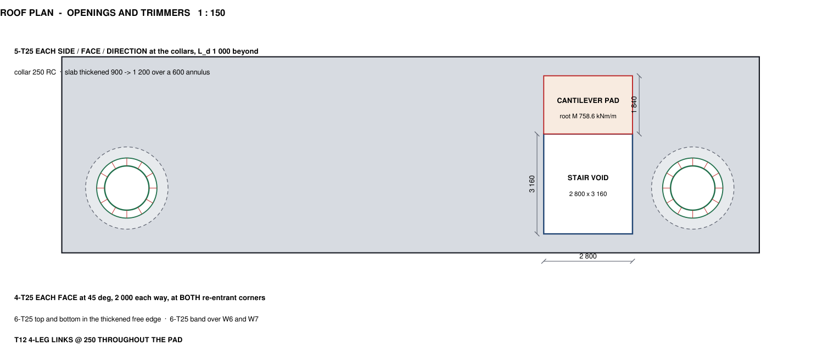
Fig 7.6 : Roof plan, openings and trimmers
Sump pit and internal walls
7.21 Clean sump SU-01. The sump pit in bay 5 is 1 500 x 1 500 x 1 500 mm internally (3.375 m³), with its invert at (-)7.600 and base slab at (-)8.000. The walls are 300 mm and the base 400 mm thick, reinforced with T16 @ 150 each face each way, and the pit is cast monolithic with the mat in the same continuous pour. The opening in the mat is trimmed with 4-T20 each face each side, anchored L_{d} 800 beyond, and the tanking membrane is dressed around the pit.
7.22 Wall W5 and partitions W8. Wall W5 (200 mm) is a fire and gas-tight wall with no pressure difference across it, and carries T12 @ 150 each face each way. The four W8 partitions are 110 mm non-structural walls reinforced with A252 mesh on both faces.
Summary of design
7.23 Principal elements. The design of the principal elements of the underground structure and the headhouse is summarised in Table 7.4.
Table 7.4 : Summary of design, underground structure and headhouse
Element | Thickness | Main reinforcement | Links | Util.
Pressure slab | 900 | T25 @ 150 EF EW | T12 4L @ 250 end 1 500; 2L @ 300 mid | 51 %
Perimeter walls W1 - W4 | 600 | T16 @ 150 EF EW | T12 closed @ 200 | 68 %
Walls W6, W7 | 400 | T20 @ 150 EF EW | T12 4L @ 200 | 69 %
Mat foundation | 600 | T16 @ 150 EF EW | T12 on 250 x 250 grid | 84 %
Headhouse roof | 500 | T20 @ 150 EF EW | T12 4L @ 175 / 250 | 90 %
Headhouse walls HW1 - HW4 | 400 | T16 @ 150 EF EW | T12 4L @ 250 | 59 %

CHAPTER 8
DESIGN OF STAIRCASES, HEADHOUSE AND CLOSURES
(MAIN STAIRCASE, ENTRY STAIRWELL, HEADHOUSE, BLAST DOORS AND ESCAPE SHAFTS)
Main staircase
8.1 Basis. The main staircase is within the stair shaft. The blast pressure in the shaft acts on the shaft walls and the blast doors; it does not produce a net load on the stair slabs, which are open on both faces. The staircase is therefore designed to IS 456 with the normal partial safety factors for the static loads.
8.2 Flight. Each flight has a waist of 200 mm and spans between the landings.
θ = tan⁻¹ (170.833 / 280) = 31.4°, cos θ | 0.8535
Waist 0.200 x 25 / 0.8535 | 5.858 kPa
Steps 0.5 x 0.170833 x 25 (IS 456 Cl. 33.2) | 2.135 kPa
Finishes | 1.000 kPa
Imposed load (plant route and escape route) | 5.000 kPa
Total 13.99 kPa; w_{u} = 1.5 x 13.99 | 21.0 kPa
L_{eff} = 1 960 + 600 + 600 (IS 456 Cl. 33.1(b)) | 3 160 mm
d = 200 - 30 - 6 | 164 mm
M = w_{u} L_{eff}² / 8 | 26.2 kNm/m
A_{st} required 380 mm²/m; minimum 0.12 % x 200 = 240 mm²/m
Provided T12 @ 150 main (754 mm²/m), M_{u} = 50.3 kNm/m | Utilisation 52 %
Distribution T10 @ 200; top steel T12 @ 150 for 800 mm into the flight, anchored L_{d} 480
Deflection: L/d = 19.3 < 20 x 1.9 = 38 (p_{t} 0.46 %, f_{s} = 146) | OK
Shear: V = 33.2 kN/m, τ_{v} = 0.202 < k τ_{c} = 1.20 x 0.479 = 0.575 N/mm² | OK, no links

8.3 Landings. Landings L1 and L2 and the arrival landing are 200 mm slabs spanning across the 2 800 mm shaft.
Load = self 7.50 + finishes 1.50 + imposed 7.50 + flight reaction 27.70 | 44.20 kPa
L_{eff} = 2 800 + 200 (IS 456 Cl. 22.2(a)) | 3 000 mm
M = 44.2 x 3.000² / 8 | 49.7 kNm/m
A_{st} required | 745 mm²/m
Provided T12 @ 125 bottom (905 mm²/m), M_{u} = 59.5 kNm/m | Utilisation 84 %
Top steel T12 @ 125 for 900 mm from each support; distribution T10 @ 200
Deflection: L/d = 18.3 < 20 x 1.35 = 27 | OK
Shear: V = 66.3 kN/m, τ_{v} = 0.404 < 1.20 x 0.519 = 0.622 N/mm² | OK

The arrival landing at (-)6.100 is the surface of the mat, and flight 3 lands on the 900 mm cantilever pad of the pressure slab at (-)2.000. The landings bear on walls W6 and W7, but the design of those walls does not rely on the landings as props.
Covered entry stairwell
8.4 Basis. The covered entry stairwell is outside the protective boundary and is designed to IS 456 for static loads. Its design is summarised below.
Flight: 12R @ 166.67 / 300, 1 500 wide, waist 250
θ = 29.05°; w_{u} = 1.5 x 15.233 | 22.85 kPa
L_{eff} = 3 300 + 750 + 750; d = 250 - 30 - 8 = 214 mm | 4 800 mm
M = 22.85 x 4.800² / 8 | 65.8 kNm/m
Provided T16 @ 200 main (1 005 mm²/m), M_{u} = 87.3 kNm/m, x_{u}/d = 0.162 | Utilisation 75 %
Distribution T10 @ 200; top steel T16 @ 200 for 1 200 mm, anchored L_{d} 640
Deflection L/d = 22.4 < 30; shear τ_{v} = 0.256 < 0.532 N/mm² | OK
Side walls, 250 thick, retaining 2.9 m
Pressure at base = 0.5 x 20 x 2.900 + 0.5 x 10 = 34 kPa; M = 14.0 kNm/m; A_{st} req 168 mm²/m
Provided T12 @ 200 EF EW (minimum steel of IS 456 Cl. 32.5 governs) | Utilisation 31 %
Raking roof, 250 thick, 1 500 clear
w_{u} = 1.5 x 33.65 = 50.5 kPa; M = w l² / 12 | 9.5 kNm/m
Provided T12 @ 200 EF EW (minimum steel governs), M_{u} = 48.2 kNm/m | Utilisation 20 %
Top landing, 250 thick
w_{u} = 54.9 kPa, L_{eff} = 1 750 mm, M = 21.0 kNm/m
Provided T12 @ 200 EF EW, M_{u} = 50.6 kNm/m | Utilisation 41 %
Platform, headwall and raft
Platform 250 and headwall 250: T12 @ 200 EF EW; stepped raft 300: T12 @ 200 EF EW
Door lintel over 1 000 clear, 250 x 350: 3-T12 top + 3-T12 bottom, T8 @ 150

8.5 Opening corner. At the top of the flight the tension face of the slab turns through an obtuse angle of 209°. A bar bent round such a corner has the resultant of its bend force directed out of the concrete and would spall the cover. The main bars are therefore not bent round this corner; each layer is continued straight, crossed and anchored L_{d} = 640 mm into the opposite face, and a U-bar T16 @ 200 is added across the corner (SP 34, Cl. 5.5). At the foot of the flight the corner closes (151°) and the bars are bent normally.
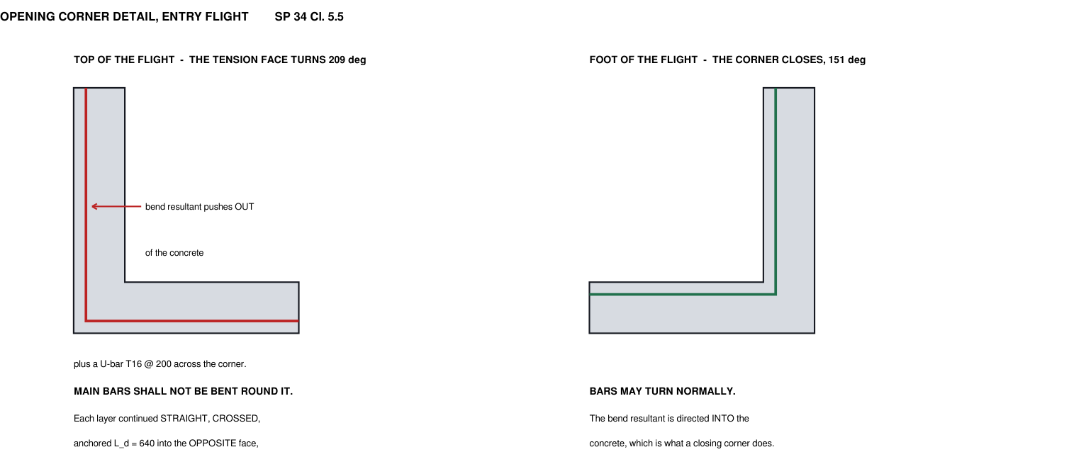
Fig 8.1 : Opening corner detail at the top of the entry flight
Entry headhouse
8.6 Roof slab (500 mm). The headhouse roof is a 4 000 x 5 000 mm panel monolithic with 400 mm walls on all four sides (l_{y}/l_{x} = 1.25) and is designed for 396.5 kPa. It has been analysed by three methods and the most conservative has been adopted.
d = 500 - 75 - 10 | 415 mm
M_{u,lim} = 0.133 x 43.75 x 1000 x 415² | 1 002 kNm/m
Method 1, one-way fixed-fixed strip, M_{p} = w L_{n}² / 16 = 396.5 x 4.0² / 16 | 396.5 kNm/m (adopted)
Method 2, IS 456 Table 26, Case 1, α_{x} = 0.045 | 285.5 kNm/m
Method 3, yield line, fixed on four edges | 162.2 kNm/m
A_{st} required (Method 1) 1 879 mm²/m; minimum 600 mm²/m
Provided T20 @ 150 EF EW = 2 094 mm²/m, M_{u} = 438.5 kNm/m | Utilisation 90 %
x_{u}/d = 0.174 < 0.46 | Ductile
Shear
V at d = 396.5 (2.000 - 0.415) | 628.4 kN/m
τ_{v} = 1.514 N/mm²; τ_{c} = 0.502 N/mm² (static M35, p_{t} 0.505 %) | Links required
V_{us} = 420.0 kN/m; A_{sv}/s_{v} = 2.327 mm²/mm; spacing limit 300 mm
Provided T12 4-legged links @ 175 in the end 1 200 mm each side, @ 250 elsewhere | OK

The yield line capacity for a slab fixed on four edges is w_{u} = 48 m / [a² (√(3 + (a/b)²) - a/b)²], which reduces to the fixed-fixed strip value w L²/16 as b tends to infinity. The one-way strip value has been adopted because it does not depend on full fixity of all four edges under a blast load. The roof has no opening. Its top steel is continuous over every support and anchored L_{d} = 800 mm into the walls, and 300 x 300 mm haunches with diagonal T16 @ 150 are provided at all four wall-roof junctions. Corner torsion steel (IS 456 Cl. D-1.8) is not required, since all four edges carry full hogging steel continuous into the walls.
8.7 Walls HW1 to HW4 (400 mm). The walls are designed for the full blast pressure of 383 kPa acting on either face over a clear height of 2.4 m.
d = 400 - 50 - 8 | 342 mm
M_{p} = 383 x 2.400² / 16 | 137.9 kNm/m
A_{st} required 766 mm²/m; minimum vertical 480 / horizontal 800 mm²/m
Provided T16 @ 150 EF EW = 1 340 mm²/m, M_{u} = 235.2 kNm/m, x_{u}/d = 0.135 | Utilisation 59 %
V at d = 328.6 kN/m; τ_{v} = 0.961 > τ_{c} 0.444 N/mm² | Links required
V_{us} = 176.9 kN/m; A_{sv}/s_{v} = 1.189 mm²/mm; spacing limit min (0.75d = 256, 300) | 256 mm
Provided T12 4-legged links @ 250 throughout all four walls | OK
Axial: worst N = 793 + 29 = 822 kN/m, f = 2.06 N/mm² = 12 % of 0.4 f_{ck,dyn} | OK

8.8 Door opening in HW2. The 900 x 2 100 mm door in HW2 interrupts 1 340 x 0.900 = 1 206 mm² per face, and 2 No. T20 (628 mm²) are provided at each jamb on each face, anchored L_{d} 800 beyond. The door head is at +0.100 and the roof soffit at +0.400, leaving only 300 mm of wall over the door. The 300 mm of wall and the 500 mm roof are therefore designed together as an 800 mm deep edge band.
w = 383 x 2.100 / 2 = 402 kN/m; M = w L² / 12 = 27.1 kNm; V = 181 kN
d = 800 - 40 - 8 - 10 = 742 mm; τ_{v} = 0.610 N/mm² | OK
Provided edge band 400 x 800: 4-T20 top + 4-T20 bottom, T12 4-legged links @ 150 over the opening and 600 mm each side | OK

The door frame is cast in and welded to the reinforcement cage for EMP continuity.
8.9 Wall HW3. HW3 stands on the pressure slab over bay 6 and has no wall below it. Its load is carried by a strip of the one-way pressure slab acting as a beam, with an effective width of 0.400 + 2 x 1.05 = 2.5 m (45° spread through the 900 mm slab).
Two-way roof distribution (IS 456 Cl. 24.5): line load 476 + 29 = 505 kN/m
Equivalent UDL = 505 / 2.5 + 22.5 + 2.0 = 226 kPa; M = 226 x 5.0² / 16 | 354 kNm/m
Against the slab capacity of 1 362 kNm/m | 26 %
One-way roof bound: line load 822 kN/m, equivalent 353 kPa, M = 552 kNm/m | 41 %

No change in the slab is required. For robustness, 4 No. T25 additional bars top and bottom are placed in a 1 200 mm band under HW3, lapped 1 250 mm (50 φ) into the main mesh.
Blast doors
8.10 Requirements. Blast Doors 1 and 2 are proprietary tested assemblies, each 1 200 x 2 100 mm, rated not less than 7 bar, gas-tight and rebound-rated. Each door and its frame performs four functions at the same time:-
8.10.1 Positive pressure. The door takes the full 383 kPa from the stair shaft, in the same plane as the 400 mm wall in which it is set.
8.10.2 Rebound. The negative phase of the blast and the rebound of the structure pull the leaf away from its frame. The door and its latching resist load in both directions.
8.10.3 Gas-tightness. The door is part of the envelope tested at +300 Pa. The seal seats on the steel frame, not on the concrete.
8.10.4 EMP continuity. The frame is cast in and welded to the reinforcement cage, so the cage is continuous around the opening. The same rule is applied to the frame of the headhouse security door and of the gas-tight door D-05 in W5.
8.11 Door D-05 in wall W5. Wall W5 separates the plant room (bay 5), which contains the activated carbon filter beds, from the airlock (bay 6), and the primary escape route passes through it. It is fitted with a gas-tight, fire-rated door D-05, which is not blast rated since there is no pressure difference across W5.
Escape shaft heads and ladders
8.12 Hatch loading. Each escape shaft is a 1 400 mm bore through the pressure slab, within a 250 mm collar of 1 900 mm outside diameter, with its head at +0.150 (ESC 1) or +0.700 (ESC 2). The hatch at the head closes an opening in the protective boundary and is designed for the full blast pressure of 383 kPa.
Force on the leaf = 383 x π x 0.700² | 589.6 kN
Moment, circular plate simply supported, M = w a² (3 + ν) / 16, ν = 0.30 | 38.71 kNm/m
Shear at the seating = w a / 2 | 134.1 kN/m
Flat Fe250 plate, t = √(6M / σ) = 30.5, say 32 mm; mass of a 1 600 dia x 32 mm leaf | 505 kg

8.13 Hatch adopted. A flat plate of 505 kg cannot be opened by a person climbing out of the shaft. The hatch is therefore a ribbed steel weldment, with the following particulars:-
8.13.1 Leaf. 1 600 mm diameter, 12 mm face plate, 8 radial ribs 150 x 10 mm and a 150 x 12 mm perimeter ring; indicative mass about 322 kg.
8.13.2 Seating. A steel seating ring cast into the 250 mm collar, with 150 mm bearing all round.
8.13.3 Fastening. Four quarter-turn dogs, so that the leaf resists uplift due to the negative phase and rebound as well as downward pressure.
8.13.4 Operation. Counterbalanced or spring-assisted, and openable from inside by one person without a key or tool.
8.13.5 EMP bonding. The leaf, the seating ring and the collar reinforcement are electrically continuous, and the hatch is procured as a single item covering both its structural and its bonding requirements.
8.14 Ladders. One ladder type serves both shafts, with the following particulars:-
8.14.1 Rungs. 20 mm diameter galvanised mild steel rungs, 400 mm clear width, at equal pitch within each shaft: 297.6 mm over 21 spaces in ESC 1 and 295.7 mm over 23 spaces in ESC 2.
8.14.2 Stringers and fixing. Two 50 x 10 mm galvanised flat stringers, fixed by cast-in lugs to the collar and the roof slab bore, with expansion-anchored brackets at 1.5 m centres over the lower 3.2 m.
8.14.3 Clearances. Not less than 200 mm behind the rungs and 750 mm clear climbing space in front, with grab rails extending 1 100 mm above the head.
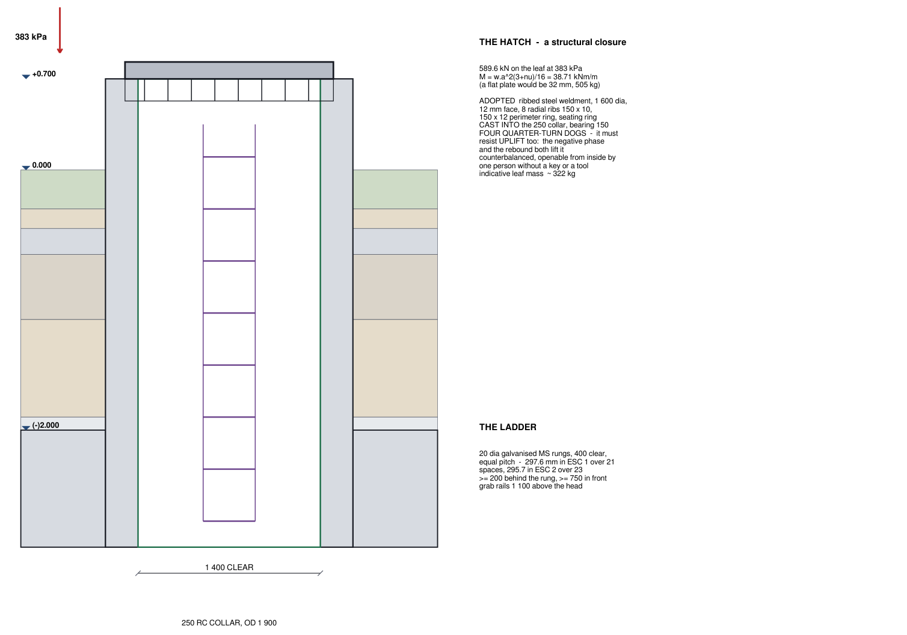
Fig 8.2 : Escape shaft head, hatch and ladder
CHAPTER 9
DESIGN OF THE SENTRY POST
(SLAB, BEAMS, COLUMNS, FOOTINGS, LINTELS AND WALL TIES)
General
9.1 Design basis. The sentry post is an observation post outside the protective boundary. It has been designed as a conventional reinforced concrete moment-resisting frame for gravity, seismic and wind loads, to IS 456 : 2000, IS 1893 (Part 1) : 2016 and IS 13920 : 2016, in M30 concrete with Fe500 reinforcement. All members are designed for the base shear of 73.18 kN.
9.2 Blast. The post is not designed for blast. The reflected pressure of 1 366 kPa on its 4.0 x 6.7 m face amounts to about 36 600 kN, and resisting it would need about 700 mm of reinforced concrete on all four above-ground faces, which is not justified for a peacetime observation post. The protection of the shelter does not depend on the post in any way.
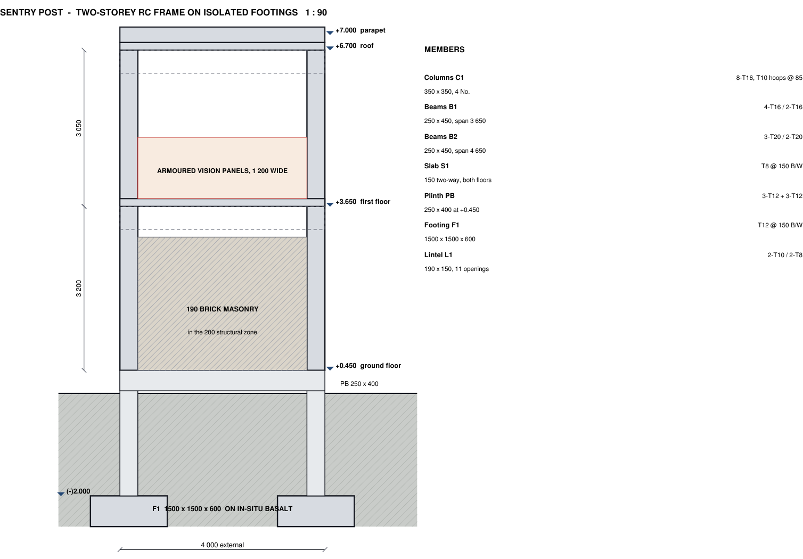
Fig 9.1 : Sentry post, two-storey RC frame on isolated footings
Slab S1 (150 mm, two-way)
9.3 Design. The slab is a two-way panel on beams at both floors, designed for the first-floor load of 11.625 kPa, which governs.
Cover 30 mm, T8 bars: d_{x} = 150 - 30 - 4 = 116 mm; d_{y} = 150 - 30 - 8 - 4 = 108 mm
l_{x} = min (3 400 + 116, 3 650) = 3 516 mm; l_{y} = min (4 400 + 108, 4 650) = 4 508 mm
l_{y} / l_{x} = 1.282 < 2 | Two-way
IS 456 Table 26, Case 9 (four edges discontinuous, corners restrained): α_{x} = 0.0777, α_{y} = 0.056
M_{x} = 0.0777 x 11.625 x 3.516² | 11.17 kNm/m
M_{y} = 0.0560 x 11.625 x 3.516² | 8.05 kNm/m
A_{st} required: x 229, y 176 mm²/m; minimum 0.12 % x 150 = 180 mm²/m
Provided T8 @ 150 both ways bottom (335 mm²/m), M_{u} = 16.09 / 14.92 kNm/m | Utilisation 69 % / 54 %
Deflection: l_{x}/d_{x} = 30.3 < 20 x 1.68 = 33.6 (taken as simply supported) | OK
Shear: V_{u} = 13.6 kN/m, τ_{v} = 0.117 < 1.30 x 0.390 = 0.507 N/mm² | OK

9.4 Detailing. The slab is detailed to IS 456 Annex D as given in Table 9.1. The corner torsion steel is essential to the use of the Table 26 coefficients and is inspected before concreting.
Table 9.1 : Detailing of slab S1
Clause | Requirement | Provided
D-1.4 | 50 % of mid-span bottom steel to within 0.1 L of the edge; the rest curtailed at 0.25 L | As required
D-1.6 | Top steel at discontinuous edges, 50 % of mid-span steel, 0.1 L into the span | T8 @ 300 top, 400 mm band, all four edges
D-1.8 | Corner torsion steel, 3/4 of mid-span steel, four layers, over l_{x}/5 | T8 @ 200 in four layers, 700 x 700 at every corner

Beam B1 (250 x 450, span 3 650)
9.5 Section. The section satisfies the limits of IS 13920 Cl. 6.1: b = 250 ≥ 200 mm, b/D = 0.556 ≥ 0.3 and clear span / D = 3 300 / 450 = 7.33 ≥ 4.
9.6 Flexure. The support moments under the load combinations are given in Table 9.2. The seismic moment at the first-floor joint is 51.96 kNm.
Table 9.2 : Beam B1, support moments (kNm)
Combination | Hogging moment
1.5 (DL + LL) | 29.8
1.2 (DL + LL + EL) = 1.2 (19.87 + 51.96) | 86.2
1.5 (DL + EL) = 1.5 (17.01 + 51.96) | 103.5 (governs)
0.9 DL + 1.5 EL | 93.2

d = 450 - 30 - 8 - 8 = 404 mm; M_{u,lim} = 0.133 x 30 x 250 x 404² | 162.8 kNm
M_{u} = 103.5 kNm < 162.8, A_{st} required | 661 mm²
Top at supports: 4-T16 (804 mm²), M_{u} = 122.6 kNm, x_{u}/d = 0.321 | Utilisation 84 %
Reversal 1.5 (17.01 - 51.96) = 52.4 kNm sagging, A_{st} 313 mm²
IS 13920 Cl. 6.2.3, bottom ≥ 50 % of top = 0.5 x 804 | 402 mm² (governs)
Bottom: 2-T16 continuous (402 mm²), M_{u} = 66.0 kNm | OK
Minimum 0.24 √f_{ck} / f_{y} x b d = 266 mm²; maximum 2.5 % = 2 525 mm² | OK

9.7 Shear by capacity design. The design shear is the shear that accompanies the flexural capacity of the beam (IS 13920 Cl. 6.3.3), V_{u} = 1.2 (D + L) L/2 ± 1.4 (M_{u}^{As} + M_{u}^{Bh}) / L.
Gravity: 1.2 x 80.1 / 2 | 48.1 kN
Sway: 1.4 x (122.6 + 66.0) / 3.650 | 72.3 kN
V_{u} | 120.4 kN
τ_{v} = 1.192 N/mm² < τ_{c,max} 3.50 N/mm² | OK
Earthquake share = 72.3 / 120.4 = 60 % > 50 %, so τ_{c} = 0 in the hinge zone (Cl. 6.3.4)
A_{sv}/s_{v} = 120.4 x 10³ / (0.87 x 500 x 404) = 0.685 mm²/mm, i.e. T8 2-legged at 147 mm
Hinge zone spacing ≤ min (d/4 = 101, 8 x 16 = 128), not less than 100 mm (Cl. 6.3.5) | 100 mm
Provided T8 2-legged hoops @ 100 over 2d = 810 mm from each face, @ 150 elsewhere | OK
Deflection: l/d = 3 650 / 404 = 9.0 < 20 | OK

Beam B2 (250 x 450, span 4 650)
9.8 Flexure. The support moments of B2 are given in Table 9.3.
Table 9.3 : Beam B2, support moments (kNm)
Combination | Hogging moment
1.5 (DL + LL) | 56.3
1.2 (DL + LL + EL) = 1.2 (37.51 + 51.96) | 107.4
1.5 (DL + EL) = 1.5 (31.25 + 51.96) | 124.8 (governs)
0.9 DL + 1.5 EL | 106.1

M_{u} = 124.8 kNm < 162.8, A_{st} required | 822 mm²
Top at supports: 3-T20 (942 mm²), M_{u} = 139.8 kNm, x_{u}/d = 0.376 | Utilisation 89 %
Bottom ≥ 0.5 x 942 = 471 mm²; mid-span 49.6 kNm needs 297 mm²
Bottom: 2-T20 continuous (628 mm²), M_{u} = 98.9 kNm | OK

Three T20 bars are used in place of five T16 bars, which would need 256 mm of width in the 250 mm beam.
9.9 Shear by capacity design. The design shear of B2 is worked out as for B1.
Gravity: 1.2 x 121.4 / 2 | 72.8 kN
Sway: 1.4 x (139.8 + 98.9) / 4.650 | 71.9 kN
V_{u} = 144.7 kN; τ_{v} = 1.433 N/mm² | OK
Earthquake share 49.7 %; taken as 50 % and τ_{c} = 0 in the hinge zone
A_{sv}/s_{v} = 0.823 mm²/mm (T8 2-legged at 122 mm); hinge spacing limit 100 mm governs
Provided T8 2-legged hoops @ 100 over 810 mm from each face, @ 150 elsewhere | OK
Deflection: l/d = 4 650 / 404 = 11.5 < 20 | OK

Column C1 (350 x 350)
9.10 Slenderness and loads. The columns are short and are designed for the axial loads and moments given below.
Clear height, ground storey = 3 650 - 450 - 450 = 2 750 mm; l_{ex} = 1.2 x 2 750 = 3 300 mm
l_{ex} / D = 9.43 < 12 | Short column
e_{min} = l/500 + D/30 = 17.2, not less than 20 mm; M_{min} = 5.5 kNm | Not critical
Per column: DL 148.4 kN, LL 19.1 kN, seismic axial ±36.127 kN
1.5 (DL + LL) = 251.3 kN; 1.5 (DL + EL) = 276.8 kN; 1.5 (DL - EL) = 168.4 kN

9.11 Longitudinal steel. Eight T16 bars (1 608 mm², p = 1.31 per cent) are provided, distributed on all four faces, within the limits of 0.8 and 6 per cent (IS 456 Cl. 26.5.3.1). Clear cover is 40 mm and d′ = 56 mm (d′/D = 0.16). The uniaxial capacities have been computed from the IS 456 stress block and the Fe500 stress-strain curve.
Uniaxial capacity M_{u1} at P_{u} = 168.4 / 251.3 / 276.8 kN | 105.8 / 111.7 / 112.9 kNm
P_{uz} = 0.45 x 30 x 120 892 + 0.75 x 500 x 1 608 | 2 235 kN
P_{u} / P_{uz} = 0.124 < 0.2, α_{n} = 1.0 (IS 456 Cl. 39.6)
Earthquake in Z with 30 % in X (IS 1893 Cl. 6.3.2.2): M_{ux} = 25.6, M_{uy} = 66.8 kNm
25.6 / 112.9 + 66.8 / 112.9 = 0.227 + 0.592 | 0.819 < 1.0, OK

9.12 Strong column - weak beam. The check of IS 13920 Cl. 7.2.1, ΣM_{c} ≥ 1.4 ΣM_{b}, at the first-floor joints is given in Table 9.4.
Table 9.4 : Strong column - weak beam check at the first floor
Joint | ΣM_{b} (kNm) | 1.4 ΣM_{b} (kNm) | ΣM_{c} (kNm) | Check
First floor, X direction (B1) | 122.6 | 171.6 | 112.9 + 101.0 = 213.9 | OK
First floor, Z direction (B2) | 139.8 | 195.7 | 213.9 | OK

9.13 Transverse reinforcement. The ties and the special confining reinforcement are designed as under.
General ties: diameter ≥ max (6, 16/4) = 8 mm; spacing ≤ min (350, 16 x 16 = 256, 300)
IS 13920 Cl. 7.4: hoops over the full length at ≤ half the least dimension | 175 mm
Provided T8 hoops @ 150 outside the confining zone | OK
Confining length l_{o} ≥ max (350, 2 750 / 6 = 458, 450) | 500 mm
Spacing ≤ 0.25 x 350 = 87.5, between 75 and 100 mm | 85 mm
A_{sh} = 0.18 s h (f_{ck}/f_{y}) [(A_{g}/A_{k}) - 1] = 0.18 x 85 x 270 x 0.06 x 0.680 | 168.5 mm²
Provided T10 hoops + one cross-tie each way @ 85, 3 legs x 78.5 = 235.5 mm², over 500 mm from every joint face and through the joint | OK
Storey drift under the service seismic load < 3 mm against 0.004 h = 12.8 mm | OK

Isolated footing F1 (1 500 x 1 500 x 600)
9.14 Founding. The footings are founded on in-situ basalt at (-)2.000, below the black cotton soil horizon and clear of the backfill of the shelter excavation.
9.15 Base pressure. The base pressures are worked out as under.
Service
P = 167.5 (column) + 36.1 (seismic axial) + 33.75 (footing) | 237.4 kN
M = 29.3 kNm; e = 0.123 m < L/6 = 0.250 m | No tension
q_{max} = 105.5 (1 + 6 x 0.123 / 1.5) | 157.6 kPa
Against 3 240 kPa (4.9 %) and the soaked rock value 1 961 kPa (8.0 %) | OK
Ultimate, 1.5 (DL + EL)
P_{u} = 1.5 (148.4 + 36.127) = 276.8 kN; M_{u} = 1.5 x 29.27 = 43.9 kNm
e_{u} = 43.9 / 276.8 = 0.159 m < 0.250 m; average pressure 276.8 / 2.25 = 123.0 kPa
q_{u,max} = 123.0 (1 + 6 x 0.159 / 1.5) | 201.1 kPa

9.16 Design of the base. The base is designed conservatively for the maximum pressure acting over the whole cantilever.
Cantilever from the column face = (1 500 - 350) / 2 | 575 mm
M_{u} = 201.1 x 0.575² / 2 | 33.2 kNm/m
d = 600 - 50 - 8 | 542 mm
A_{st} required 142 mm²/m; minimum 0.12 % x 600 = 720 mm²/m | Minimum governs
Provided T12 @ 150 both ways bottom (754 mm²/m) | OK
One-way shear at d from the face (33 mm from the edge): V_{u} = 6.6 kN/m, τ_{v} = 0.012 N/mm² | OK
Punching at d/2 (IS 456 Cl. 31.6.1): b₀ = 4 x (350 + 542) = 3 568 mm
V_{u} = 276.8 - 123.0 x 0.892² = 178.9 kN; τ_{v} = 0.093 N/mm² < 0.25 √30 = 1.369 N/mm² | OK
Anchorage of column starters: L_{d} (compression) = 37 x 16 = 592 mm; available 526 + 128 (bend) = 654 mm | OK

The 600 mm depth is governed by the anchorage of the column starter bars, not by bending or shear.
Lintels and wall ties
9.17 Lintel L1. One lintel type, L1, is used over all eleven openings in the sentry post (ground floor door D1 900 and window W1 1 200; first floor door D1 900 and eight vision-panel openings 1 200 wide). The lintel carries only the masonry above it, since the floors and roof are carried by beams B1 and B2.
Section 190 x 150, M30 / Fe500, cover 30, bearing 200 each end
Effective span = min (clear + d, bearing centres) = min (1 315, 1 400) | 1.315 m
Masonry height at the 60° arching limit = 0.866 x 1.315 | 1.139 m
w = 0.190 x 20 x 1.139 | 4.33 kN/m
M = 0.935 kNm, V = 2.85 kN; M_{u} = 1.403 kNm against M_{u,lim} = 10.03 kNm | 14 %
A_{st} required 29.5 mm²; minimum 0.85 b d / f_{y} = 37.1 mm² | Minimum governs
Provided 2-T10 bottom (157 mm²), 2-T8 top, T6 2-legged links @ 150 | OK
τ_{v} = 0.195 < τ_{c} 0.56 N/mm² | Nominal links only

The lintel has been designed for masonry standing just below the 60° arching height, which is the heaviest load any opening height can produce, so the design covers every opening in the post.
9.18 Wall ties. The brick infill is tied to the columns with 6 mm mild steel ties at every fifth course (about 450 mm) up both column faces, projecting 200 mm into the bed joint and anchored to the column by a cast-in or drilled and grouted 10 mm dowel. The top course is built tight to the beam soffit and the joint packed, consistent with the response reduction factor of 3.0 adopted for a frame with unseparated infill.
Summary
9.19 Reinforcement of the sentry post. The reinforcement of the sentry post is summarised in Table 9.5.
Table 9.5 : Reinforcement of the sentry post
Member | Size (mm) | Reinforcement
Slab S1 | 150 thick | T8 @ 150 both ways bottom; T8 @ 300 top at edges; T8 @ 200 corner mats in four layers
Beam B1 | 250 x 450 | 4-T16 top at supports, 2-T16 bottom continuous; T8 2L @ 100 / 150
Beam B2 | 250 x 450 | 3-T20 top at supports, 2-T20 bottom continuous; T8 2L @ 100 / 150
Column C1 | 350 x 350 | 8-T16; T10 hoops + cross-ties @ 85 over 500 mm at joints; T8 @ 150 elsewhere
Plinth beam PB | 250 x 400 | 3-T12 top + 3-T12 bottom
Footing F1 | 1 500 x 1 500 x 600 | T12 @ 150 both ways bottom
Lintel L1 (11 No.) | 190 x 150 | 2-T10 bottom, 2-T8 top, T6 2L @ 150

CHAPTER 10
CBRN PROTECTION AND VENTILATION
(COLLECTIVE PROTECTION, FILTRATION, OVERPRESSURE AND CLOSED-MODE ENDURANCE)
Design basis
10.1 Principle. The occupants are protected against chemical and biological agents and radioactive dust by collective protection. All air entering the gas-tight envelope is filtered, and the envelope is held above atmospheric pressure so that any leakage flows outwards. The design basis is given in Table 10.1.
Table 10.1 : Ventilation design basis
Parameter | Value
Occupancy / endurance | 9 persons / 96 hours
Gas-tight envelope | Bays 1 to 6; 67.80 m², 216.96 m³
Clean zone (bays 1 to 5) | 57.80 m²; occupied volume 184.96 m³ with the airlock closed
Design flow | 300 m³/h per train; two trains, one duty and one standby (N+1)
Flow per person | 33.3 m³/h
Air changes, envelope / clean zone | 1.38 / 1.62 per hour
Check against FEMA 453 (0.25 cfm/ft²) | 57.8 m² = 622.2 ft², requiring 264.3 m³/h; 300 m³/h provided
Survival / working-shelter rates | 5 and 15 m³/h per person = 45 and 135 m³/h; 300 m³/h provided
Operating overpressure | +50 to +100 Pa
Leakage limit | 0.15 volume/h at +300 Pa = 32.5 m³/h (11 % of one train)
Pressure cascade, dirty to clean | 0, +10, +20, +35, +50 Pa
Duct and plenum loss (excluding the filter stages) | 161 Pa

Filtration
10.2 Threats and filter stages. Particulate agents and gaseous agents are removed by different mechanisms, and the filter stages are therefore in series, as given in Table 10.2.
Table 10.2 : Threats and means of removal
Threat | Form | Removed by
Radioactive dust, fallout, biological agents | Aerosol, 0.1 to 10 μm | HEPA filter, EN 1822 class H14, 99.995 % at the most penetrating particle size
Chemical warfare agents | Vapour | Impregnated activated carbon (ASZM-TEDA)
Coarse dust; the blast pulse | - | Pre-filter; blast valve

10.3 Filter train. Each filter train consists of seven stages in the order shown in Fig 10.1: weather louvre with sand and debris trap; blast valve (closes in less than 2 ms and holds for 1.3 s); pre-filter G4/F7; HEPA filter H14; activated carbon bed ASZM-TEDA (300 000 mg.min/m³); fan with electric drive and hand crank; and supply plenum at +50 to +100 Pa. A differential pressure gauge is fitted across every stage and a flow meter on each train, to indicate filter loading and to set the change-out of each stage. The fan is selected on the pressure drop of the filters in the dirty condition, and the hand crank is sized for the same duty.
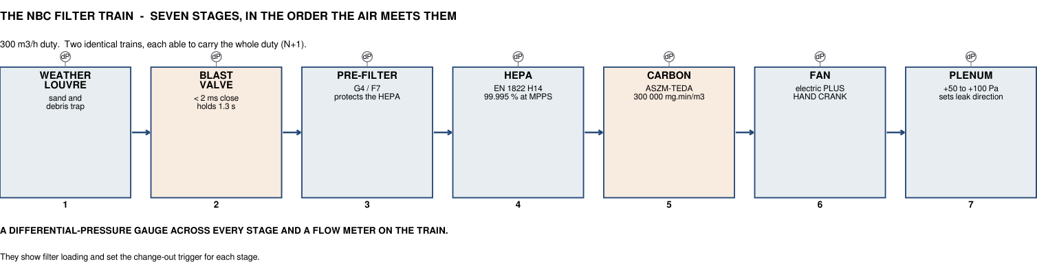
Fig 10.1 : NBC filter train, seven stages
10.4 Blast valves. Five blast valves protect the openings through which air enters and leaves, as given in Table 10.3. They are recessed into the walls (IS 4991 Cl. 6.2.1) and each has a manual quarter-turn gas-tight damper on its inner side.
Table 10.3 : Blast valves
Tag | Size | Location | Function
BV-1, BV-2 | DN100 | West wall W1, bay 1 | Fresh air intake from shaft SH-1
BV-3 | DN100 | Wall W6 at (14998, 4900) | Exhaust from the airlock to the stair shaft
BV-4, BV-5 | DN350 | East wall, bay 8 | Generator combustion and cooling air, 2 600 m³/h, from shaft SH-2

10.5 Carbon beds. The activated carbon beds give out heat when they adsorb, and the filter bay is therefore included in the fire load of the shelter (Chapter 14). The plant room is separated from the airlock by the fire and gas-tight wall W5.
Air distribution and overpressure
10.6 Air path. Fresh air is drawn through the intake shaft SH-1 (600 x 600 mm, gooseneck head at +1.500, west of the box), enters through BV-1 and BV-2 in the west wall of bay 1, and is carried along the clean zone to the filter trains in bay 5 in a raw-air duct. The raw-air duct is fully welded with no push-fit or slip joints, is run exposed along its whole length and labelled, and is tested to the +300 Pa envelope standard. Filtered air is distributed to the rooms, flows through the three stages of the airlock and leaves through BV-3 into the stair shaft. The air path is shown in Fig 10.2.
10.7 Room distribution. The operations room and the berthing bay are not occupied at the same time, and two volume control dampers switch the flow between day and night settings, as given in Table 10.4. The occupied room of the pair receives 135 m³/h, i.e. 15 m³/h per person.
Table 10.4 : Room air distribution
Room | Use | Volume (m³) | Day (m³/h) | Night (m³/h) | Extract (m³/h)
U-01 | Emergency stores, ESC 1 | 46.40 | 30 | 30 | -
U-02 | Lavatory and medical | 28.80 | 30 | 30 | 45
U-03 | Operations room | 56.00 | 135 | 45 | -
U-04 | Berthing, 9 berths | 28.80 | 45 | 135 | -
U-05 | CBRN plant and sump | 24.96 | 60 | 60 | -
U-06 | Decontamination airlock | 32.00 | 300 transfer | 300 transfer | to BV-3
 | Total supply |  | 300 | 300

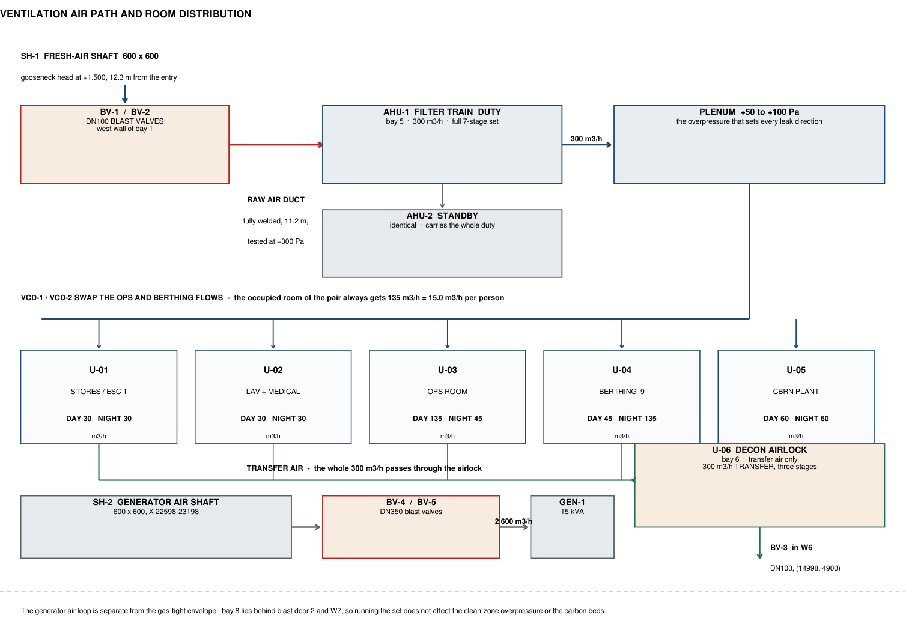
Fig 10.2 : Ventilation air path and room distribution
10.8 Overpressure cascade. The pressure steps down from the clean zone to the stair shaft through the three airlock stages, as given in Table 10.5 and Fig 10.3, so that at every door air moves from clean to dirty. No air is supplied directly to the airlock; the whole 300 m³/h passes through it.
Table 10.5 : Overpressure cascade
Zone | Pressure | Maintained by
Stair shaft, bay 7 | 0 Pa | Atmosphere, outside the envelope
Airlock stage 1, dirty end | +10 Pa | Transfer from stage 2
Airlock stage 2 | +20 Pa | Transfer from stage 3
Airlock stage 3, clean end | +35 Pa | Transfer from the clean zone
Clean zone, bays 1 to 5 | +50 Pa | Supply plenum, +50 to +100 Pa

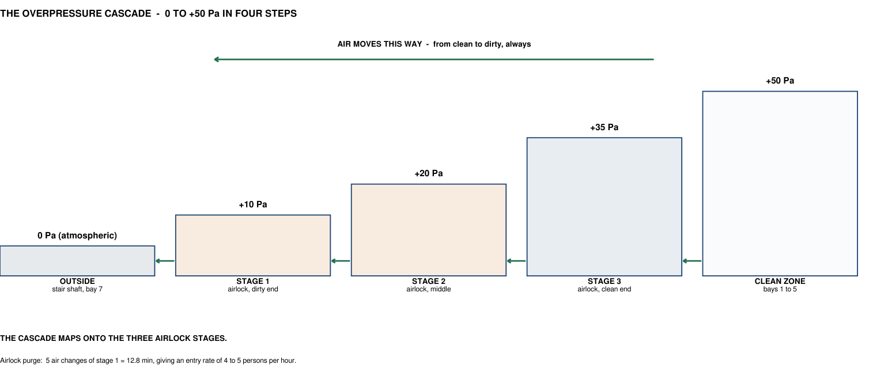
Fig 10.3 : Overpressure cascade through the airlock
10.9 Decontamination airlock. The airlock has three stages, 2 000 x 2 000, 2 000 x 1 500 and 2 000 x 1 500 mm. Each entry requires five air changes of the airlock volume before the next person can pass.
Purge volume = 5 x (2.0 x 2.0 x 3.2) | 64 m³
Purge time at 300 m³/h | 12.8 min
Entry rate through the airlock | 4 to 5 persons per hour

10.10 Trap seals. Every water trap within the envelope is a pressure boundary. Traps are provided with 75 mm deep seals, which hold 736 Pa, i.e. 7.4 times the operating overpressure and 2.5 times the test pressure, and are kept primed as a routine maintenance task.
Closed mode
10.11 Endurance. In the closed mode all five blast valves are shut and there is no fresh air. The endurance is set by the carbon dioxide produced and the oxygen consumed by the occupants.
Allowable CO₂ rise 0.04 % to 1.0 % = 0.0096 volume fraction; occupied volume 184.96 m³
CO₂ produced = 9 x 0.020 m³/h | 0.18 m³/h
Time to reach 1.0 % without scrubbing = 0.0096 x 184.96 / 0.18 | 9.9 h
CO₂ scrubber, soda lime store 40 kg at 20 kg/day | 48 h
Oxygen store, 2 x 50 litre cylinders at 150 bar = 15 m³ at 4.5 m³/day | 80 h

The CO₂ scrubber is therefore an essential item, and the closed mode can be maintained for 48 hours on the soda lime store. For the remainder of the 96 hours the shelter operates in the filtered mode.
10.12 CO<sub>2</sub> scrubber loop. The recirculation flow through the scrubber, Q = CO₂ production / (efficiency x target concentration), is 72.0 m³/h at 50 per cent single-pass efficiency and a target of 0.5 per cent. A recirculation loop of 75 m³/h has been adopted. Its fan draws about 11.6 W at 250 Pa, within the allowance of 0.10 kW on the essential board.
10.13 Operating modes. The operating modes are given in Table 10.6. The generator air path through BV-4 and BV-5 serves bay 8 only, which is outside the gas-tight envelope. All five blast valves close on the arrival of the shock, and BV-4 and BV-5 are then reopened for generator operation, so that the generator can run in the closed mode without affecting the clean zone.
Table 10.6 : Operating modes
Mode | Condition
1. Normal | Peacetime ventilation
2. Filtered (protective) | Full seven-stage filtration; overpressure maintained
3. Closed | From attack to all-clear; blast valves shut; CO₂ scrubbing and oxygen supply; 48 h
4. Purge | Airlock purge for each entry, 12.8 min
5. Generator running | BV-4 and BV-5 open for bay 8; independent of modes 1 to 4

Heat balance
10.14 Heat gains. The sensible heat gain within the envelope in the closed mode is the electrical load dissipated inside it (5.733 kW) and the sensible heat of the occupants (9 x 70 W = 0.630 kW), a total of 6.363 kW, or 2.199 GJ over 96 hours.
10.15 Heat sink. Almost all of this heat is absorbed by the concrete of the envelope and the rock around it, since the air in the envelope has a heat capacity of only 262 kJ/K. The concrete that can respond within 96 hours (a thermal penetration depth of √(αt) = 0.436 m) has been taken as a 0.30 m layer over the 414.38 m² of internal surface, with a heat capacity of 273 493 kJ/K.
10.16 Cooling duty. To hold the internal air at 30 °C from a ground temperature of 26 °C, the structure absorbs 273 493 x 4 = 1.094 GJ and the remaining 1.105 GJ is to be removed, a mean sensible duty of 3.20 kW. With a latent load of 0.405 kW the mean duty is 3.60 kW (1.02 TR), and a closed-mode cooling duty of 4 kW (1.14 TR) has been adopted.
Testing
10.17 Envelope leakage test. On completion, the gas-tight envelope is tested at +300 Pa. The leakage must not exceed 0.15 volume changes per hour (32.5 m³/h). The test is repeated after any work that penetrates the envelope, and the raw-air duct is re-tested after any work in bays 1 to 4.
CHAPTER 11
EMP PROTECTION
(SHIELDING, POINTS OF ENTRY, BONDING AND EARTHING)
The threat
11.1 High-altitude EMP. A nuclear burst high above the atmosphere produces no blast or fallout at the ground but generates an intense electromagnetic pulse. Gamma rays from the burst eject electrons from air molecules by Compton scattering, and the geomagnetic field turns these electrons into a transverse current sheet that radiates a nearly plane wave over a very large area. The pulse has three components, as given in Table 11.1.
Table 11.1 : Components of high-altitude EMP
Component | Time scale | Couples to
E1 | Nanoseconds | Short conductors, cables, equipment enclosures and circuit boards; the component that damages electronics
E2 | Microseconds to milliseconds | Similar to lightning; conventional surge protection is effective
E3 | Seconds | Long conductors such as power lines and pipelines (quasi-DC induced currents)

11.2 Purpose of protection. EMP is not a hazard to the occupants, who are protected by the structure against blast, CBRN agents and radiation. EMP protection is provided so that the communication and control equipment of the operations room continues to function after the event.
11.3 Design requirement. The mission equipment is protected to MIL-STD-188-125-1, which requires a shielding effectiveness of 80 dB from 10 kHz to 1 GHz, verified by a survey to IEEE Std 299. The lower end of the band is set by the E3 component and the upper end by the fast rise of E1.
Zone concept
11.4 EMP zones. The installation is divided into three EMP zones, as given in Table 11.2 and Fig 11.1.
Table 11.2 : EMP zones
Zone | Extent | Protection
Zone 0 | Everything above grade: sentry post, headhouse, covered stairwell, shaft heads | No shielding credit taken
Zone 1 | The buried box, all eight bays; the reinforcement cage | Low-frequency attenuation; taken as margin only
Zone 2 | Welded steel shielded enclosure in the operations room, bay 3 | 80 dB, 10 kHz to 1 GHz, on its own

11.5 Design rule. The Zone 2 enclosure is designed to provide the full 80 dB on its own. No attenuation from the concrete box is credited at any frequency, and the reinforcement cage is treated as additional margin.
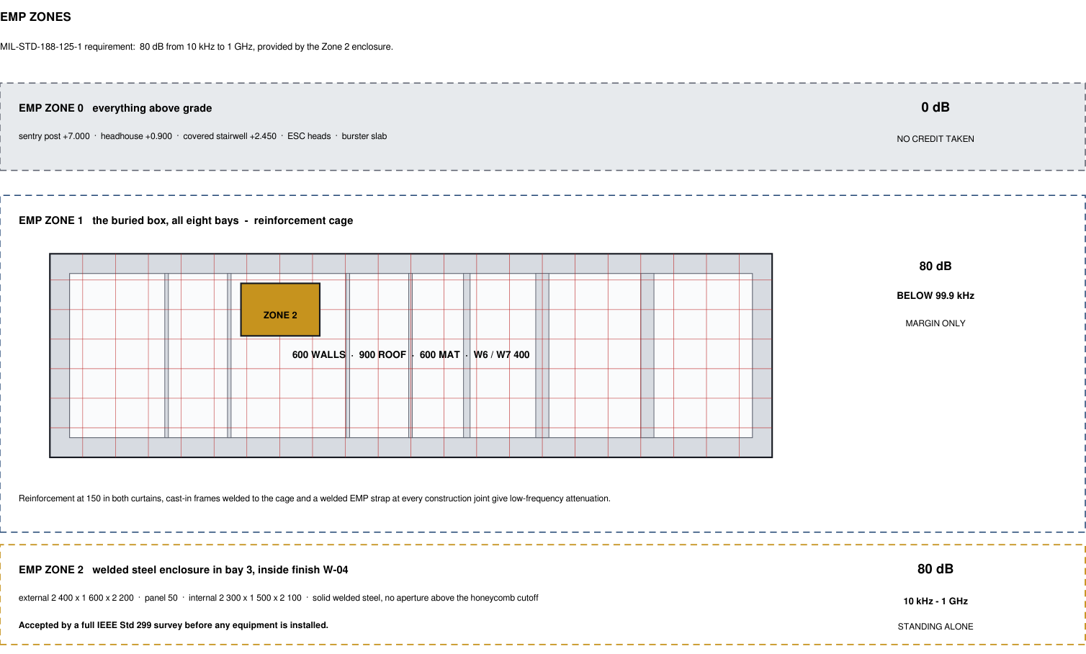
Fig 11.1 : EMP zones
Reinforcement cage
11.6 Shielding by the cage. A reinforcement cage acts as a mesh, whose shielding effectiveness falls at 20 dB per decade of frequency. For the 150 mm bar spacing adopted in both curtains of every element, SE = 20 log₁₀(λ / 2s) gives the values in Table 11.3 and Fig 11.2.
Table 11.3 : Shielding effectiveness of the 150 mm cage
Frequency | Wavelength | SE (dB)
10 kHz | 29 979 m | 99.99
100 kHz | 2 998 m | 79.99
1 MHz | 299.8 m | 59.99
10 MHz | 29.98 m | 39.99
100 MHz | 2.998 m | 19.99
999.31 MHz | 300.2 mm | 0.00

The cage provides 80 dB up to about 100 kHz, which is where the slow E3 component acts on long conductors. The full band is provided by the Zone 2 enclosure.
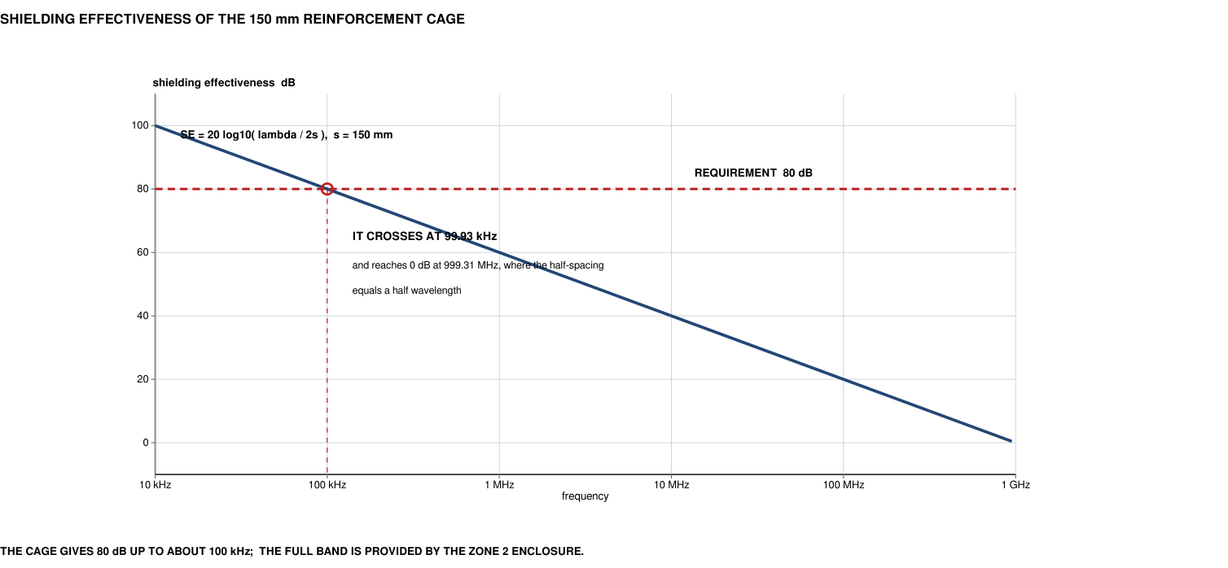
Fig 11.2 : Shielding effectiveness of the reinforcement cage
11.7 Structural measures. The following measures in the structural design maintain the continuity of the cage:-
11.7.1 Main bar spacing limited to 150 mm in both curtains.
11.7.2 Every blast door frame, the headhouse door frame, every blast valve sleeve and the service entry plate cast in and welded to the cage.
11.7.3 A welded copper or galvanised steel strap across every construction joint.
11.7.4 No movement joint anywhere within the protective envelope.
Zone 2 enclosure
11.8 Enclosure. The Zone 2 enclosure is a welded steel shielded room in the operations room, with the particulars given in Table 11.4. A clear space of at least 300 mm is kept on every free face so that the survey can reach every seam, and the enclosure is clear of the circulation route at Y 2500 - 3400.
Table 11.4 : Zone 2 enclosure
Item | Particulars
Location | Bay 3 (internal 3 500 x 5 000 x 3 200), at X 5820 - 8220, Y 3700 - 5300
External size | 2 400 x 1 600 x 2 200 mm
Shielded panel | 50 mm panels, solid welded steel
Internal clear size | 2 300 x 1 500 x 2 100 mm (3.45 m², 7.245 m³)
Shielded envelope area | 25.28 m² (walls 17.60, roof 3.84, floor 3.84)
Total seam length | 24.80 m, continuously welded or gasketed
Clearances | 300 mm north, south and west; 800 mm east; 1 000 mm above (850 mm clear above the duct zone)

11.9 Shield performance. For a solid steel shield the loss is the sum of absorption and reflection. For low-carbon steel (σ = 1.0 x 10⁷ S/m, μ_{r} = 200) the skin depth at 10 kHz is 0.1125 mm, and about 1 mm of steel gives 80 dB by absorption alone at the lowest frequency of the band; the reflection term adds a further 97 dB. The steel panel is therefore not the limiting item; the performance of the enclosure is governed by its seams, its door and its points of entry, which is why the acceptance test is a survey of the joints.
11.10 Points of entry. Every conductor or opening that crosses the Zone 2 boundary is treated at the boundary, as given in Table 11.5.
Table 11.5 : Points of entry of the Zone 2 enclosure
Point of entry | Treatment | Performance
Access (MIL-STD Sec 5.4) | RF-gasketed or knife-edge shielded door | Not less than 80 dB
Ventilation (Sec 5.5) | Honeycomb waveguide panel, 6 mm cell x 25 mm deep | 88.3 dB (array included)
Power (Sec 5.7.2.1) | Pulse current injection (PCI) protection device on every conductor, mounted on the boundary | Pulse-tested to MIL-STD-188-125-1
Signal (Sec 5.7.4.1) | Optical fibre with no metallic strength member or armour | Not a penetration

11.11 Honeycomb waveguide panel. A tube whose bore is small compared with the wavelength does not pass energy below its cutoff frequency. The ventilation opening of the enclosure is closed by a honeycomb panel of such tubes, designed as under.
Cell size d = 6 mm; depth L = 25 mm
TE11 cutoff f_{c} = 1.8412 c / (π d) = 1.8412 x 2.998 x 10⁸ / (π x 0.006) | 29.28 GHz
Attenuation of one cell below cutoff, A = 32 L / d = 32 x 25 / 6 | 133.3 dB
Cell area (√3 / 2) x 6² = 31.18 mm²; cells per m² = 10⁶ / 31.18 | 32 075
Array correction for n apertures, -10 log₁₀(32 075) | - 45.1 dB
Net attenuation of the panel = 133.3 - 45.1 | 88.3 dB > 80 dB

The panel is mounted inboard of the blast valve, so that the valve takes the blast pressure and the honeycomb takes the radio frequency energy, and it is procured with a certified attenuation curve for the complete panel.
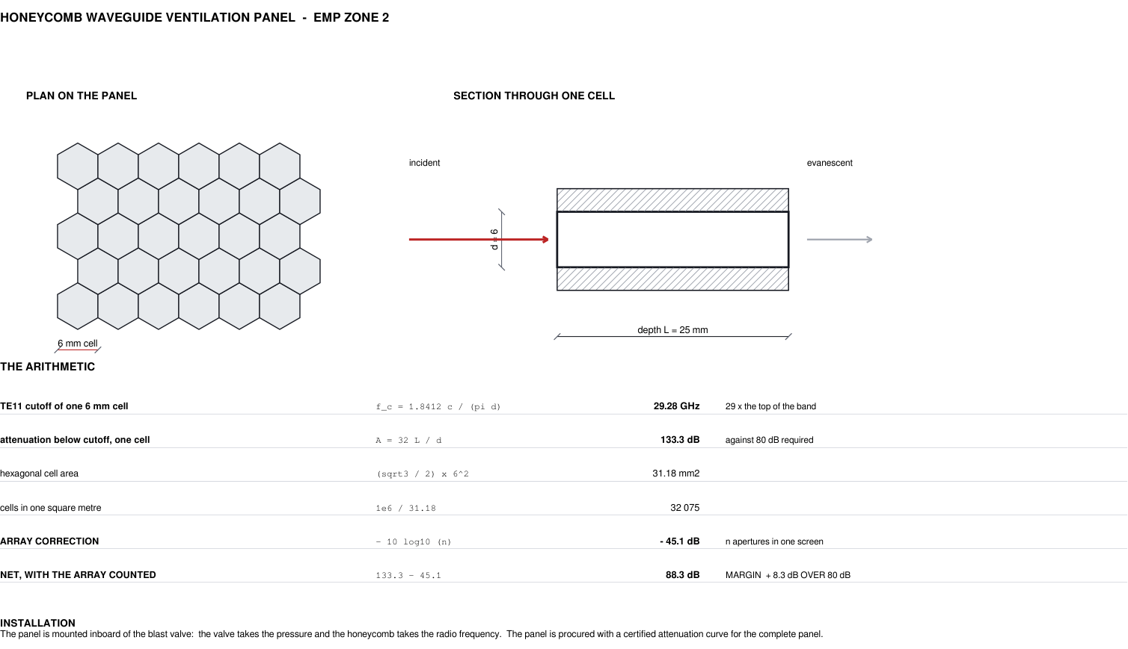
Fig 11.3 : Honeycomb waveguide ventilation panel
Bonding and earthing
11.12 Bonding. At EMP frequencies a bonding strap behaves as an inductance, and its impedance rises with frequency. The comparison in Table 11.6 shows the benefit of a short, wide strap.
Table 11.6 : Impedance of bonding straps
Strap | Inductance | X at 1 MHz | X at 10 MHz | X at 100 MHz
600 x 25 x 3 mm | 512.2 nH | 3.22 Ω | 32.2 Ω | 321.8 Ω
100 x 50 x 3 mm (adopted) | 38.9 nH | 0.24 Ω | 2.45 Ω | 24.5 Ω

The following bonding rules are adopted: every bond not more than 100 mm long; width to length ratio not less than 5 : 1; flat strap only, never a round wire or pigtail; clean bare metal at both ends, protected after making off; and the Zone 2 shield bonded to the structure at one point only, so that no loop is formed.
11.13 Earthing. Deccan basalt has a resistivity of 1 000 to 10 000 Ω.m, in which a single 3 m x 16 mm rod has a resistance of 335 Ω at the lower bound. The mat and its reinforcement cage form a large concrete-encased electrode (136.4 m², equivalent radius 6.589 m) with a resistance of about 38 Ω in the same ground, and are used as the main earth electrode. All earthing and bonding conductors are connected to the structure at a single point.
Verification
11.14 Acceptance survey. The Zone 2 enclosure is surveyed to IEEE Std 299 over 10 kHz to 1 GHz on completion, with every penetration made off, every panel closed and the door shut. Every seam, the door perimeter and each point of entry is surveyed, and the acceptance level is 80 dB. No equipment is installed in the enclosure until the survey has been passed.
11.15 Checks during construction. The following checks are made at the stage at which a defect can still be corrected:-
11.15.1 Continuity of the reinforcement cage across every construction joint, before concreting.
11.15.2 Continuity of every cast-in frame, sleeve and the service entry plate to the cage, before concreting.
11.15.3 Earth resistance of the structure electrode, early in the works.
11.15.4 Resistance of every bonding strap after making off.
CHAPTER 12
WATER SUPPLY, DRAINAGE AND SEWAGE
(WATER BALANCE, INTERNAL DRAINAGE, SUMP, SEPTIC TANK AND OPERATING PROCEDURE)
Principles
12.1 Tanked structure. The underground structure is tanked, not drained. Four rules follow from this and govern the whole drainage design:-
12.1.1 Nothing through the roof. No rainwater outlet, vent or soil stack passes through the 2.0 m cover, which would breach both the radiation shield and the roof membrane. There is no downpipe on the buried roof.
12.1.2 One service crossing. All pipes and cables cross the envelope through the service entry plate on the north wall (X 11398 - 12198). The rising main from the sump uses it, and no other drainage penetration is made.
12.1.3 Three separate streams. Clean water (seepage and condensate) goes to the storm soakaway; peacetime foul water goes to the septic tank and soak pit; decontamination effluent goes to a holding tank and is removed by tanker. The streams are never combined.
12.1.4 Safety. No failure of the drainage may block an escape route, breach the envelope or flood an entrance.
12.2 Water supply. Potable water for the 96-hour occupation is stored in a 1 000 litre tank in bay 1, giving 27.8 litres per person per day. In peacetime the installation is supplied from the campus water supply.
Water balance
12.3 Daily flows. The flows to be handled are given in Table 12.1.
Table 12.1 : Daily water balance
Source | Basis | Rate | Held in / discharged to
Structural seepage | 0.5 l/m²/day x 401 m² | 200 l/day | Clean sump SU-01 (3 375 l), then storm soakaway SK-02
Condensate and washdown | Dehumidifier DH-1, through a 75 mm seal trap | 200 l/day | Clean sump SU-01, then storm soakaway SK-02
Foul water, peacetime | 10 users x 45 lpcd | 450 l/day | Septic tank ST-01 (1 125 l), then soak pit SK-01
Decontamination effluent | Airlock stages 1 and 2, on use | On use | Tank TK-01 (1 000 l), removed by tanker
Stairwell surface water | Approach and stairwell | 0.10 l/s | Sump SU-02 (1.0 m³), then soakaway SK-03

12.4 Seepage area. The seepage allowance is applied to the external envelope below the design water table.
Submerged wall height (-)2.000 to (-)6.700 | 4.700 m
Perimeter 2 x (22.0 + 6.2) = 56.40 m; wall area 56.40 x 4.700 | 265.08 m²
Mat underside 22.0 x 6.2 | 136.40 m²
Total 401.48 m² x 0.5 l/m²/day | 200 l/day
Storage of the clean sump against the inflow = 3 375 / 400 | 8 days

The clean sump holds eight days of inflow without pumping, four times the 48-hour closed-mode period.
Internal drainage
12.5 Floor drainage. The design of the internal drainage is given in Table 12.2. With a flow of 0.0046 l/s against a pipe capacity of 6.72 l/s, the drains are sized by minimum bore and self-cleansing velocity, not by flow.
Table 12.2 : Internal drainage
Item | Provision
Floor falls | 1 in 80 in wet areas, 1 in 100 elsewhere; spine fall 1 in 400 to the sump along Y 3100
Falls formed in | Floor screed, 25 mm at the sump edge to 78 mm at the far corner (average 52 mm)
Gravity drains | DN100 minimum at 1 in 100 minimum; capacity 6.72 l/s at 0.85 m/s
Traps | 75 mm deep seal, primed
Rising main | DN50, 0.76 m/s at 1.5 l/s; welded or flanged, no push-fit joint within the envelope
Airlock | Falls 1 in 80 to separate gullies; 50 mm upstand at W5 and at Blast Door 1

12.6 Trap seals. The trap seals also resist the internal overpressure, as given in Table 12.3.
Table 12.3 : Trap seal depth against overpressure
Seal depth | Holds | Against +100 Pa | Against +300 Pa
50 mm | 491 Pa | 4.9 : 1 | 1.6 : 1
75 mm (adopted) | 736 Pa | 7.4 : 1 | 2.5 : 1
100 mm | 981 Pa | 9.8 : 1 | 3.3 : 1

12.7 Clean sump SU-01. The clean sump is 1 500 x 1 500 x 1 500 mm internally (3.375 m³), with its invert at (-)7.600, and is cast monolithic with the mat. It has two submersible pumps, PU-01 (duty) and PU-02 (standby), each of 1.5 l/s, alternating automatically, and a hand pump PU-03 that needs no power. The control levels above the invert are: stop +300, start +900 and high-level alarm +1 200 mm. The duty pump starts about once in 3.4 days and runs for about 15 minutes, and the standby pump and the hand pump are therefore tested monthly.
Sewage
12.8 Septic tank. In the protective modes sealed-cassette chemical toilets are used and nothing is discharged. The septic tank serves the installation in peacetime and is designed to IS 2470 (Part 1).
Design population 10; 45 lpcd | 450 l/day
Required capacity: 450 l detention (24 h) + 600 l sludge | 1 050 l
Provided 1.5 x 0.75 x 1.0 m liquid depth | 1 125 l (+7.1 %)
L / B = 2.0; width 750 mm; freeboard 300 mm; overall depth 1.30 m | OK

The tank has two compartments with a baffle at two-thirds of the length, inlet and outlet tees and a 50 mm cowled vent carried at least 2 m above grade.
12.9 Soak pit. The effluent from the septic tank is dispersed through soak pit SK-01, 2.200 m in diameter with an effective depth of 3.500 m, giving a side area of 24.19 m² against 22.5 m² required at an absorption rate of 20 l/m²/day. The pit is filled with 40 - 80 mm brickbat or stone, capped with 300 mm of sand and covered with an RC slab. A percolation test to IS 2470 (Part 2) Cl. 4 is carried out at the location before construction. The storm soakaway SK-02 uses the same detail.
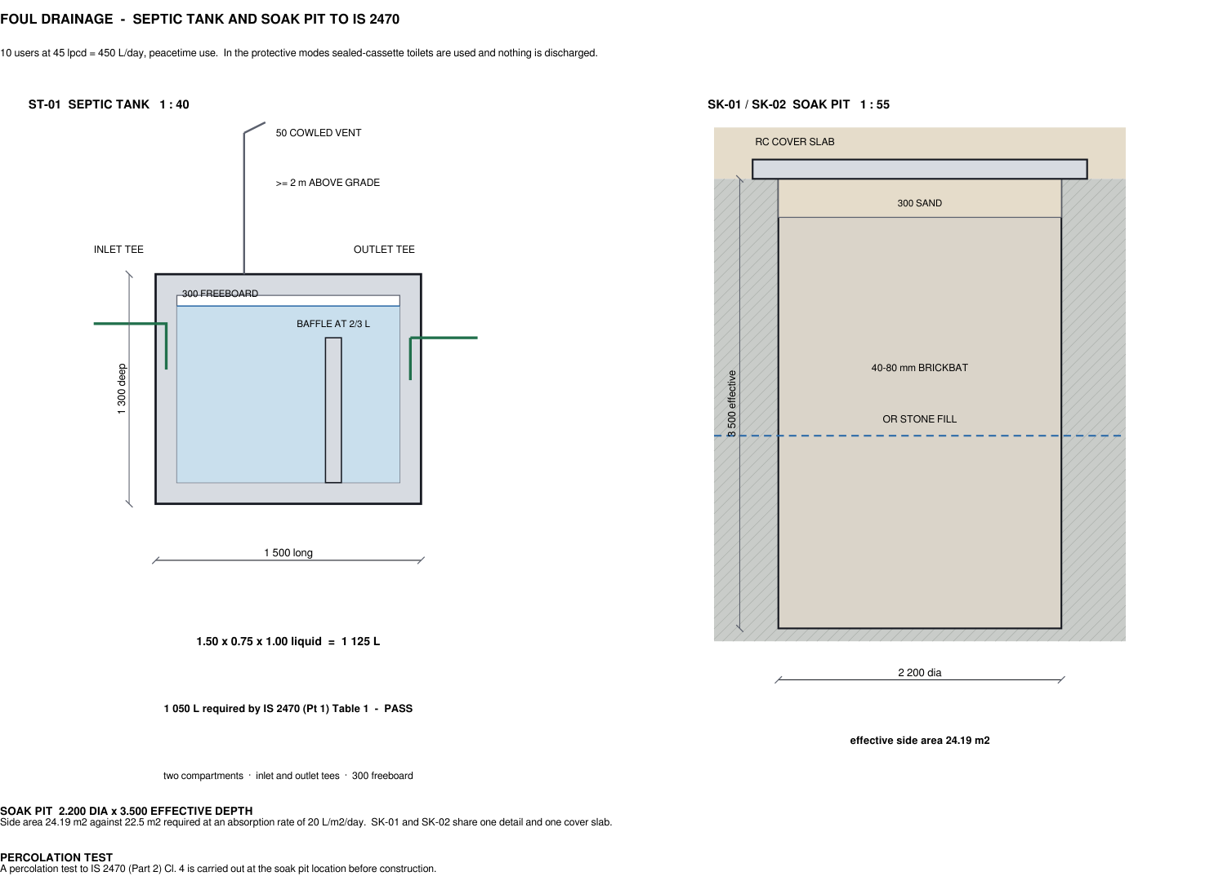
Fig 12.1 : Septic tank and soak pit
12.10 Decontamination effluent. Effluent from airlock stages 1 and 2 is collected in the 1 000 litre tank TK-01 and is removed by tanker. It is never discharged to the ground.
Operating procedure
12.11 Streams in each mode. The disposal of each stream in each operating mode is given in Table 12.4.
Table 12.4 : Disposal of water in each operating mode
Stream | Peacetime | Protective | Closed | Purge | Recovery
Seepage and condensate | Sump, pumped | Sump, pumped | Sump, pumped | Sump, pumped | Sump, pumped
Foul water | Septic tank | Sealed cassette | Sealed cassette | Sealed cassette | Septic tank
Decontamination effluent | None | TK-01, tanker | None | TK-01, tanker | TK-01, tanker
Stairwell surface water | SU-02, soakaway | SU-02, soakaway | Outside envelope | SU-02, soakaway | SU-02, soakaway

12.12 Changeover on warning. On receipt of warning the following actions are taken:-
12.12.1 The lavatory is changed over to sealed-cassette chemical toilets.
12.12.2 Every trap is checked to be primed.
12.12.3 The clean sump is pumped down to its stop level.
12.12.4 Pumps PU-01 and PU-02 are confirmed on the essential board and the changeover is tested.
12.13 Closed mode. Seepage and condensate continue to arrive at about 400 litres per day with all blast valves shut, and the clean sump pump remains on the essential supply at about 10 per cent duty. If the power fails the standby pump is started, and if both pumps are unserviceable the hand pump is used. No opening is made in the envelope to drain water.
12.14 Recovery. After the all-clear, the foul drainage is restored only after the ground outside has been checked, TK-01 is emptied before decontamination is resumed, the trap seals are checked while the envelope is still pressurised, the standby pumps and hand pump are tested, and the volume pumped during the closed period is recorded as a measure of the actual seepage.
CHAPTER 13
ELECTRICAL SERVICES
(SOURCES, LOAD SCHEDULE, DISTRIBUTION AND ESSENTIAL SUPPLY)
Sources of supply
13.1 Sources. Power is supplied from three sources:-
13.1.1 Mains. The campus electric supply, through a meter panel, in peacetime.
13.1.2 Generator. A 15 kVA diesel generator GEN-1 in bay 8, outside the gas-tight envelope and within the EMP boundary of the box.
13.1.3 Battery. A 48 V battery with inverter, which supplies the essential loads on failure of both the mains and the generator.
Load schedule
13.2 Connected load. The connected load is given in Table 13.1. Standby units (the second filter fan and the standby pumps) do not run with their duty units and are not counted.
Table 13.1 : Electrical load schedule
Tag | Load | Board | kW | Remarks
L-01 | General lighting, bays 1 to 8, LED | DB-E | 0.520 | -
L-02 | Emergency lighting, maintained, DC | DB-E | 0.100 | -
P-01 | Small power, socket outlets | DB-M | 1.000 | -
F-01 | Filter train fan, one duty of two | DB-E | 0.379 | Hand crank also
D-01 | Dehumidifier DH-1 | DB-E | 1.000 | -
U-01 | Clean sump pump, one duty of two | DB-E | 0.334 | -
U-02 | Stairwell sump pump, one duty of two | DB-M | 0.223 | -
Z-01 | EMP Zone 2 operations and communication equipment | DB-Z2 | 1.500 | -
S-01 | Fire detection and alarm panel | DB-E | 0.100 | -
B-01 | Battery charger and inverter | DB-M | 0.800 | -
G-01 | Generator auxiliaries | DB-M | 0.300 | -
 | Connected load |  | 6.256 | 7.360 kVA at pf 0.85

Generator rating | 15.0 kVA
Connected load | 7.360 kVA
Generator utilisation | 49.1 %
Largest motor, filter fan 0.379 kW; direct-on-line starting | about 2.7 kVA

The generator runs at about half load, which avoids light-load running of the diesel engine and leaves margin for additional load. Motor starting does not govern the size of the set.
Distribution
13.3 Boards. The distribution consists of three boards, shown in Fig 13.1:-
13.3.1 DB-M, main LV board. In bay 8, outside the gas-tight envelope, with changeover between the mains and the generator.
13.3.2 DB-E, essential board. In bay 5, within the envelope, fed from DB-M and from the battery inverter on failure of both sources.
13.3.3 DB-Z2, Zone 2 sub-board. Inside the shielded enclosure in bay 3, fed from DB-E through the pulse current injection protection on the Zone 2 boundary.
13.4 Service entry. Every conductor crossing the protective envelope passes through the service entry plate, with PCI protection on every power conductor and optical fibre for all signal circuits. No other cable penetration is made.
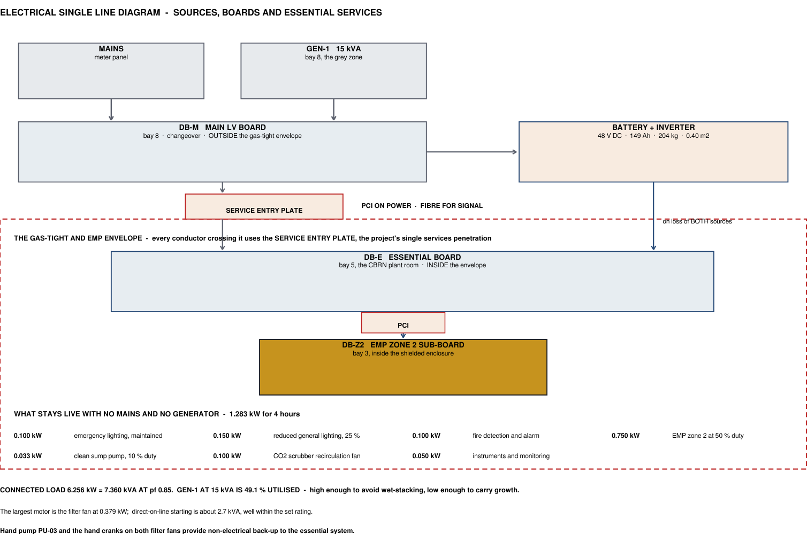
Fig 13.1 : Electrical single line diagram
Essential supply
13.5 Essential loads. The loads that remain live with neither the mains nor the generator available are given below.
Emergency lighting, maintained | 0.100 kW
Reduced general lighting, 25 % | 0.150 kW
Fire detection and alarm | 0.100 kW
EMP Zone 2 equipment at 50 % duty | 0.750 kW
Clean sump pump at 10 % duty | 0.033 kW
CO₂ scrubber recirculation fan | 0.100 kW
Instruments and monitoring | 0.050 kW
Total essential load | 1.283 kW
Battery for 4 h at 48 V (depth of discharge 0.80, inverter efficiency 0.90) | 149 Ah
Battery mass and floor area | 204 kg, 0.40 m²

The battery is housed in a cabinet in bay 5. Since the generator can run during the closed mode (Chapter 10), the battery is required to carry the essential load only during changeover and short interruptions.
13.6 Non-electrical back-up. The two filter fans are fitted with hand cranks and the clean sump with a hand pump, so that ventilation and dewatering continue even if all electrical sources fail.
Generator fuel
13.7 Day tank. The fuel for 96 hours of generator operation is worked out as under.
Energy over 96 h | 600.6 kWh
Fuel at 0.35 l/kWh | 210.2 litres
Day tank: 210 l usable, 250 l nominal, bund 275 l (110 %) | Bay 8

The tank is of welded steel with a bund, contents gauge and low-level alarm to the panel. Its filling and vent pipes (DN25, metallic, with a lockable filler cap) are run up the existing generator air shaft SH-2 and bonded to the shaft earth, so that no additional penetration of the protective boundary is made.
CHAPTER 14
FIRE AND LIFE SAFETY
(FIRE STRATEGY, COMPARTMENTATION AND EVACUATION PLAN)
Fire strategy
14.1 Basis. The shelter is a sealed underground volume of 332.8 m³ supplied with 300 m³/h of filtered air, about 0.9 air changes per hour, and it has no smoke vent, since every opening in the envelope is a blast valve or a blast door. The fire strategy is therefore to prevent fires, to detect them early, to extinguish them while they are small, and to evacuate by a route away from the fire if a fire cannot be controlled.
14.2 Features of the design. The following features of the design support the strategy:-
14.2.1 Generator compartment. The largest fire load, the generator with its fuel and exhaust, is in bay 8 behind Blast Door 2 in the 400 mm wall W7, separated from the occupied bays by the stair shaft.
14.2.2 Separate ventilation. Bay 8 has its own air path of 2 600 m³/h through BV-4 and BV-5, which does not connect with the gas-tight envelope, so that a generator fire is ventilated away from the occupied bays.
14.2.3 Escape from dead ends. The two end bays, bays 1 and 8, each contain an escape shaft, so that no occupant is in a dead end without a way out.
14.2.4 Short travel. The longest travel distance to the primary route is about 14.6 m.
14.3 Fire load. The fire loads in the shelter are given in Table 14.1.
Table 14.1 : Fire load
Bay | Fire load | Measures
8 | Generator, fuel system and exhaust | Separate compartment behind BD 2; separate ventilation; bunded day tank
5 | CBRN filter trains (activated carbon) | Separated from the airlock by the fire and gas-tight wall W5 with door D-05
3 | Operations room, EMP Zone 2 enclosure | Electronic equipment and cabling; detection
4 | Berthing, 9 berths | Bedding and personal effects
1 | Stores | Detection

14.4 Compartmentation. Bays 1 to 6 form one smoke compartment 20.8 m long, since the four W8 partitions are non-structural and have permanent 900 mm openings. Blast Doors 1 and 2, and wall W5 with door D-05, are the fire barriers within the shelter.
14.5 Detection and lighting. A fire detection and alarm panel and maintained emergency lighting are provided on the essential board and are supplied from the battery if both the mains and the generator fail.
14.6 Water. The 1 000 litre tank in bay 1 is the 96-hour potable water supply for the occupants and is not used as firefighting water except on the orders of the commander.
Evacuation plan
14.7 Escape routes. Three escape routes are provided, as given in Table 14.2 and Fig 14.1.
Table 14.2 : Escape routes
Route | Path | Exit
R1 (primary) | Any bay, along the spine, through Blast Door 1 into the stair shaft, up the main staircase (24 risers, 1 200 mm wide) | Headhouse at (-)2.000, then up the covered stairwell (12 risers) to the entry door at grade
R2 | Escape shaft ESC 1 in bay 1, 1 400 mm diameter, ladder | Head at +0.150; climb 6.250 m
R3 | Escape shaft ESC 2 in bay 8, 1 400 mm diameter, ladder | Head at +0.700; climb 6.800 m

R1 is the primary route and the only one that does not require a climb; it is the route for an injured person. R2 and R3 are emergency exits.
14.8 Choice of route. The route to be used depends on the location of the fire, as given in Table 14.3.
Table 14.3 : Route decision rule
Fire in | Route | Reason
Bay 8, generator | R1, or R2 if the spine is smoke-logged | Blast Door 2 shut; bay 8 separately ventilated; ESC 2 is within the fire compartment and is not used
Bays 1 to 6 | R1 if the route to bay 7 is clear; otherwise R2 from the west end, R1 or R3 from the east end | Bays 1 to 6 form one smoke compartment
Bay 7, stair shaft | R2 or R3 | The primary route is affected; both blast doors shut
Headhouse or stairwell | R2 or R3 | The surface end of R1 is affected

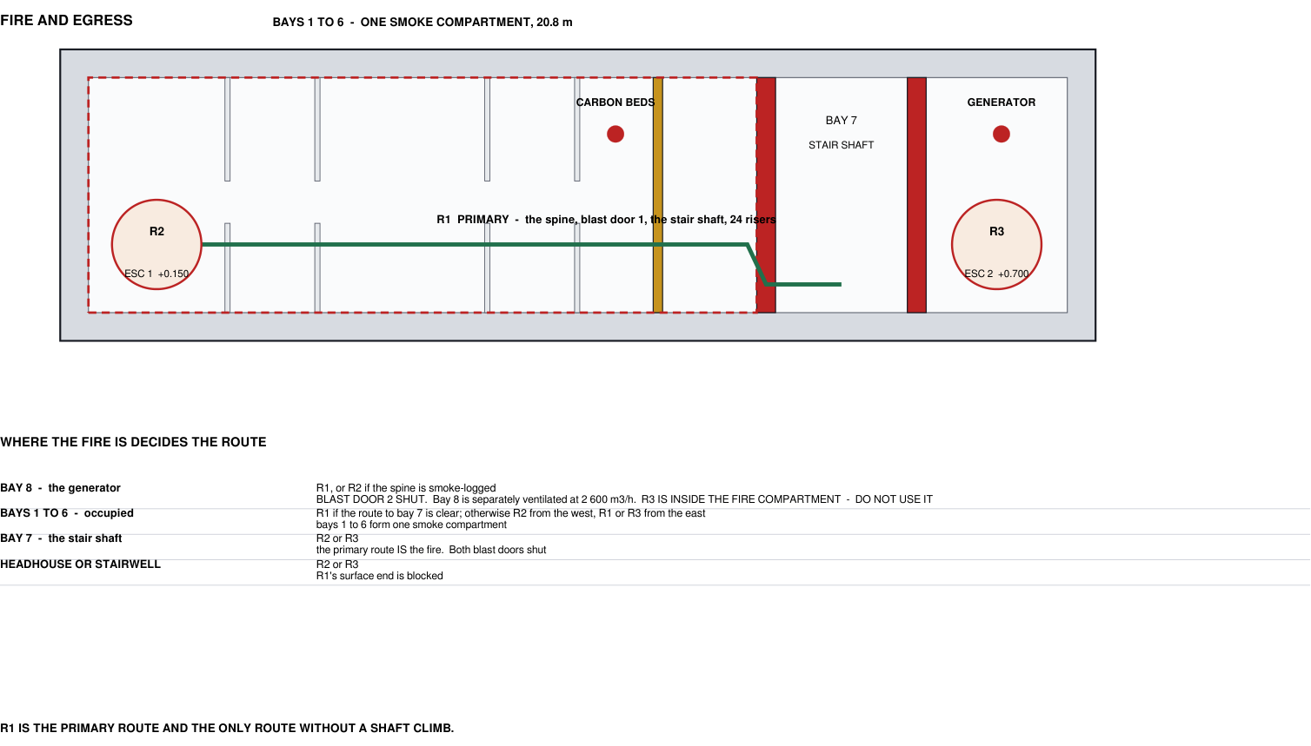
Fig 14.1 : Fire and egress, escape routes and decision rule
14.9 Immediate actions. On discovering a fire the following actions are taken:-
14.9.1 The alarm is raised.
14.9.2 The fire is attacked while it is small, provided the route behind the person is clear.
14.9.3 The blast door between the occupants and the fire is shut.
14.9.4 The generator is stopped if the fire is in bay 8 or its origin is not known.
14.9.5 The occupants evacuate by the route given in Table 14.3, without passing the fire to reach a preferred route.
14.9.6 A roll call of the nine occupants is taken at the exit.
14.10 Fire party. With nine occupants, every occupant forms part of the fire party and is practised in the fire drill and the use of the escape routes and shaft ladders.
CHAPTER 15
SITE LAYOUT, FINISHES AND CONCEALMENT
(EXTERNAL WORKS, AIR SHAFTS, SCHEDULE OF FINISHES AND CONCEALMENT)
External works
15.1 External works reserve. The septic tank, soak pits and soakaways are grouped in an external works reserve of 18.0 x 11.0 m at X 33 000 - 51 000, Y 6 500 - 17 500, 10.0 m clear of the east face of the excavation and downhill of the shelter. The layout is shown in Fig 15.1 and the items are listed in Table 15.1.
Table 15.1 : External works
Tag | Item | Centre (X, Y) | Serves
ST-01 | Septic tank 1.5 x 0.75 m | (36 750, 16 000) | 10 users, 450 l/day
SK-01 | Foul soak pit, 2.2 m diameter | (44 000, 16 000) | Septic tank effluent
SK-02 | Storm soakaway, 2.2 m diameter | (35 000, 8 500) | Clean sump and entry channel
SK-03 | Stairwell soakaway | (41 400, 8 500) | Stairwell sump SU-02
SK-04 | Headhouse soakaway | (47 800, 8 500) | Headhouse floor gully
IC-01, IC-02 | Inspection chambers 600 x 450 | (7 500, 9 800), (40 200, 16 000) | Change of direction; de-sludging

15.2 Reasons for the layout. All effluent is released downhill of, and away from, the buried box, whose backfill is more permeable than the surrounding rock. The grouping gives one percolation test location, one keep-clear zone and one common services trench, and the cover slabs and septic vent are 11 to 22 m from the shelter, so that they do not indicate its position.
15.3 Clearances. The clearances required by IS 2470 are met: foul soak pit to septic tank 5.40 m against 5 m, and soak pit to the nearest building 10.97 m against 2 m. There is no well within 15 m of the foul soak pit.
15.4 Pipe runs. The external pipe runs are: septic tank to soak pit, DN100 at 1 in 100, 5.40 m; rising main from the service entry plate to the storm soakaway, DN50, 27.00 m; entry channel to the storm soakaway, DN100 at 1 in 100, 32.35 m, routed west clear of the stairwell excavation; and stairwell sump to its soakaway, DN50 rising main, 29.60 m.
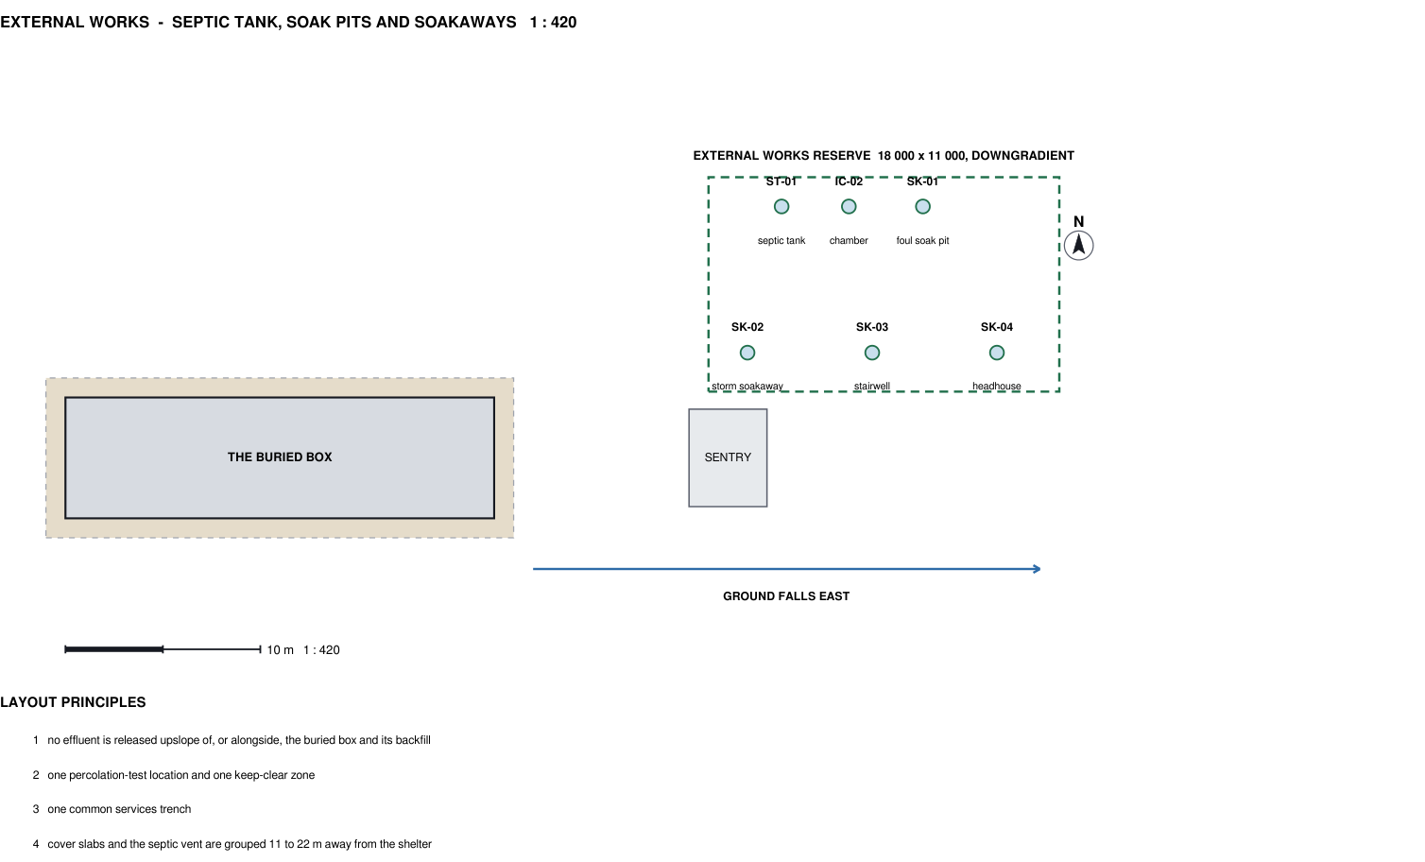
Fig 15.1 : External works, septic tank, soak pits and soakaways
15.5 Air shafts. The fresh-air intake shaft SH-1 (600 x 600 mm) is centred at (-2 400, 3 100), west of the box, and the generator air shaft SH-2 (600 x 600 mm) is at X 22 598 - 23 198, east of the box. Both have gooseneck heads at +1.500. The two shafts are 25.30 m apart at opposite ends of the box, which separates the fresh air intake from the generator exhaust.
Schedule of finishes
15.6 Finishing rules. The finishes have been selected for decontamination, drainage and the protection of the envelope. The following rules apply throughout:-
15.6.1 No voids. No suspended ceiling, dry lining, boxing-in or cavity of any kind is provided anywhere in the gas-tight envelope. Every finish is applied directly to the concrete, so that every duct, pipe and surface can be inspected and decontaminated.
15.6.2 Cast-in fixings. No fixing is drilled into the tanked envelope. Bunk frames, handrails, cable trays, duct supports and door frames are fixed to cast-in sockets or frames only.
15.6.3 Coved junctions. Every junction in a wet or clean area, floor to wall, wall to soffit and around every gully and sleeve, is coved.
15.6.4 Stair finishes. The stair treads carry a cast-in non-slip nosing with no build-up on the tread, so that the 280 mm going is maintained.
15.7 Finish codes. The finish codes are given in Table 15.2 and the room finish schedule in Table 15.3.
Table 15.2 : Finish codes
Code | Finish | Performance
F-01 | Sealed power-floated screed | Decontaminable, non-dusting, washdown-resistant, laid to falls, coved to the skirting
F-02 | Seamless coved heavy-duty wet-area finish | Impervious, coved 150 mm up every wall in one piece, resistant to decontaminant; no joints or tiles
F-03 | Non-slip decontaminable floor and tread finish | Wet-slip resistant, abrasion resistant; treads, landings and shaft floor
F-04 | Abrasion and oil-resistant floor | Fuel and oil resistant, laid to falls, bunded plinth under the generator
F-05 | Power-floated non-slip slab finish | External grade, non-slip when wet, 1 in 80 fall to the gully
F-06 | In-situ concrete, non-slip, cast nosing | External grade; covered stairwell
S-01 / S-02 | Coved skirting 150 integral with the floor / hard skirting 100 | Decontamination / impact resistance
W-01 | Fair-face RC with sealed washable coating | Applied direct to the concrete; no cavity or lining
W-02 | W-01 with impervious finish to full height | Wet areas, continuous with the F-02 cove
W-03 / W-05 | Fair-face RC, sealed / external grade | Grey zone and stair shaft / headhouse and stairwell
W-04 | EMP Zone 2 shielded enclosure lining | Welded steel room; finish subordinate to shielding
C-01 / C-02 / C-03 | Exposed RC soffit, sealed | Decontaminable in the envelope; sealed elsewhere; external grade in the stairwell

Table 15.3 : Room finish schedule
Room | Name | Floor | Skirting | Wall | Ceiling | Door | Remarks
U-01 | Emergency stores, ESC 1 | F-01 | S-01 | W-01 | C-01 | D-04 | Falls 1:100
U-02 | Lavatory and medical | F-02 | S-01 | W-02 | C-01 | D-04 | Wet area, falls 1:80
U-03 | Operations room | F-01 | S-01 | W-01, W-04 | C-01 | D-04 | Zone 2 enclosure
U-04 | Berthing | F-01 | S-01 | W-01 | C-01 | D-04 | Bunk fixings cast in
U-05 | CBRN plant and sump | F-02 | S-01 | W-02 | C-01 | D-05 | Wet area, falls 1:80
U-06 | Decontamination airlock | F-02 | S-01 | W-02 | C-01 | D-01, D-05 | Wet area, 50 mm upstands
U-07 | Stair shaft | F-03 | S-02 | W-03 | C-02 | D-01 | Cast-in nosing
U-08 | Generator bay, ESC 2 | F-04 | S-02 | W-03 | C-02 | D-01 | Bunded plinth
G-01 | Stairwell top landing | F-06 | S-03 | W-05 | C-03 | D-03 | Channel at threshold
G-02 | Stairwell flight | F-06 | S-03 | W-05 | C-03 | - | Non-slip
G-03 | Stairwell platform | F-06 | S-03 | W-05 | C-03 | D-02 | Gully to sump
G-04 | Headhouse | F-05 | S-02 | W-05 | C-02 | D-02 | Hose-down, 1:80 fall
G-05 | Stair void edge | F-05 | S-02 | W-05 | - | - | 1 100 mm guarding

Concealment
15.8 Measures. The buried structure is concealed by the following measures:-
15.8.1 Turf. The whole buried roof is covered by 300 mm of topsoil and turf (30.87 m³), re-laid from the 92.82 m³ of topsoil stripped from the site itself, so that the restored surface matches its surroundings.
15.8.2 Ground form. The finished grade over the box is crowned and falls at 1 in 50, a natural-looking fall, and the berms against the headhouse and stairwell are graded at 1.5 : 1 to read as ground.
15.8.3 No surface drainage features. There is no roof outlet, downpipe, manhole or gully anywhere on the buried roof; the cover drains through the granular filter on the sloping burster slab to the berm toe.
15.8.4 No spoil heap. All surplus excavation (1 113.94 m³) is re-used on site as engineered fill and crushed rubble, and no spoil heap is left.
15.9 Above-ground elements. The elements that stand above grade are the sentry post (parapet +7.000), the covered stairwell head (+2.450), the two air shaft goosenecks (+1.500), the headhouse roof (+0.900) and the escape shaft heads (+0.700 and +0.150). The sentry post is a manned observation post and is meant to be seen, and the headhouse is the entrance; the protected volume itself lies below ground under graded, turfed cover.
CHAPTER 16
WORKS MANAGEMENT
(CONSTRUCTION METHODOLOGY, QUANTITIES, COST ESTIMATE AND PROGRAMME)
General
16.1 Scope. The works management of the project covers the construction methodology, the quantities of the principal materials, the bill of quantities, the cost estimate, the master construction programme, quality control, procurement and safety. The estimated cost of the works is Rs 2,97,90,913 and the works are programmed for completion in 224 working days.
Construction methodology
16.2 Sequence of construction. The works are executed in the following sequence:-
16.2.1 Initial works. Site clearance, removal of shrubs, water and electricity provision, setting out and checking, and the confirmatory boreholes.
16.2.2 Excavation. Stripping and stockpiling of topsoil; excavation of the soil cap with the batter; excavation of rock by hydraulic breaker to formation at (-)6.800, with the sump pit to (-)8.000; continuous dewatering; trimming and inspection of the formation, with any weak seam replaced by M15 concrete.
16.2.3 Foundation. Anti-termite treatment; 100 mm PCC blinding; horizontal tanking membrane with protection screed; mat reinforcement in two curtains with the link grid, wall starters, sump pit and cast-in items; and the mat and sump cast in a single continuous pour.
16.2.4 Walls. Perimeter walls and walls W5 to W7 in two lifts, with waterstops and EMP straps at the construction joints and the blast door frames, blast valve sleeves and service entry plate welded to the cage before concreting.
16.2.5 Pressure slab. Falsework to the 3.2 m soffit; T25 reinforcement in both curtains with the links, trimmers and escape shaft collars; the 900 mm slab cast in a single continuous pour of about 112 m³; curing for 14 days and props retained for a further 14 days.
16.2.6 Tanking and backfill. Vertical tanking of the walls and roof membrane with protection screed, each inspected before it is covered; backfill placed symmetrically in layers compacted to 95 per cent of MDD (IS 2720 Part 28); relief plugs in the mat grouted after backfilling.
16.2.7 Engineered cover. Compacted engineered fill laid to falls, basalt rubble, the 200 mm burster slab, granular filter and turf, in that order.
16.2.8 Headhouse, stairwell and sentry post. Headhouse walls and roof, covered entry stairwell with its raft on replaced granular fill, and the sentry post footings, frame and brickwork.
16.2.9 Services and finishes. Filter trains, blast valves, generator, drainage and pumps, electrical installation, EMP Zone 2 enclosure, finishes, doors and hatches.
16.2.10 Testing and commissioning. Envelope leakage test at +300 Pa, IEEE Std 299 survey of the Zone 2 enclosure, commissioning of all services and hand-over.
16.3 Critical operations. The two single pours (the mat with the sump, and the pressure slab) have no construction joint to fall back on. Each is carried out to a written pour plan with standby batching and pumping plant and a second source of supply, and is not started unless the whole pour can be completed.
Quantities
16.4 Concrete. The quantities of concrete are given in Table 16.1.
Table 16.1 : Quantity of concrete
S No | Element | Grade | Quantity (m³)
1.1 | PCC levelling bed under the mat, 100 mm | M15 | 17.17
1.2 | Monolithic mat raft foundation, 600 mm | M35 | 81.84
1.3 | Perimeter walls W1 to W4, 600 mm | M35 | 108.29
1.4 | Internal walls W5 to W7 | M35 | 24.32
1.5 | Pressure slab, 900 mm, net of the stair void | M35 | 114.72
1.6 | Main staircase flights and landings | M35 | 4.8
1.7 | Sump pit and equipment plinths | M35 | 6.4
1.8 | Entry headhouse, 400 mm walls and 500 mm roof | M35 | 28.56
1.9 | Covered entry stairwell, 250 mm walls and roof | M35 | 18.2
1.10 | Burster slab in the engineered cover, 200 mm | M30 | 38.4
1.11 | Sentry post RC frame (footings, plinth, columns, beams, slabs) | M30 | 18.6
1.12 | Escape shaft collars ESC 1 and ESC 2, 250 mm, OD 1 900 | M35 | 6.285
 | Total concrete |  | 467.59

16.5 Reinforcement. The quantity of reinforcement is given in Table 16.2.
Table 16.2 : Quantity of reinforcement (Fe500D)
S No | Bar diameter and application | Net weight (kg) | Gross weight incl. 5 % wastage (t)
2.1 | 8 mm bars (hoops, ties, sentry post) | 1,120 | 1.18
2.2 | 10 mm bars (distribution steel, secondary links) | 1,480 | 1.55
2.3 | 12 mm bars (shear links, burster slab, partitions) | 9,390 | 9.86
2.4 | 16 mm bars (perimeter walls, mat) | 24,140 | 25.35
2.5 | 20 mm bars (walls W6 / W7, headhouse, haunches) | 8,740 | 9.18
2.6 | 25 mm bars (pressure slab, opening trimmers) | 19,690 | 20.67
 | Total reinforcement | 64,560 | 67.79

Bill of quantities and cost estimate
16.6 Bill of quantities. The bill of quantities has been prepared in five parts, as given in Table 16.3. The rates include materials, and the labour deployed on each item is priced separately in the amount. The complete bill is placed at Appendix B.
Table 16.3 : Abstract of the bill of quantities
Part | Description | Items | Amount (Rs)
I | Survey, site clearance and excavation | 4 | 19,12,726
II | Substructure and foundation works | 5 | 12,83,471
III | Superstructure and structural RCC | 11 | 41,45,877
IV | Reinforcement steel and shielding | 7 | 63,33,152
V | CBRN, EMP, closures and ancillary services | 10 | 1,05,45,028
 | Total Basic Cost |  | 2,42,20,254

16.7 Cost estimate. The final project cost has been worked out by adding the cost heads to the total basic cost, as given in Table 16.4.
Table 16.4 : Cost estimate
S No | Cost head | Basis | Amount (Rs)
1 | Total Basic Cost | Sum of Parts I to V | 2,42,20,254
2 | Contingencies | 3.0% of basic cost | 7,26,608
3 | Water and Electricity Provisions | 1.0% of basic cost | 2,42,203
4 | Specialist CBRN / EMP and Engineering Consultant | 6.0% of basic cost | 14,53,215
5 | Site Supervision and Quality Assurance | 2.0% of basic cost | 4,84,405
6 | Statutory Clearances and Liaisoning | 1.0% of basic cost | 2,42,203
7 | Contractor's Overhead and Profit | 10.0% of basic cost | 24,22,025
 | Final Project Cost |  | 2,97,90,913

The estimated cost of the project is Rs 2,97,90,913 (Rupees Two Crore Ninety Seven Lakh Ninety Thousand Nine Hundred and Thirteen only).
16.8 Distribution of cost. Parts IV and V, the reinforcement and the protective equipment, account for about 70 per cent of the basic cost. The single largest items are the two NBC filter trains (Rs 37.73 lakh), the two blast doors (Rs 25.50 lakh) and the pressure slab reinforcement (Rs 20.11 lakh).
Construction programme
16.9 Programme parameters. The master construction programme has been prepared with the following parameters:-
16.9.1 Duration. 224 working days, from 02 November 2026 to 26 July 2027.
16.9.2 Working week. Six days a week, with a relaxation of three days a month during the monsoon.
16.9.3 Milestones. Substructure complete by 18 December 2026; superstructure complete by 26 March 2027; hand-over on 26 July 2027.
16.10 Master construction schedule. The summary of the master construction schedule is given in Table 16.5.
Table 16.5 : Master construction schedule (summary)
S No | Activity | Working days | Start | Finish
1 | Initial works: site clearance, water and electricity | 4 | 02-11-26 | 05-11-26
2 | Substructure works | 40 | 02-11-26 | 18-12-26
3 | Centre line works and PCC under the mat | 4 | 14-11-26 | 18-11-26
4 | Mat raft and 600 mm perimeter walls to (-)3.2 m, waterproofing and side backfill | 20 | 19-11-26 | 11-12-26
5 | Superstructure RCC works and brickwork | 82 | 19-12-26 | 26-03-27
6 | First slab: walls and 900 mm pressure slab | 25 | 19-12-26 | 16-01-27
7 | Second slab: walls to ground level, waterproofing and backfill | 23 | 18-01-27 | 13-02-27
8 | 2 m engineered cover and burster slab | 4 | 10-02-27 | 13-02-27
9 | Third slab (first floor slab) RCC works | 10 | 15-02-27 | 25-02-27
10 | Fourth slab (headhouse roof slab) RCC works | 10 | 26-02-27 | 09-03-27
11 | Deshuttering, cleaning and housekeeping | 32 | 17-02-27 | 26-03-27
12 | Finishing works | 112 | 16-03-27 | 26-07-27
13 | Brickwork and spiral staircase | 12 | 16-03-27 | 29-03-27
14 | Internal plaster, plumbing, drainage and waterproofing | 18 | 20-03-27 | 09-04-27
15 | External plaster | 8 | 29-04-27 | 08-05-27
16 | Vision panels and windows | 8 | 20-05-27 | 28-05-27
17 | Door works | 8 | 05-06-27 | 14-06-27
18 | External painting | 12 | 22-06-27 | 05-07-27
19 | Internal painting, final coat | 6 | 09-07-27 | 15-07-27
20 | Testing and commissioning of all services | 4 | 22-07-27 | 26-07-27
21 | Hand-over | 0 | 26-07-27 | 26-07-27
 | Total duration | 224 | 02-11-26 | 26-07-27

16.11 Monsoon. The excavation, the substructure and the backfill are programmed for completion between November and February, in the dry season, so that the box is complete and backfilled before the monsoon, which is the condition assumed in the flotation check (Chapter 7).
Procurement
16.12 Long-lead items. The protective equipment is procured from specialist suppliers. The blast doors, blast valves, filter trains, EMP Zone 2 enclosure, generator, escape hatches, armoured vision panels and pumps are ordered immediately after award of the work. The blast door frames and the blast valve sleeves are required first, since they are welded into the W6, W7 and perimeter wall cages before those walls are cast.
16.13 Specification of protective items. Each protective item is procured with a type test certificate: blast doors for 7 bar with rebound, blast valves for closure in less than 2 ms, HEPA filters to EN 1822 H14, carbon beds for 300 000 mg.min/m³, the honeycomb panel with a certified attenuation curve for the complete panel, and the PCI devices to MIL-STD-188-125-1.
Quality control
16.14 Hold points. Work does not proceed beyond the hold points given in Table 16.6 until the inspection has been carried out and the work accepted.
Table 16.6 : Hold points
No | Hold point | Reason
1 | Formation, before blinding | Last sight of the founding rock; weak seams found and replaced
2 | Horizontal tanking, before the protection screed | The membrane under the mat cannot be reached again
3 | Mat reinforcement, cover and cast-in items | 75 mm bottom cover; sleeves, earth pits and EMP straps
4 | Wall reinforcement, lifts 1 and 2 | Blast door frames and sleeves welded to the cage
5 | Pressure slab before concreting | Governing element, single pour, T25 at 150 in both curtains
6 | Headhouse walls and roof | Most highly utilised element (90 %)
7 | Vertical tanking, before backfilling | The external face is seen only once
8 | Roof membrane integrity test, before the cover | 2 m of cover is placed over it permanently
9 | Sentry post founding stratum, footings, slabs and masonry | Footings on in-situ rock; masonry before plastering
10 | Trial mix and admixtures (IS 10262, IS 2645) | Before the first structural pour
11 | Envelope leakage test at +300 Pa | Acceptance of the gas-tight envelope
12 | IEEE Std 299 survey of the Zone 2 enclosure | Before any equipment is installed

16.15 Tests. In addition, the following tests are carried out: cube tests of every pour at 7 and 28 days; slump at the point of placing; cover checks before every pour; compaction of backfill to 95 per cent of MDD (IS 2720 Part 28); electrical continuity of the cage across every construction joint and cast-in frame; and the percolation test at the soak pit location.
Safety
16.16 Safety measures. The principal hazards and the measures against them are given in Table 16.7.
Table 16.7 : Safety measures
Hazard | Measures
Deep excavation (6.8 m) | Soil cap battered not steeper than 1 : 1; edge protection and barricading; ladders at the working face; daily inspection of the face, especially after rain
Rock breaking | Hydraulic breaker only, no blasting; dust suppression by water; hearing protection; exclusion zone around the machine
Dewatering | Standby pump and generator; discharge through a settling pit
Heavy reinforcement and formwork | Designed falsework for the 900 mm slab; props retained for 14 days after curing; safe access to the deck
Confined spaces (sump, shafts, enclosure) | Permit to work, gas testing and forced ventilation before entry
Welding and hot work | Hot work permit, fire watch and extinguishers, particularly inside the steel enclosure
Lifting of heavy items | Lifting plan for blast doors, hatches, filter trains and generator
Work at height | Guard rails at the stair void and shaft heads; harness during ladder installation

16.17 Testing and commissioning. On completion, every service is tested and commissioned, the envelope leakage test and the Zone 2 survey are carried out, the operating procedures and drills are handed over, and the installation is handed over to the user.
CHAPTER 17
ENVIRONMENTAL MANAGEMENT PLAN
(ENVIRONMENTAL ASPECTS OF THE WORKS AND THEIR CONTROL)
Environmental setting
17.1 Setting. The site is an undeveloped plot within the campus, with the CBRN Live Training Area to the south and the perimeter track and nullah line to the east. The ground falls towards the nullah, which is the principal receptor for surface water from the site. The surface soil is black cotton clay, and the monsoon (June to October) brings about 700 mm of rain.
Aspects and controls
17.2 Environmental aspects. The environmental aspects of the works, derived from the quantities of the project, and the controls adopted are given in Table 17.1.
Table 17.1 : Environmental aspects and controls
Aspect | Quantity | Control
Excavation and spoil | About 1 540 m³, largely rock | All surplus re-used on site as engineered fill and rubble; no spoil heap; topsoil stripped and stockpiled for re-use
Rock breaking | About 1 000 m³ | Hydraulic breaker, no blasting; working hours as permitted by the station; dust suppression by water spraying
Dust | Excavation, haulage, stockpiles | Water spraying of the haul route and stockpiles; covered transport
Dewatering and surface water | Continuous during the substructure | Discharge through a settling pit; silt fencing on the downhill side towards the nullah
Black cotton soil | From the stairwell raft area and the batter | Kept separate from the granular fill; not used under any structure
Concrete | About 468 m³; cement at 400 kg/m³ (M35) and 360 kg/m³ (M30) | Ready mixed or site batched with controlled washout; washout water settled before discharge
Curing water | 14-day curing of all pours | Curing compounds and wet hessian to limit water use
Foul water in service | 450 l/day, peacetime | Septic tank and soak pit to IS 2470, downhill and away from the shelter
Decontamination effluent | Holding tank 1 000 l | Removed by tanker to an approved disposal point; never discharged to ground
Fuel | Day tank 250 l | Bunded to 110 %; spill kit in bay 8
Generator emissions and noise | 15 kVA set | Exhaust discharged through the dedicated shaft SH-2, away from the intake
Spent CBRN filters | HEPA and carbon cartridges | Bagged, sealed and disposed of as hazardous waste through an authorised agency
Site restoration | Whole roof area and berms | Re-laid turf from the site stockpile; berms graded to blend with the ground

Monitoring
17.3 Monitoring. The following are monitored during the works: compaction of backfill (IS 2720 Part 28); groundwater level in the confirmatory boreholes and the dewatering discharge; dust and noise during rock breaking; and the percolation test before the soak pits are built.
CHAPTER 18
CONCLUSION
(SUMMARY OF THE DESIGN)
Summary
18.1 Conclusion. The CBRN Hardened Underground Ops Room has been planned, analysed and designed for the protection of nine occupants for 96 hours against a nuclear air burst of 344.7 kPa peak overpressure, CBRN contamination, nuclear radiation, fallout and EMP. The salient features of the design are as under:-
18.1.1 Structure. A buried reinforced concrete box 22.0 x 6.2 m founded on basalt at (-)6.800, with 600 mm walls and mat, 400 mm protective walls W6 and W7, and a 900 mm pressure slab under 2.0 m of engineered cover with a burster slab.
18.1.2 Blast design. The design blast pressure of 383 kPa has been derived with a dynamic load factor of 1.111 for a ductility ratio of 5. The response is quasi-static (t_{d}/T = 10 to 100), and all elements have been designed to IS 456 with the plastic mechanism moment and dynamic material strengths, with no dynamic increase on shear. The highest utilisations are the headhouse roof (90 per cent) and the mat (84 per cent); the governing pressure slab is 51 per cent utilised in flexure with x_{u}/d = 0.139.
18.1.3 Protective boundary. The boundary is formed by two 7 bar blast doors in 400 mm walls, the perimeter walls, the mat and the pressure slab, with two escape shafts closed by blast hatches designed for the full pressure.
18.1.4 Sentry post. A two-storey RC frame on footings on rock, designed for seismic Zone III to IS 1893 and detailed to IS 13920.
18.1.5 CBRN protection. Two 300 m³/h NBC filter trains in N+1, an overpressure of +50 to +100 Pa with a four-step cascade through a three-stage airlock, and a closed-mode endurance of 48 hours on CO₂ scrubbing and oxygen.
18.1.6 EMP protection. A welded steel Zone 2 enclosure providing 80 dB from 10 kHz to 1 GHz on its own, with a honeycomb ventilation panel of 88.3 dB, PCI-protected power and optical fibre signals, and a continuous reinforcement cage as additional margin.
18.1.7 Services. A tanked drainage system with eight days of sump storage and a hand pump, a 15 kVA generator at 49 per cent load with a four-hour battery for essential loads, and a fire and life safety plan with three escape routes and a route decision rule.
18.1.8 Works management. A bill of quantities of 38 items, an estimated cost of Rs 2,97,90,913 and a construction programme of 224 working days from November 2026 to July 2027.
18.2 Learning value. The project has brought together structural dynamics, reinforced concrete design, geotechnical engineering, building services and construction management in the design of a single protective installation, and has shown how each protective requirement, from the blast pressure to the bar spacing and the position of every opening, shapes the civil engineering of the structure.
APPENDIX A
REINFORCEMENT SCHEDULE
(UNDERGROUND STRUCTURE, STAIRS, HEADHOUSE AND SENTRY POST)
A.1 General. The reinforcement of every element is scheduled below. All bars are Fe500D (Fe500 for the sentry post). Laps are 50 φ and staggered, and bars are detailed to SP 34 and BS 8666.
Table A.1 : Reinforcement, underground structure
Element | Size (mm) | Cover (mm) | d (mm) | Main reinforcement | Links | x_{u}/d | Util.
Perimeter walls W1 - W4 | 600 | 75 / 50 / 40 | 517 | T16 @ 150 EF EW | T12 closed @ 200 | 0.089 | 68 %
Wall W5 | 200 | 40 | 154 | T12 @ 150 EF EW | - | - | -
Walls W6, W7 | 400 | 50 / 40 | 342 | T20 @ 150 EF EW | T12 4L @ 200 | 0.211 | 69 %
Partitions W8 (4 No.) | 110 | 25 | - | A252 mesh both faces | - | - | -
Mat foundation | 600 | 75 / 50 | 517 | T16 @ 150 EF EW | T12 on 250 x 250 grid | 0.089 | 84 %
Pressure slab, mid-span | 900 | 75 | 812.5 | T25 @ 150 EF EW | T12 4L @ 250 end 1 500; 2L @ 300 | 0.139 | 51 %
Pressure slab, cantilever pad | 900 | 75 | 812.5 | T25 @ 150 top continuous | T12 4L @ 250 throughout | 0.139 | 56 %
Sump pit walls / base | 300 / 400 | 50 | 244 | T16 @ 150 EF EW | - | - | -

Table A.2 : Additional reinforcement, underground structure
Location | Reinforcement
Wall starters | T16 @ 150 each face, 900 mm leg into the mat, lap 800 (50 φ) above a 150 mm kicker
Haunches at wall-roof and wall-mat junctions | 500 x 500 haunch, diagonal T20 @ 150
Mat free edges | T16 @ 150 U-bars closing both curtains
Sump pit opening in the mat | 4-T20 each face, each side, L_{d} 800 beyond
Blast door jambs, W6 and W7 | 4-T20 each jamb, each face, L_{d} 800 beyond
Blast door header | 400 x 1 100: 4-T20 top + 4-T20 bottom, T12 4L @ 150
Escape shaft collars ESC 1 and ESC 2 | 5-T25 each side, each face, each direction, L_{d} 1 000 beyond; T16 @ 150 hoops in 3 layers + T16 @ 150 radials; slab thickened 900 to 1 200 over a 600 annulus
Stair void free edge | Thickened 900 to 1 200 over 600; 6-T25 top + 6-T25 bottom, T12 closed @ 150
Stair void side bands | 6-T25 each face, top and bottom, in a 900 band over W6 and W7
Stair void re-entrant corners (2 No.) | 4-T25 each face at 45°, 2 000 long each way, anchored L_{d} beyond
Band under headhouse wall HW3 | 4-T25 extra top and bottom in a 1 200 band, lapped 1 250
Construction joints (about 6 m) | Reinforcement continuous; two waterstops; welded Cu or galvanised EMP strap

Table A.3 : Reinforcement, stairs and headhouse
Element | Size (mm) | Cover | d | Main | Distribution / links | Top steel
Main stair flight | 200 waist | 30 | 164 | T12 @ 150 | T10 @ 200 | T12 @ 150 for 800, L_{d} 480
Main stair landings L1, L2, arrival | 200 | 30 | 164 | T12 @ 125 bottom | T10 @ 200 | T12 @ 125 for 900 from supports
Entry stairwell flight | 250 waist | 30 | 214 | T16 @ 200 | T10 @ 200 | T16 @ 200 for 1 200, L_{d} 640
Entry stairwell landing, platform, headwall | 250 | 30 | 214 | T12 @ 200 EF EW | - | -
Entry stairwell side walls | 250 | 50 | 194 | T12 @ 200 EF EW | - | -
Entry stairwell raking roof | 250 | 30 | 204 | T12 @ 200 EF EW | - | -
Stepped raft | 300 | 50 | 244 | T12 @ 200 EF EW | - | -
Entry door lintel, 1 000 clear | 250 x 350 | 30 | 306 | 3-T12 top + 3-T12 bottom | T8 @ 150 | -
Opening corner, top of entry flight | - | - | - | T16 @ 200 U-bar; bars crossed, L_{d} 640 | - | -
Headhouse roof | 500 | 75 | 415 | T20 @ 150 EF EW | T12 4L @ 175 end 1 200; @ 250 | Continuous, L_{d} 800 into walls
Headhouse walls HW1 - HW4 | 400 | 50 / 40 | 342 | T16 @ 150 EF EW | T12 4L @ 250 | -
HW2 door jambs | - | - | - | 2-T20 each jamb each face | - | -
HW2 door head edge band | 400 x 800 | 40 | 742 | 4-T20 top + 4-T20 bottom | T12 4L @ 150 | -
Wall-roof haunch | 300 x 300 | - | - | Diagonal T16 @ 150 | - | -

Table A.4 : Reinforcement, sentry post
Element | Size (mm) | Cover | d | Reinforcement
Slab S1, bottom | 150 | 30 | 116 / 108 | T8 @ 150 both ways
Slab S1, top at edges | - | 30 | 116 | T8 @ 300, 400 mm into the span, all four edges
Slab S1, corners | - | - | - | T8 @ 200 in four layers, 700 x 700 at every corner
Beam B1 (span 3 650) | 250 x 450 | 30 | 404 | 4-T16 top at supports; 2-T16 bottom continuous
Beam B2 (span 4 650) | 250 x 450 | 30 | 404 | 3-T20 top at supports; 2-T20 bottom continuous
Beam hoops | - | - | - | T8 2L @ 100 over 810 from each face; @ 150 elsewhere
Column C1 | 350 x 350 | 40 | - | 8-T16 (p = 1.31 %)
Column confinement | - | - | - | T10 hoops + one cross-tie each way @ 85 over 500 from every joint face and through the joint; T8 @ 150 elsewhere
Plinth beam PB | 250 x 400 | 30 | 354 | 3-T12 top + 3-T12 bottom
Footing F1 | 1 500 x 1 500 x 600 | 50 | 542 | T12 @ 150 both ways bottom
Lintel L1 (11 No.) | 190 x 150 | 30 | - | 2-T10 bottom + 2-T8 top, T6 2L @ 150
Wall ties | - | - | - | 6 mm MS at every fifth course, 200 into the bed joint, 10 mm dowel

APPENDIX B
BILL OF QUANTITIES
(MEASURED ITEMS, RATES AND AMOUNTS)
B.1 General. The bill of quantities of the project is given below. The amount of each item comprises the material cost (quantity x rate) and the cost of the labour deployed on it. The additional cost heads and the final project cost are given in Table 16.4.
Table B.1 : Bill of quantities
S No | Description | Unit | Qty | Rate (Rs) | Material (Rs) | Labour (Rs) | Amount (Rs)
Part I : Survey, site clearance and excavation
I.1 | Confirmatory soil and rock core boreholes | No | 4 | 50,000 | 2,00,000 | 34,660 | 2,34,660
I.2 | Site clearance, grubbing and setting out | Sqm | 1800 | 44.8 | 80,640 | 15,860 | 96,500
I.3 | Mass excavation in basalt and murrum, depth about 6.8 m | Cum | 1539 | 850 | 13,08,150 | 2,04,420 | 15,12,570
I.4 | Surface dressing and anti-termite treatment | Sqm | 320 | 180 | 57,600 | 11,396 | 68,996
 | Total, Part I |  |  |  |  |  | 19,12,726
Part II : Substructure and foundation works
II.1 | Formwork for mat raft and bay 5 sump | Sqm | 125 | 410 | 51,250 | 31,500 | 82,750
II.2 | PCC levelling bed, 100 mm | Cum | 17.17 | 5,500 | 94,435 | 11,396 | 1,05,831
II.3 | Monolithic mat raft, M35, single pour | Cum | 81.84 | 8,640 | 7,07,098 | 54,984 | 7,62,082
II.4 | Pre-applied waterproofing membrane with protection screed | Sqm | 280 | 950 | 2,66,000 | 14,832 | 2,80,832
II.5 | Hydrophilic swelling waterstops at kickers | M | 68 | 650 | 44,200 | 7,776 | 51,976
 | Total, Part II |  |  |  |  |  | 12,83,471
Part III : Superstructure and structural RCC
III.1 | Formwork for 600 mm walls, 3.2 m high | Sqm | 480 | 580 | 2,78,400 | 1,33,488 | 4,11,888
III.2 | 600 mm perimeter and protective walls, M35 | Cum | 132.61 | 8,640 | 11,45,750 | 91,168 | 12,36,918
III.3 | Formwork and staging for 900 mm pressure slab | Sqm | 145 | 650 | 94,250 | 1,22,400 | 2,16,650
III.4 | 900 mm pressure slab, M35, single pour | Cum | 114.72 | 8,640 | 9,91,181 | 82,476 | 10,73,657
III.5 | Internal dog-leg staircase, RCC | Cum | 4.8 | 9,200 | 44,160 | 14,832 | 58,992
III.6 | Headhouse, 400 mm walls and 500 mm roof, M35 | Cum | 28.56 | 8,640 | 2,46,758 | 33,372 | 2,80,130
III.7 | Covered entry stairwell, 250 mm RC | Cum | 18.2 | 8,640 | 1,57,248 | 18,540 | 1,75,788
III.8 | Burster slab in the engineered cover, 200 mm, M30 | Cum | 38.4 | 8,200 | 3,14,880 | 25,260 | 3,40,140
III.9 | Sentry post RC frame | Cum | 18.6 | 8,500 | 1,58,100 | 29,664 | 1,87,764
III.10 | 110 mm internal partition walls | Sqm | 95 | 920 | 87,400 | 22,248 | 1,09,648
III.11 | Escape shaft collars ESC 1 and ESC 2, 250 mm RC, OD 1 900 | Cum | 6.285 | 8,640 | 54,302 | - | 54,302
 | Total, Part III |  |  |  |  |  | 41,45,877
Part IV : Reinforcement steel and shielding
IV.1 | Pressure slab reinforcement (T25 / T12) | Tonne | 23.22 | 78,000 | 18,11,160 | 2,00,232 | 20,11,392
IV.2 | Perimeter and protective wall reinforcement (T16 / T20) | Tonne | 17.85 | 78,000 | 13,92,300 | 1,77,984 | 15,70,284
IV.3 | Mat raft and haunch reinforcement | Tonne | 13.14 | 78,000 | 10,24,920 | 1,11,240 | 11,36,160
IV.4 | Headhouse, stairwell and staircase reinforcement | Tonne | 6.76 | 78,000 | 5,27,280 | 74,160 | 6,01,440
IV.5 | Burster slab mesh, T12 @ 150 both ways | Tonne | 2.89 | 78,000 | 2,25,420 | 33,372 | 2,58,792
IV.6 | Sentry post reinforcement | Tonne | 3.93 | 78,000 | 3,06,540 | 29,664 | 3,36,204
IV.7 | EMP continuity welding of the cage and bonding straps | Item | 1 | 3,80,000 | 3,80,000 | 38,880 | 4,18,880
 | Total, Part IV |  |  |  |  |  | 63,33,152
Part V : CBRN, EMP, closures and ancillary services
V.1 | Blast doors 1 and 2, 7 bar, rebound rated | Set | 2 | 12,50,000 | 25,00,000 | 50,400 | 25,50,400
V.2 | Escape shaft head hatches, ESC 1 and ESC 2 | Set | 2 | 4,50,000 | 9,00,000 | 22,248 | 9,22,248
V.3 | Fast-acting blast valves BV-1 to BV-3 (DN100) | Set | 3 | 1,60,000 | 4,80,000 | 10,368 | 4,90,368
V.4 | Generator blast valves BV-4 and BV-5 (DN350) | Set | 2 | 3,20,000 | 6,40,000 | 10,368 | 6,50,368
V.5 | NBC collective protection filter trains, 2 x 300 m³/h | Set | 2 | 18,50,000 | 37,00,000 | 72,576 | 37,72,576
V.6 | EMP Zone 2 welded steel shielded enclosure | Item | 1 | 8,50,000 | 8,50,000 | 44,496 | 8,94,496
V.7 | Layerwise engineered fill and basalt rubble | Cum | 620 | 420 | 2,60,400 | 81,768 | 3,42,168
V.8 | Submersible sump pumps, effluent piping and septic tank | Set | 1 | 4,20,000 | 4,20,000 | 36,500 | 4,56,500
V.9 | Internal plaster, punning and painting | Sqm | 720 | 180 | 1,29,600 | 70,032 | 1,99,632
V.10 | Testing, commissioning and envelope leakage test | Item | 1 | 2,50,000 | 2,50,000 | 16,272 | 2,66,272
 | Total, Part V |  |  |  |  |  | 1,05,45,028

Total basic cost (Parts I to V) : Rs 2,42,20,254. Final project cost : Rs 2,97,90,913.
APPENDIX C
LIST OF DRAWINGS
(INDEX OF DRAWING SHEETS)
C.1 General. The drawings of the project are presented as a separate spiral-bound book of A3 sheets. The index of the fifteen drawings is given below. The drawings are prepared on A2 sheets and reduced to A3 for binding; the scales stated are those of the A2 sheets.
Table C.1 : Drawing index
Sheet No | Drawing No | Title | Scale
01 | ARCH001 | UNDERGROUND LEVEL PLAN, HEADHOUSE LEVEL PLAN AND GROUND LEVEL PLAN | 1 : 100
02 | ARCH002 | SENTRY POST - GROUND FLOOR LEVEL, FIRST FLOOR LEVEL PLAN AND FRONT ELEVATION | As indicated
03 | ARCH003 | UNDERGROUND OPS ROOM - SECTIONAL VIEWS | 1 : 100
04 | ARCH004 | REVIT 3D VIEWS - ISOMETRIC VIEW OF UNDERGROUND LEVEL AND FRONT ELEVATION | -
05 | ARCH005 | REVIT 3D VIEWS - SIDE PROFILES OF UNDERGROUND OPS ROOM AND SENTRY POST | -
06 | STR006 | STRUCTURAL REINFORCEMENT DETAILING - ROOF SLAB AND MAT FOUNDATION | 1 : 100
07 | STR007 | STRUCTURAL REINFORCEMENT DETAILING - 600 SHEAR WALL AND MAIN STAIRCASE | As indicated
08 | STR008 | STRUCTURAL REINFORCEMENT DETAILING OF SENTRY POST - BEAMS AND COLUMN | As indicated
09 | STR009 | STRUCTURAL REINFORCEMENT DETAILING OF SENTRY POST - FOOTING AND SLAB | As indicated
10 | MEP010 | HVAC AND EMP ZONE LAYOUT PLANS - UNDERGROUND LEVEL | As indicated
11 | MEP011 | SEPTIC TANK, SOAK PIT AND SUMP PIT - PLANS, SECTIONS AND SCHEDULES | As indicated
12 | FLS012 | FIRE AND LIFE SAFETY - ESCAPE PLAN, SHAFT SECTION AND DECISION RULE | As indicated
13 | WMS013 | WORKS MANAGEMENT - MASTER PROGRAMME AND BILL OF QUANTITIES | Not to scale
14 | STR014 | STRUCTURAL REINFORCEMENT DETAILING - ENTRY HEADHOUSE ROOF AND WALLS | As indicated
15 | STR015 | STRUCTURAL REINFORCEMENT DETAILING - COVERED ENTRY STAIRWELL | As indicated

APPENDIX D
REFERENCES
(CODES, STANDARDS AND LITERATURE)
D.1 Indian Standards. The following Indian Standards have been referred to:-
D.1.1 IS 456 : 2000, Plain and Reinforced Concrete - Code of Practice.
D.1.2 IS 4991 : 1968, Criteria for Blast Resistant Design of Structures for Explosions above Ground.
D.1.3 IS 875 (Parts 1, 2, 3 and 5), Code of Practice for Design Loads (other than Earthquake) for Buildings and Structures.
D.1.4 IS 1893 (Part 1) : 2016, Criteria for Earthquake Resistant Design of Structures.
D.1.5 IS 13920 : 2016, Ductile Design and Detailing of Reinforced Concrete Structures subjected to Seismic Forces.
D.1.6 IS 3370 (Parts 1 and 2) : 2021, Concrete Structures for Retaining Aqueous Liquids.
D.1.7 IS 1786 : 2008, High Strength Deformed Steel Bars and Wires for Concrete Reinforcement.
D.1.8 IS 10262 : 2019, Concrete Mix Proportioning - Guidelines; IS 383 : 2016, Coarse and Fine Aggregate for Concrete; IS 269 : 2015, Ordinary Portland Cement.
D.1.9 IS 1904 : 1986, Design and Construction of Foundations in Soils; IS 12070 : 1987, Design and Construction of Shallow Foundations on Rocks; IS 2950 (Part 1) : 1981, Design and Construction of Raft Foundations.
D.1.10 IS 1498 : 1970, Classification and Identification of Soils; IS 2720, Methods of Test for Soils; IS 1121 (Part 1), Determination of Strength Properties of Natural Building Stones.
D.1.11 IS 2470 (Parts 1 and 2) : 1985, Installation of Septic Tanks.
D.1.12 IS 1077, Common Burnt Clay Building Bricks; IS 2645 : 2003, Integral Waterproofing Compounds for Cement Mortar and Concrete.
D.1.13 IS 732 : 2019, Electrical Wiring Installations; IS 3043 : 2018, Earthing; IS 694 : 2010 and IS 1554 (Part 1), Cables.
D.1.14 SP 16 : 1980, Design Aids for Reinforced Concrete; SP 34 : 1987, Handbook on Concrete Reinforcement and Detailing.
D.1.15 National Building Code of India 2016, Part 4, Fire and Life Safety.
D.2 Other standards. The following other standards have been referred to:-
D.2.1 UFC 3-340-02, Structures to Resist the Effects of Accidental Explosions, US Department of Defense.
D.2.2 MIL-STD-188-125-1, High-Altitude Electromagnetic Pulse (HEMP) Protection for Ground-Based C4I Facilities Performing Critical, Time-Urgent Missions.
D.2.3 IEEE Std 299, Standard Method for Measuring the Effectiveness of Electromagnetic Shielding Enclosures.
D.2.4 EN 1822, High Efficiency Air Filters (EPA, HEPA and ULPA).
D.2.5 FEMA 453, Safe Rooms and Shelters - Protecting People Against Terrorist Attacks.
D.2.6 BS 8666, Scheduling, Dimensioning, Cutting and Bending of Steel Reinforcement for Concrete.
D.3 Literature. The following literature has been referred to:-
D.3.1 Glasstone, S. and Dolan, P. J., The Effects of Nuclear Weapons, US Department of Defense and Energy Research and Development Administration.
D.3.2 Biggs, J. M., Introduction to Structural Dynamics, McGraw-Hill.
D.3.3 Soil Engineering and Material Testing Wing, CME, Report No SEMT/67/15, Report on Sub-Soil Investigation for CTW Ph-III ACCN Project at CME Pune.

